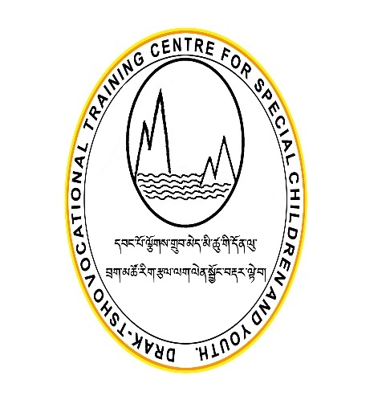
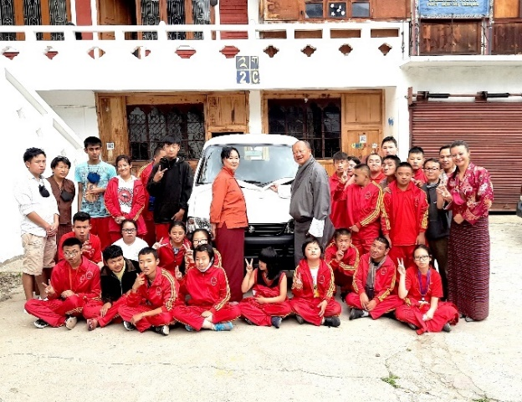
Draktsho Annual Report 2023

Table of Contents
Down Syndrome Day 3
5th march Celebrating Diversity 4
Autism Awareness Day 5
Workshop on Sustainable Agriculture 7
Mapping and Awareness Program on Persons with Disabilities 9
Scout Scarf Celebration 10
Disaster Risk Reduction Awareness 12
Teachers Day Celebration 13
Zorig Day Celebration 15
Solar Water Project 16
Draktsho Hair-Styling Day 17
Celebrating 35 Years of Successful Partnership! 18
Special Olympics Berlin Games 20
Draktsho Entrepreneurship Foundation Day 22
Community Mapping: Project Namdrel 24
Mushroom Cultivation Training 26
Community Mapping 28
Civic Engagement Workshop for Persons with Disabilities 30
Exchange Program 32
World Cerebral Palsy Day 34
Awareness and Sensitizing Workshop 36
A Blessing 37
Dental Camp 38
Medical Health Checkup Camp 39
International Day of Persons with Disabilities 40

Down Syndrome Day

Draktsho celebrated Down Syndrome Day on 21st March to create an awareness about people with this condition to let the world know and understand about Down syndrome. Draktsho celebrated the day with the theme of “With us not for us” to avoid stigma of not being unaccepting by society to promote inclusion and also to advocate for equal rights and opportunities for individuals with Down syndrome.
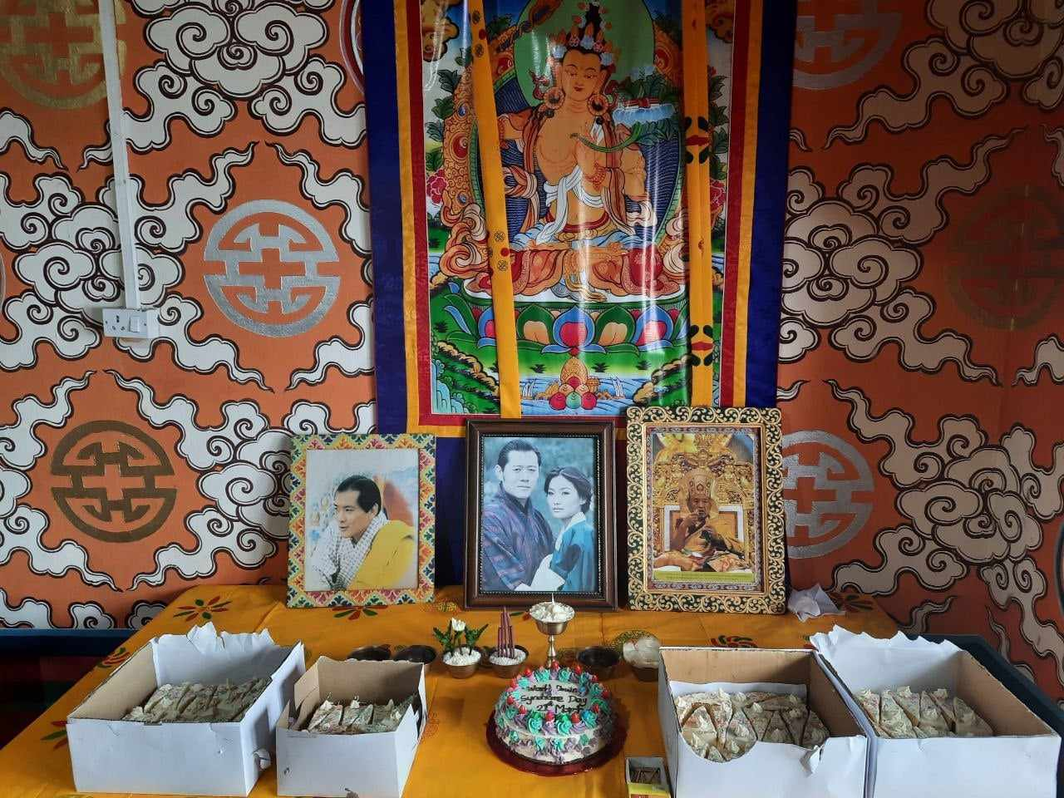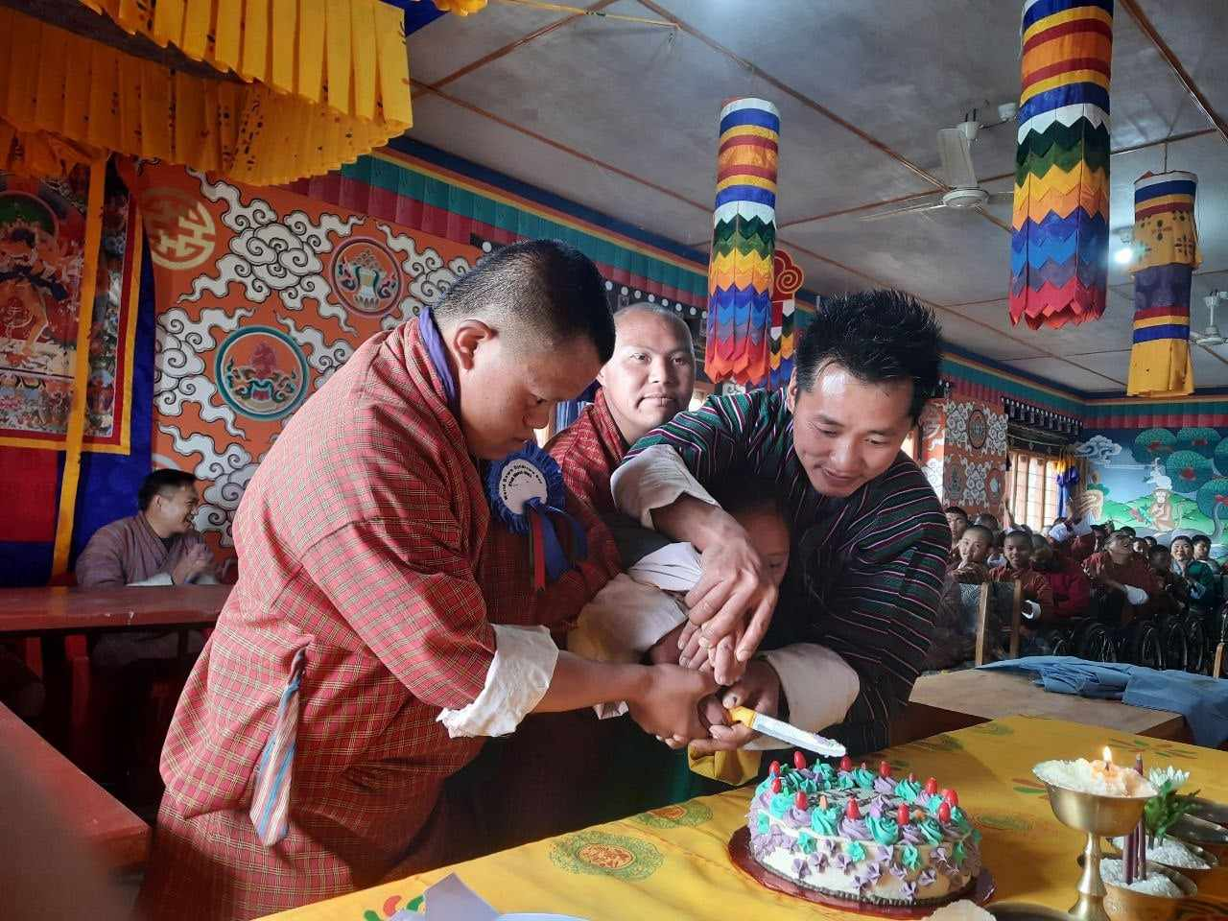
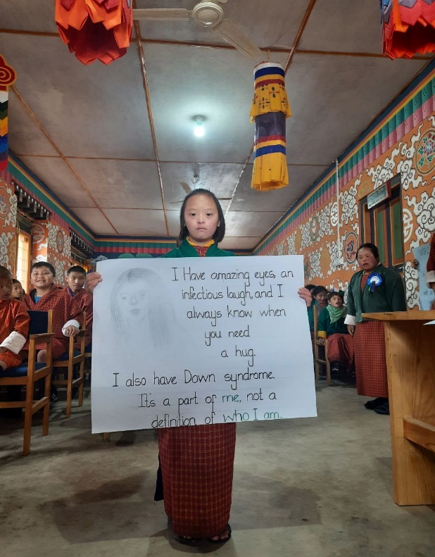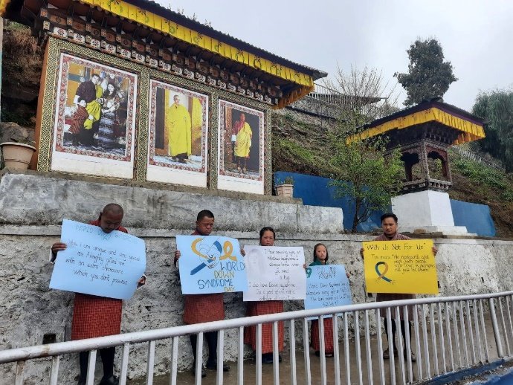

5th march Celebrating Diversity

Taj Tashi 's commitment to creating a more inclusive and diverse community is truly inspiring. It is wonderful to see a company that not only talks about inclusivity but takes concrete steps to make it a reality. Staffs of Taj Tashi came dressed in beautiful Indian costume’s and performed various Indian cultural dances for the staffs and students of Draktsho. The program concluded with a jam session where everyone joined and danced together. The students were thrilled and Draktsho aims to keep strengthen such collaborations to promote inclusion.

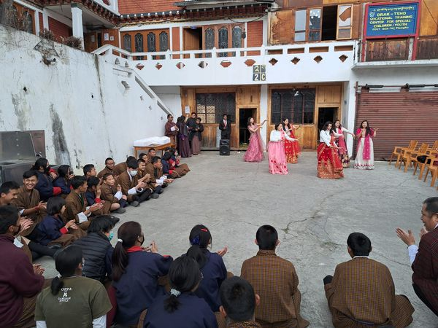

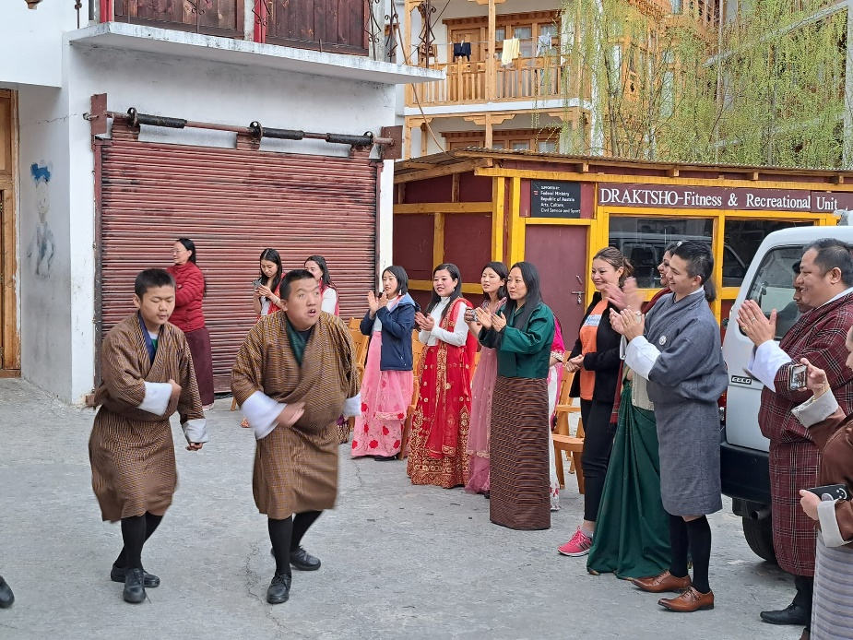

Autism Awareness Day

2nd April is observed as Autism Awareness worldwide where we come together to champion the cause of autism spectrum disorder and foster a deeper understanding and acceptance of it. Autism is a condition that affects millions of people around the world, and it's crucial that we acknowledge and embrace both the strengths and challenges that come with it. As members of society, we have a vital role to play in creating an inclusive and supportive environment for persons with autism. This day provides us with a unique opportunity to educate ourselves and others on what autism is, how it impacts individuals and families, and how we can best support and advocate for the autism community. By working together, we can create a world where individuals with autism can achieve their full potential and flourish.

Students, teachers and parents of Draktsho East Centre observed this special day cutting followed by cultural celebrations with tea and snacks.
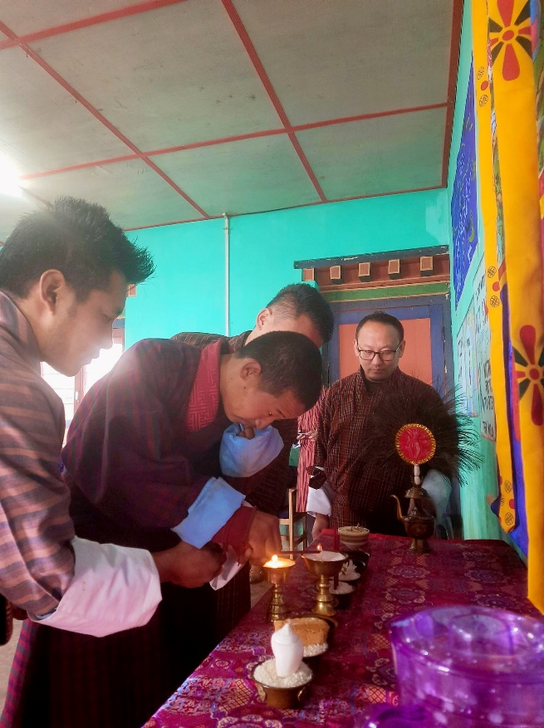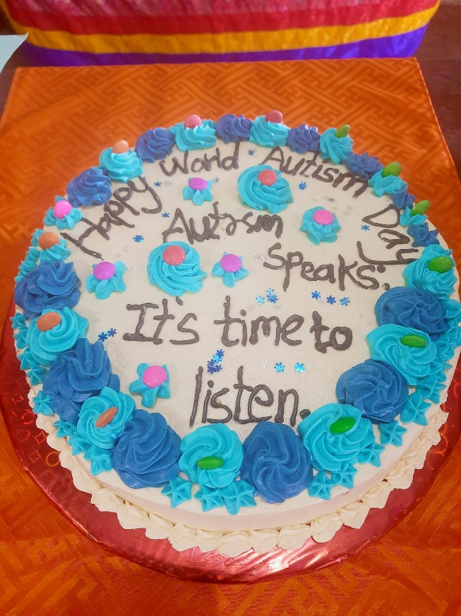

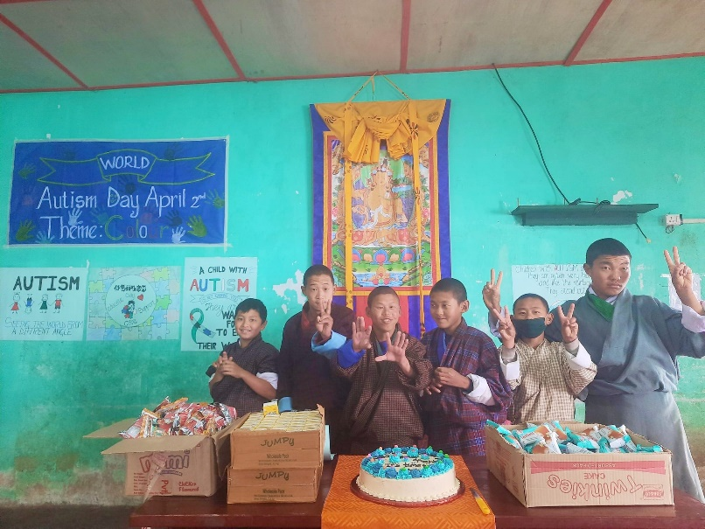

Workshop on Sustainable Agriculture

On 24th April 2023 Draktsho East conducted a workshop on sustainable development, Agriculture Practices, sustainable agriculture and use of machineries and the impact of human activities to environment, in collaboration with Sherubtse college and Khangma RAML which is Funded by UNDP. This workshop aimed at training students with disabilities in inclusive agriculture practices through physical training. 8 students who could not learn vocational skills were identified and trained in this new project so as to equip them with some agriculture knowledge that would help them be independent and also earn a living through farming.
This joint collaboration helped the students learn basic mushroom farming with other agriculture skills. The training was supported by the GEF-Small Grant Project, UNDP, Opening Your Heart to Bhutan and also READ Bhutan. The donors supported the project in establishment of the mushroom cultivation room, procurement of seeds and equioments.
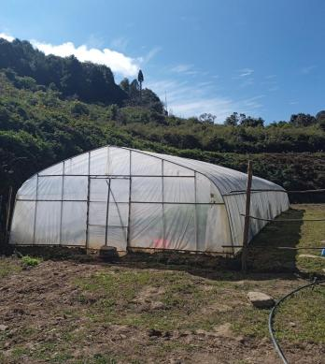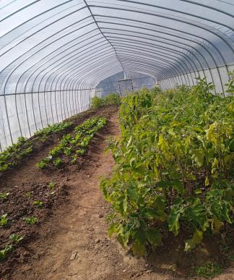
Green House funded by UNDP

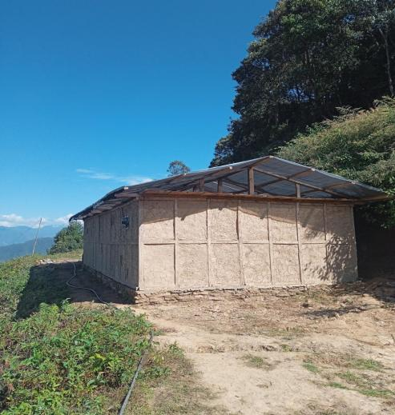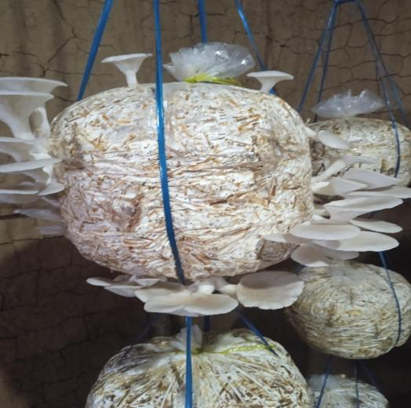
Mushroom House supported by OYHTB

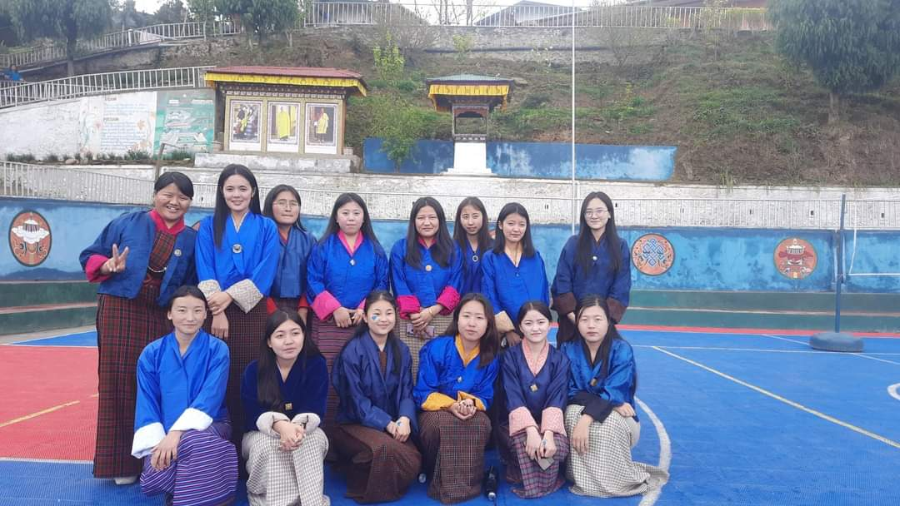
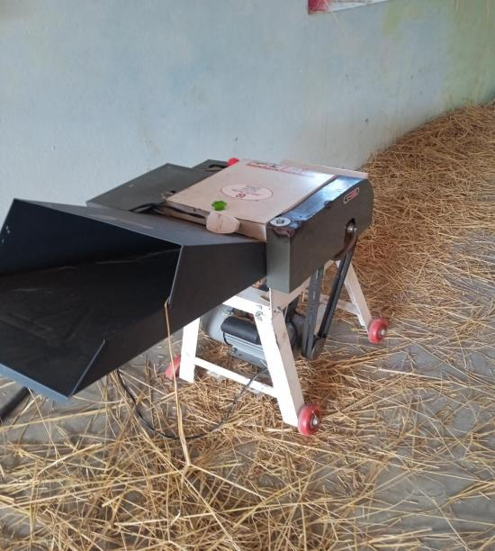
Donated by READ Bhutan

Mapping and Awareness Program on Persons with Disabilities

Draktsho conducted awareness campaign on 27th April about t its services and programs, and also organized a mapping exercise with the theme "Beyond Labels: Together we map to build a more inclusive Bhutan for Person with Disabilities". The main objective of this event was to utilize mapping as a tool to foster a more inclusive society for persons with disabilities in Bhutan, and to amplify their voices and those of their parents to advocate for their needs. The event aimed to move beyond societal labels and stereotypes associated with disabilities, and instead acknowledge the unique abilities and contributions of persons with disabilities to the society. Through the mapping exercise, barriers to accessibility and inclusion were identified, along with areas of strength and resources that could be utilized to promote greater participation and inclusion of people with disabilities in all aspects of Bhutanese society. This event was supported by Project Namdrel, IDEA, Helvetas Bhutan.

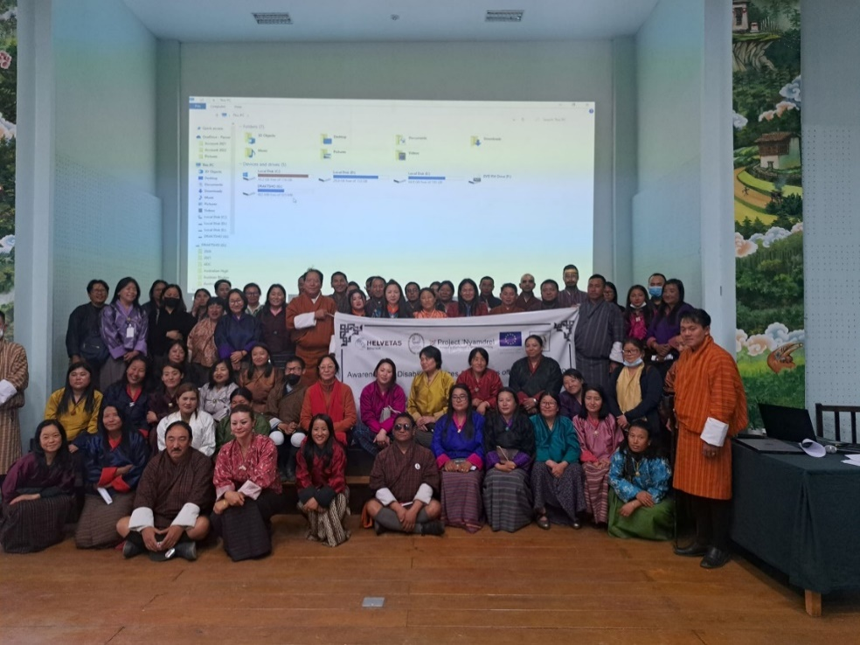

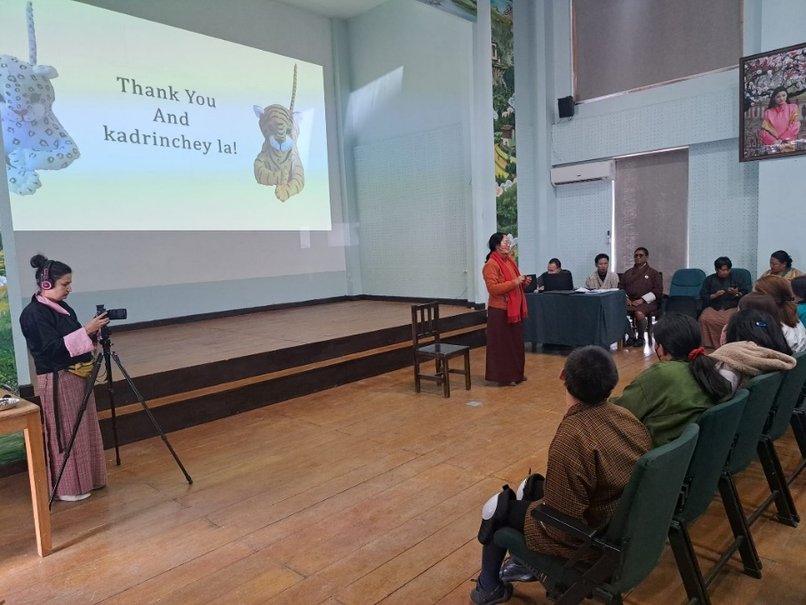

Scout Scarf Celebration

Draktsho East Centre successfully conducted Investiture ceremony of scout. A total of 50 student were awarded with Scout Scarf where they were officially given recognition as member of the Scout. The Principal of Draktsho East awarded the scarfs to the students. The same celebration was held at Thimphu in August where Founder Rigzin Padma Tsogyal awarded the Scout Scarfs to the students.

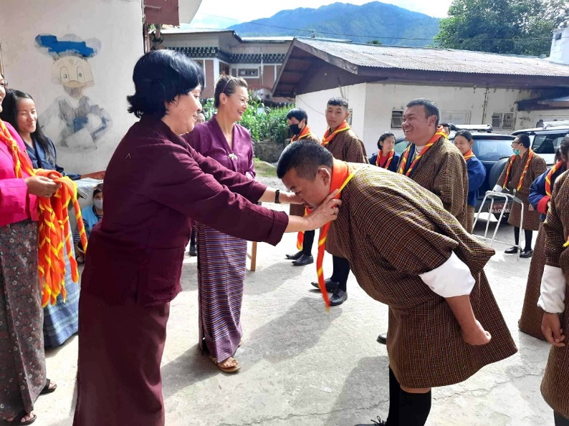

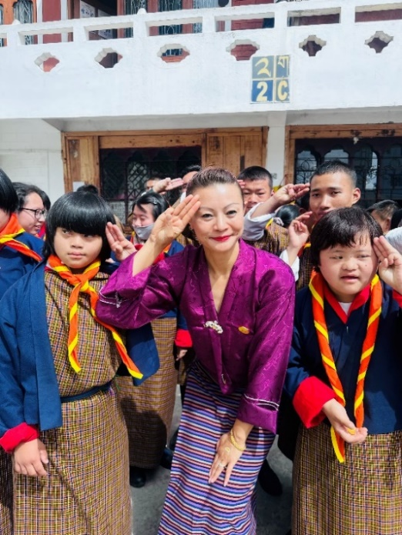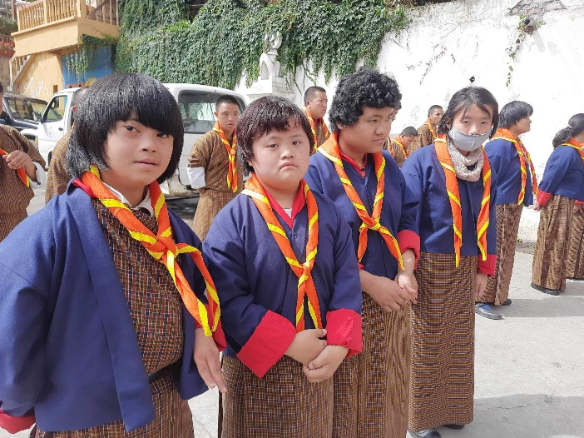

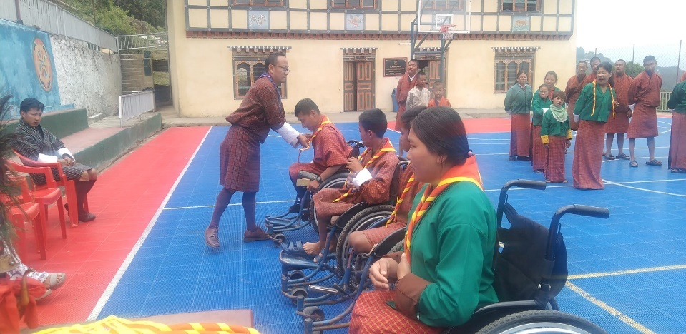

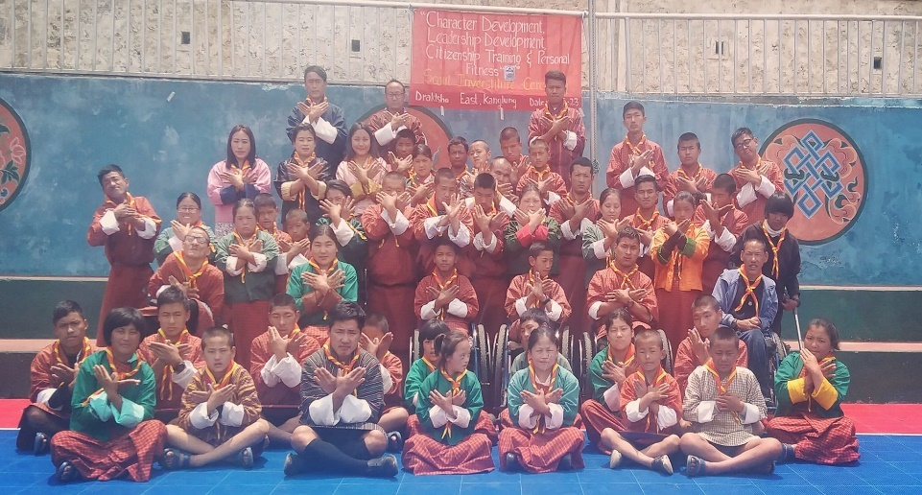

Disaster Risk Reduction Awareness

Draktsho expresses gratitude towards READ Bhutan for their invaluable contribution towards reinforcing Draktsho’s risk management strategies, which is held in high regard. The efforts of READ Bhutan to heighten awareness among the students regarding disaster mitigation measures, alongside providing them with indispensable training to competently tackle natural calamities, are truly praiseworthy. Staffs of READ Bhutan conducted sensitization sessions to the students on disaster risk reduction and also Menstrual Health and Hygiene and also donated equipment’s/tools to mitigate unforeseen natural disasters.
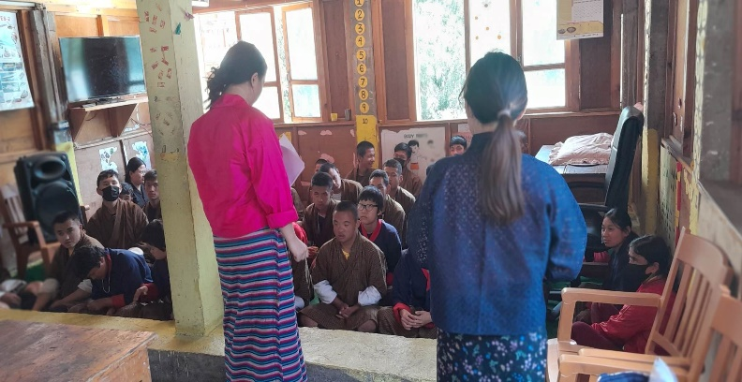
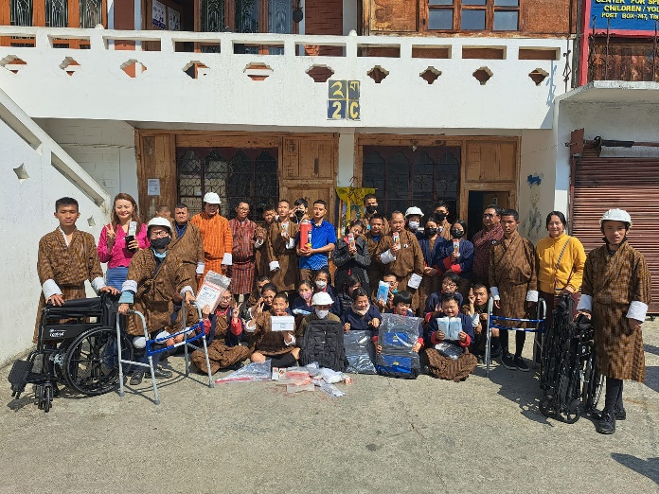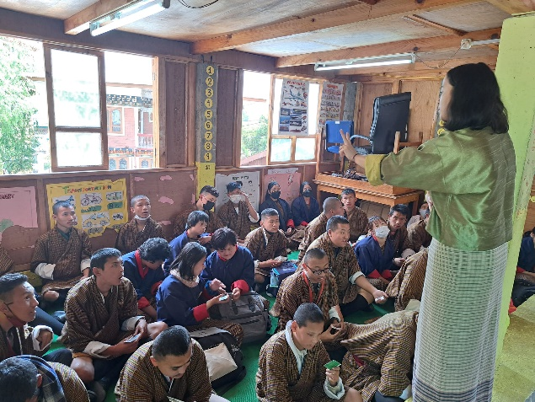

Teachers Day Celebration

2nd May in Bhutan is observed as the Teachers Day. Every year on this day students of Draktsho take the initiative to organize cultural programs, fun games, tea and snacks for their teachers showing their love, gratitude and respect for them. This event is solely organized by the student themselves withour support from the teachers. An annual special occasion where the staffs of Draktsho looks forward to from the students.

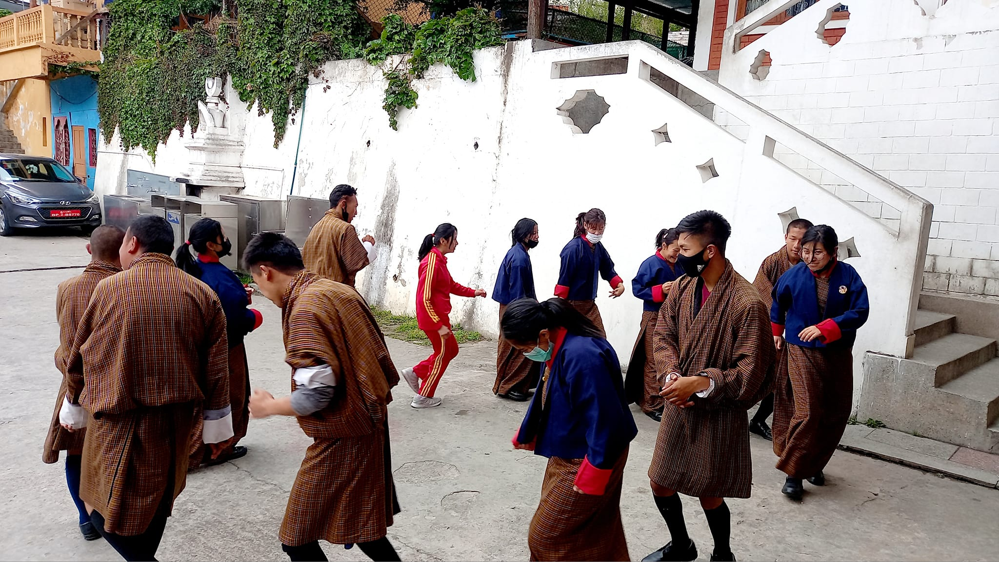
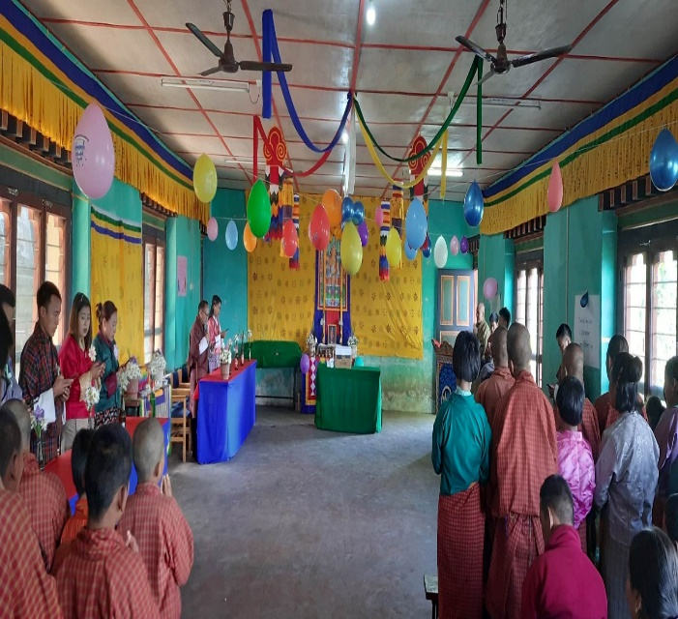

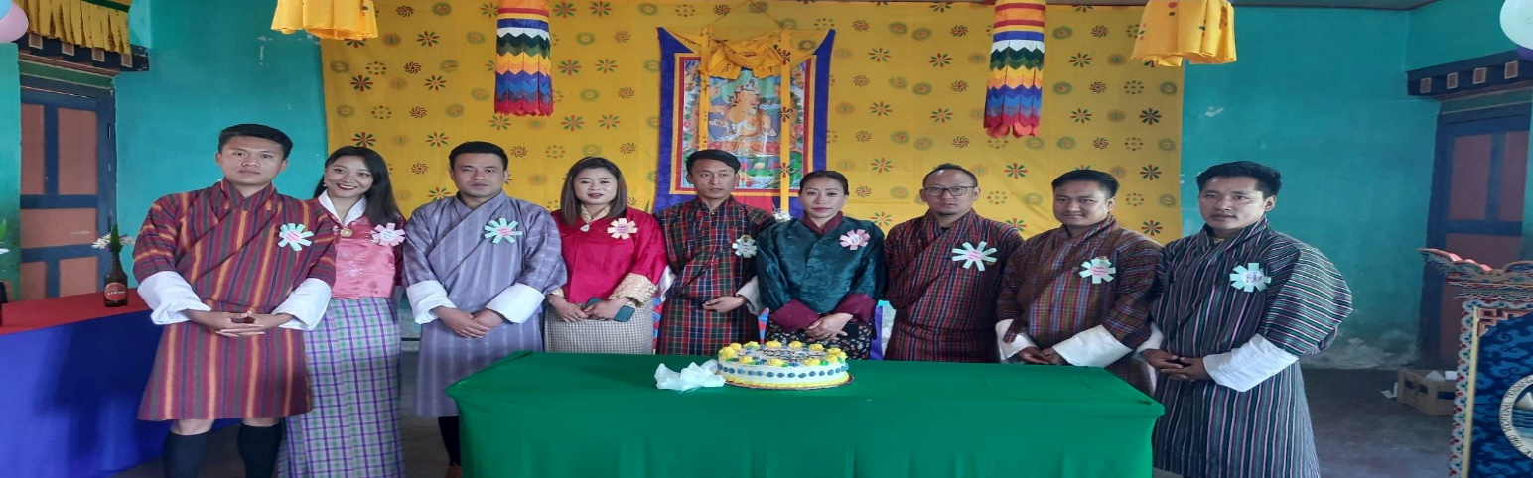

Zorig Day Celebration

The national Zorig Day is observed on 5th may 2023 coinciding with the 15th day of the third month of the Bhutanese calendar to pay respect to artisans, craftsmen and technicians for their contribution towards cultural preservation and socio-economic growth. Draktsho East celebrated the day at Kanglung Primary School. The day was started with a Lhabsang ceremony (purification)from 7am to 8 am followed by purification and blessings of the vehicle’s. Draktsho also took part at this ceremony where the vehicles of the center received blessings.
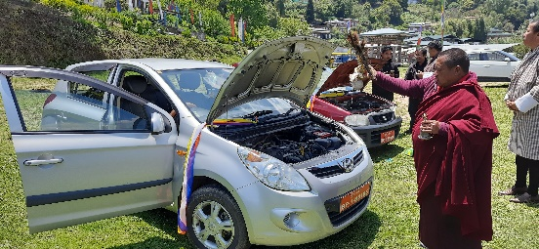

Solar Water Project
The Kanglung Gewog Administration donated and also installed solar water heating system for Draktsho East Centre on 8th May. This will help reduce consumption of electricity and also safe as which works on less sunlight and diffuse light. This installation has benefitted our students and Draktsho and we are grateful to Kanglung Gewog Administration for their support and contribution.
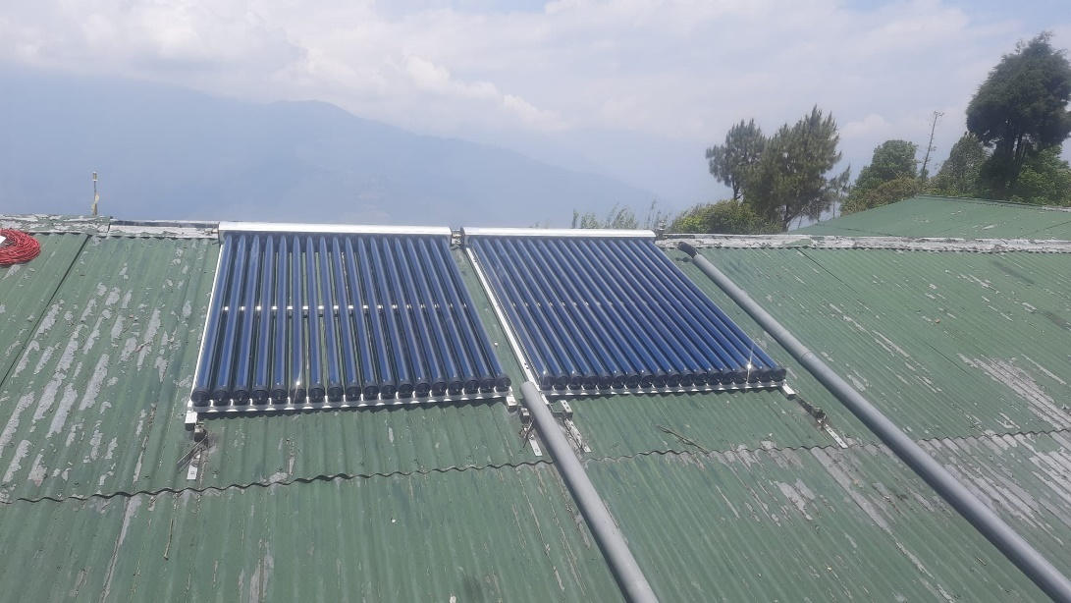

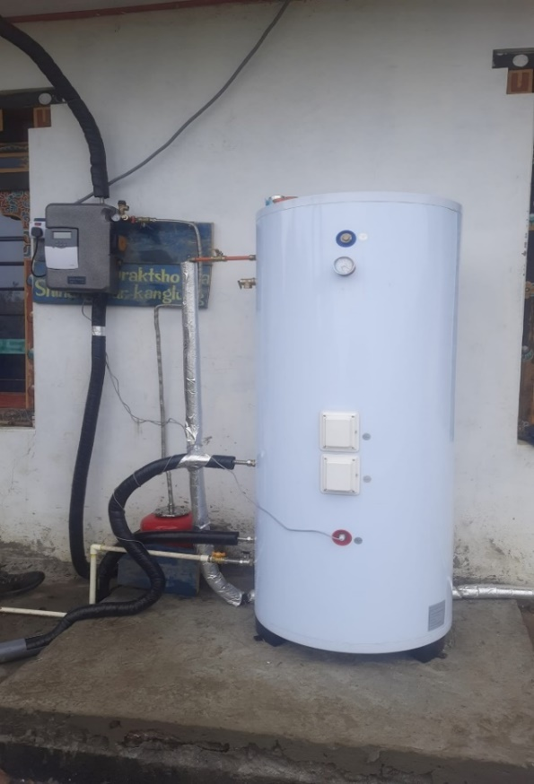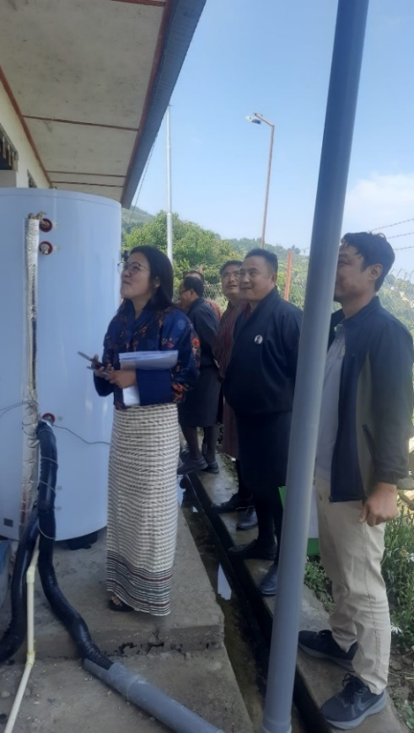

Draktsho Hair-Styling Day
A team of Desuup lead by Mr.Ugyen Deepak gave all our students and also staffs a free hair-styling and haircut on 10th May as support to our organization. The skilled Desuups hairstylists enjoyed interacting with the team and loved their new hair styles. Mr. Ugyen Deepak is a highly skilled professional hair stylist whose commitment to providing free haircuts to students is an honor for Draktsho. We express our deep appreciation to De-suung Skilling Programme for their dedicated efforts in creating a meaningful impact on the lives of the youth in Bhutan. Their commitment to this cause is truly admirable and we are grateful for their contributions to our country.

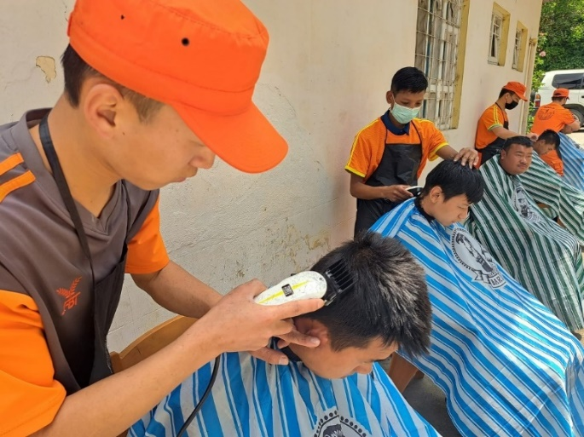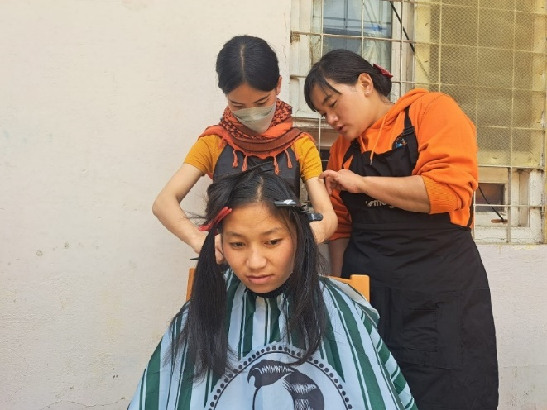

Celebrating 35 Years of Successful Partnership!

We are thrilled to commemorate the remarkable journey of collaboration between the Austrian Development Cooperation (ADC) and the Kingdom of Bhutan, spanning over three and a half decades. Throughout this journey, we have witnessed the power of collaboration, experienced remarkable successes and overcoming challenges together. One such achievement is in the realm of persons with disabilities, where completed projects have flourished, showcasing ADC's unwavering support and dedication in enhancing and empowering students of Draktsho. Today, we express our heartfelt gratitude to the Austrian Delegations led by Her Excellency Ambassador of Austria to India Katharina Wieser and The Regional Director’s visit to Draktsho. Their unwavering support on our projects and its beneficiaries has left a lasting impact on the lives of persons with disabilities. As we bid farewell to the office on this December day, let us remember that their support will always remain in the lives of persons with disabilities. They may be gone, but they will never be forgotten. Let us continue to celebrate this incredible partnership, cherishing the memories, and looking forward to even greater achievements. Together, we can make a difference!

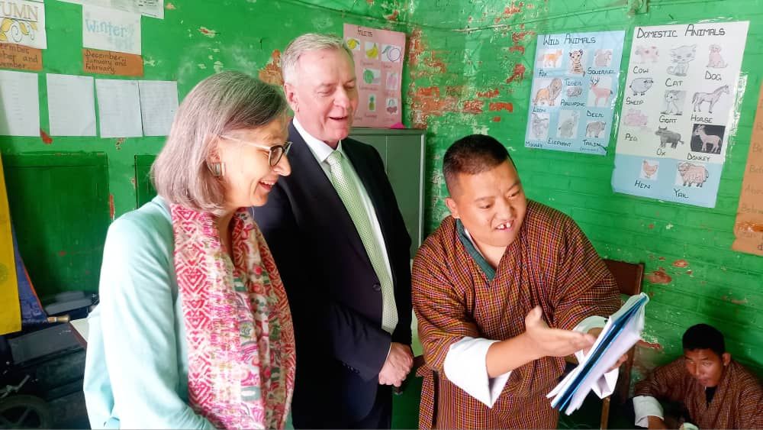

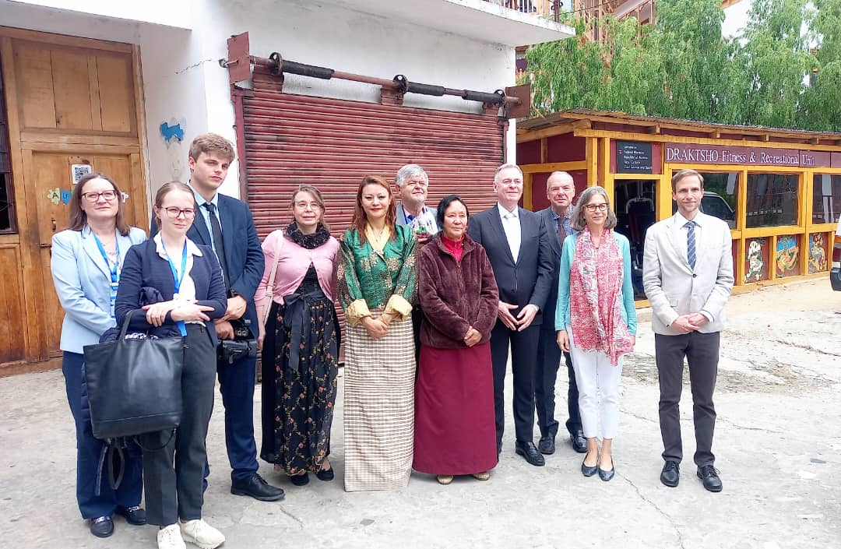

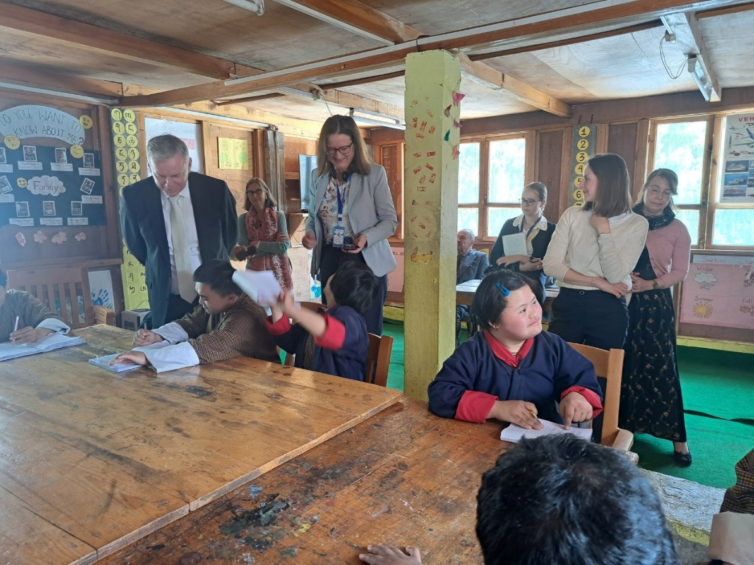

Special Olympics Berlin Games

4 athletes from Draktsho participated at the World Games from 17th -25th June,2023 which was held at Berlin, Germany. The athletes, 2 male and 2 female participated at track and field events such as 100 mts race and shot-put. Mr. Nima Yoezer won 2 gold medals at the mens100(B-Division) mts and shot-put. This is the first time in the history of Bhutan where a person with intellectual disability wins 2 gold medals at an Olympic level. Nima made it through the quarter finals, semi’s and won at the final event. He performed immensely good and we can’t express our happiness and how pride because of him.
Ms. Dechen Peldon also won her first silver medal at the women’s Shot-put category. Our athletes came home victorious creating history and making us all so proud.
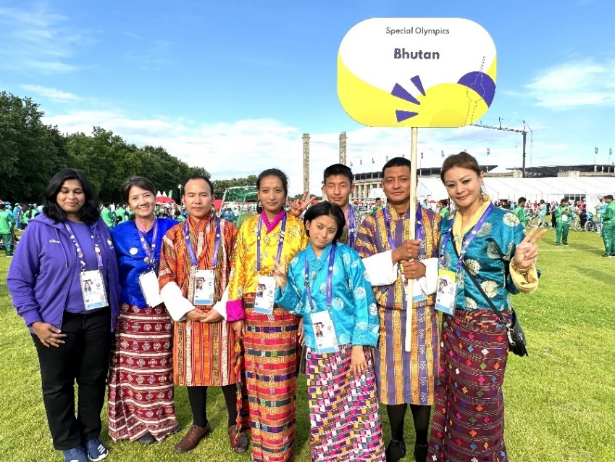
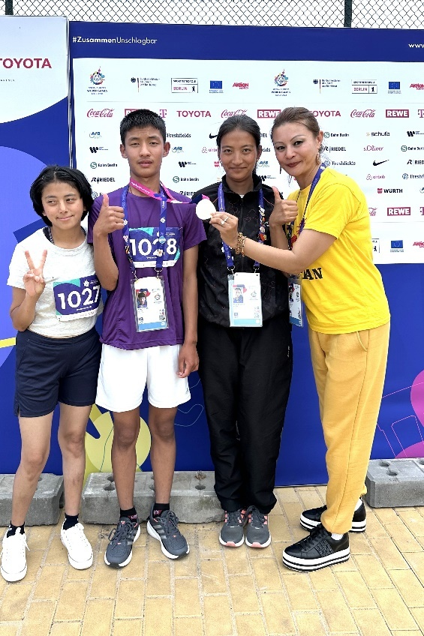 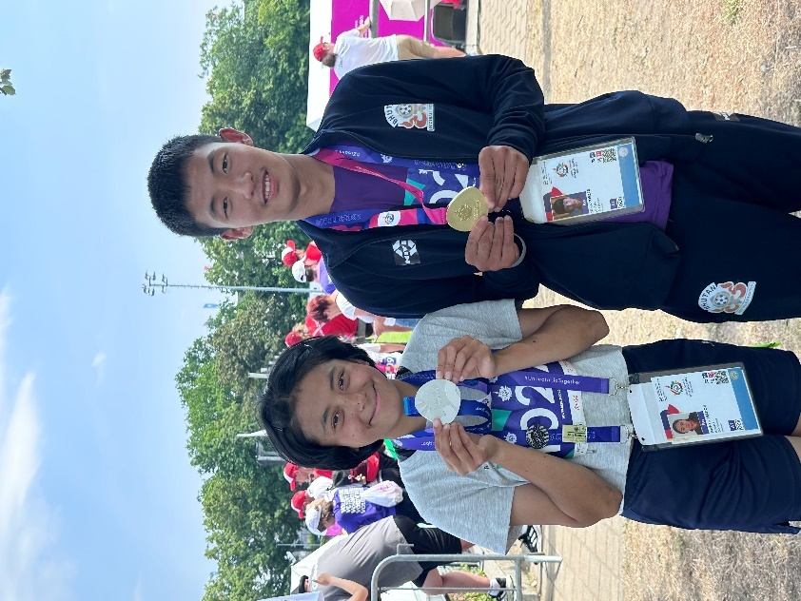Nima Yoezer with his first gold Champions Dechen Peldon and Nima

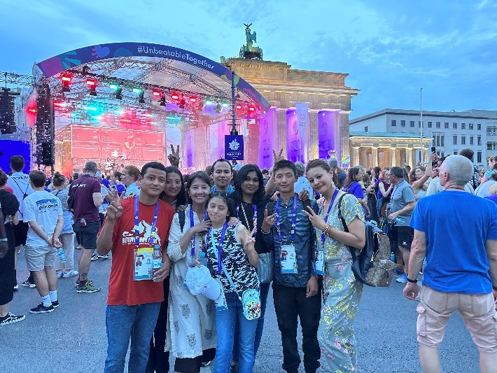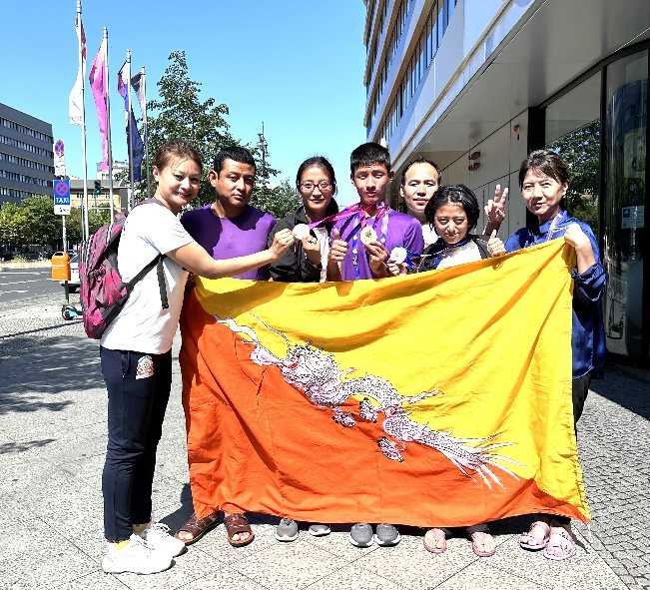

Draktsho Entrepreneurship Foundation Day

To empower persons with disabilities, Draktsho launched its Entrepreneurship Foundation that will provide financial support to aspiring entrepreneurs with disabilities. The initiative aims to address the employment challenges faced by Draktsho graduates. Initially meant only for students of Draktsho Vocational Centre, the organisation plans to expand the programme to all persons with disabilities in the country wanting to start a business. The initiative aims to enable people with disabilities with economic independence and foster a more inclusive society. Under the new initiative, students will have to pitch their business ideas and the chosen ones will get a loan of Nu 100,000.
“There are a lot of barriers to the availability of loan services and insurance schemes for persons living with disabilities. So, to break this barrier, Draktsho initiated to come up with the “Draktsho Entrepreneurship Foundation. This Entrepreneurship Foundation will be providing loan and insurance scheme for persons with disabilities and their families. We will also provide startups and also provide technical support whereby they can successfully venture into businesses.
At the launch, four beneficiaries with disabilities from Draktsho were chosen to receive the loans. The business ideas included three tailoring shops and a carpentry and furniture unit. This initiative was funded by the Bhutan Foundation on 29th June at Draktsho Thimphu centre.
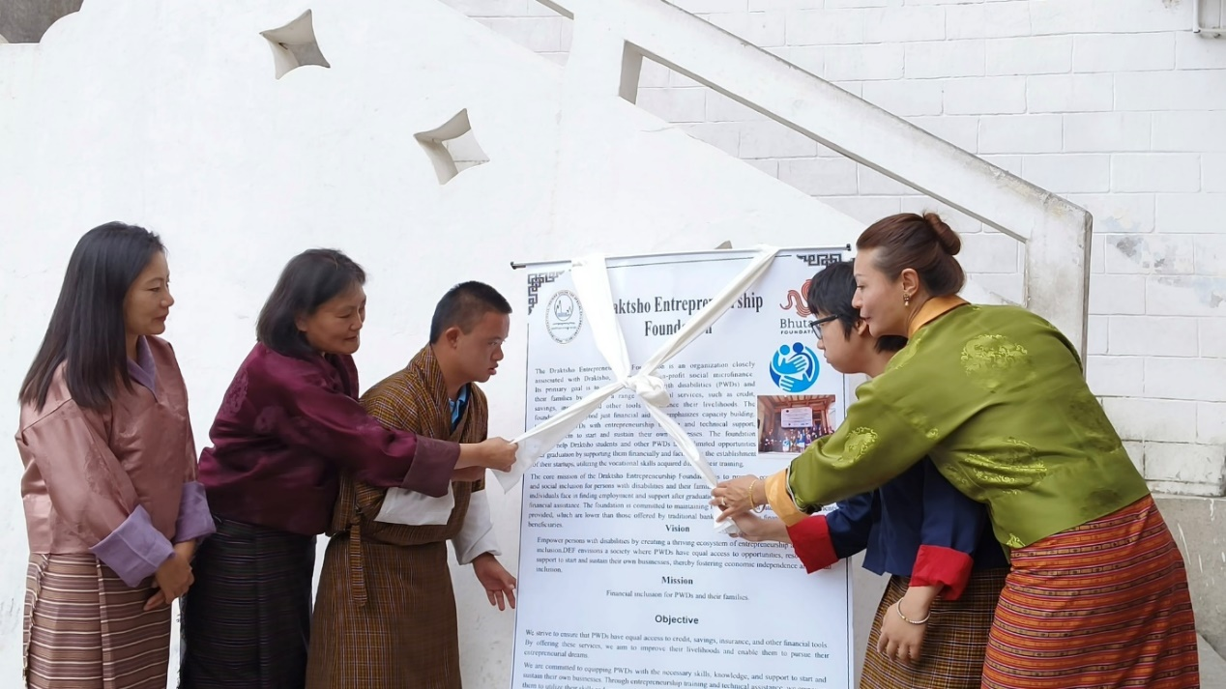
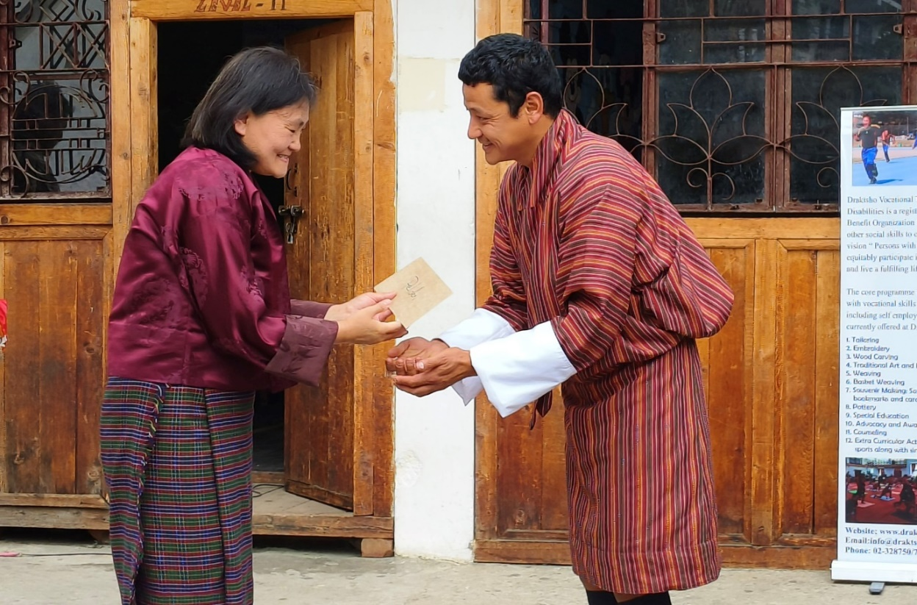

Community Mapping: Project Namdrel

On 7th August Draktsho conducted an awareness campaign highlighting its services and programs available for children and youth with disabilities at Khuruthang Middle Secondary School. The team also organized a mapping event with the theme "Beyond Labels: Together we map to build a more inclusive Bhutan for Persons with Disabilities." The main goal was to use mapping exercise as means to amplify their voices. Teachers, students and parents attended this program and this project was funded by Project Namdrel, IDEA, Helvetas Bhutan.

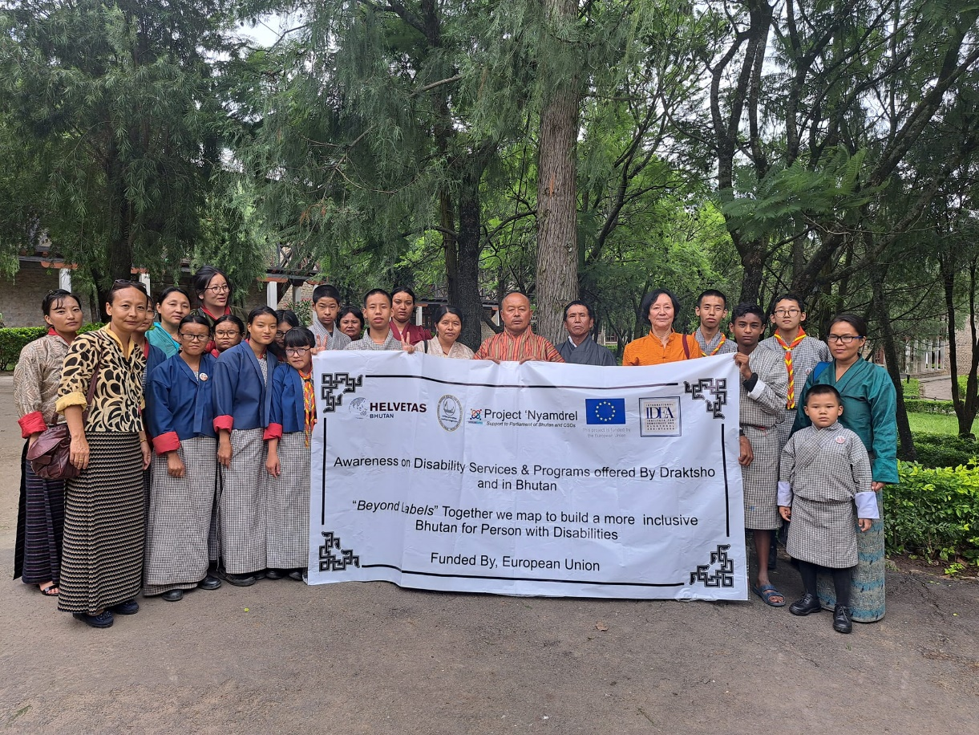
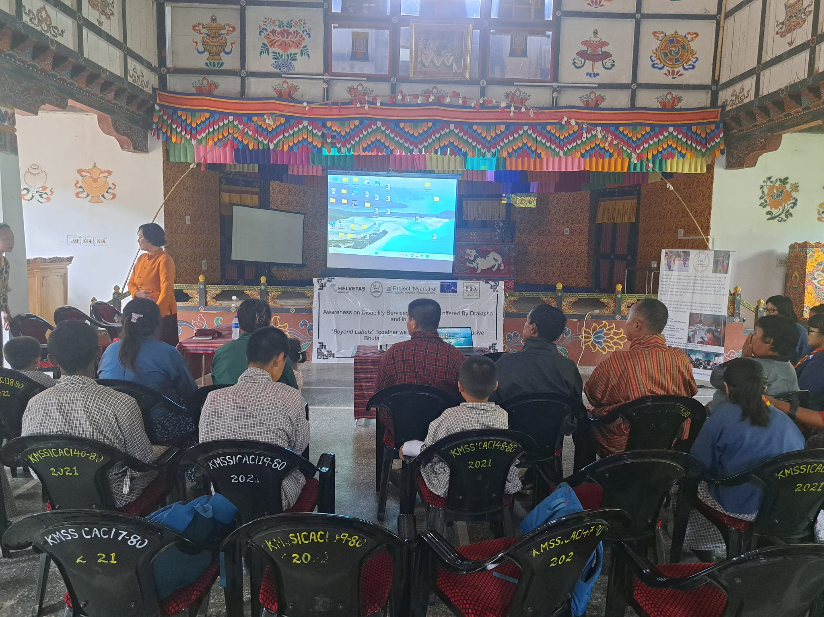

Mushroom Cultivation Training

Draktsho being a non-profit making organization relies a lot on donations and projects, therefore to sustain the organization and also create employment opportunities for students of Draktsho Centre we started a Mushroom Farming project. This project was supported by GEF-Small Grant Project, implemented by UNDP in partnership with Royal Government of Bhutan. Opening Your Heart to Bhutan also supported this initiative by raising funds to construct the mushroom house.
Mr. Sonam Gyeltshen is based in Mongar Kalapang where he runs his mushroom business. On 18th August he provided free training in mushroom cultivation to some of the students and staffs of Draktsho East Centre.
Draktsho remains ever grateful to OYHTB for their continued support as also the GEF-Small Grant Project, UNDP for supporting us start this new initiative at Draktsho East Centre in Kanglung, Tashigang.

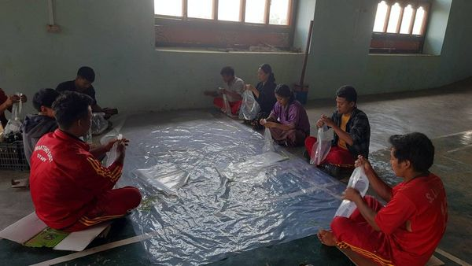

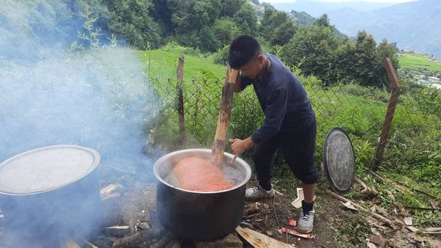

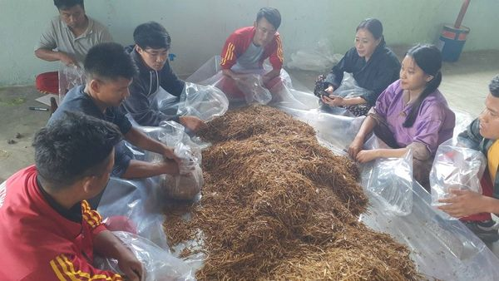

Community Mapping

Draktsho conducted an awareness campaign showcasing its services and programs at Wangsel Institute for the Deaf on 13th September. The team hosted a mapping event cantered around the theme "Beyond Labels: Together we map to build a more inclusive Bhutan for Persons with Disabilities." The primary objective was to utilize the mapping activity to empower the voices of individuals with disabilities. During the event, both parents and students openly discussed their difficulties without any communication barriers.
This project was funded by Project Namdrel, IDEA, .

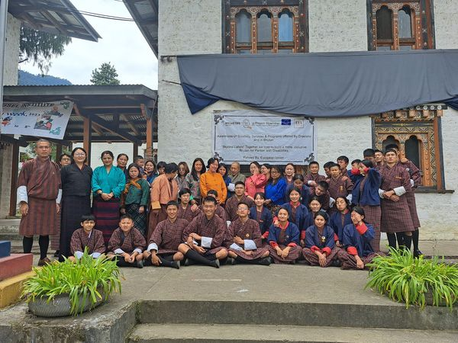

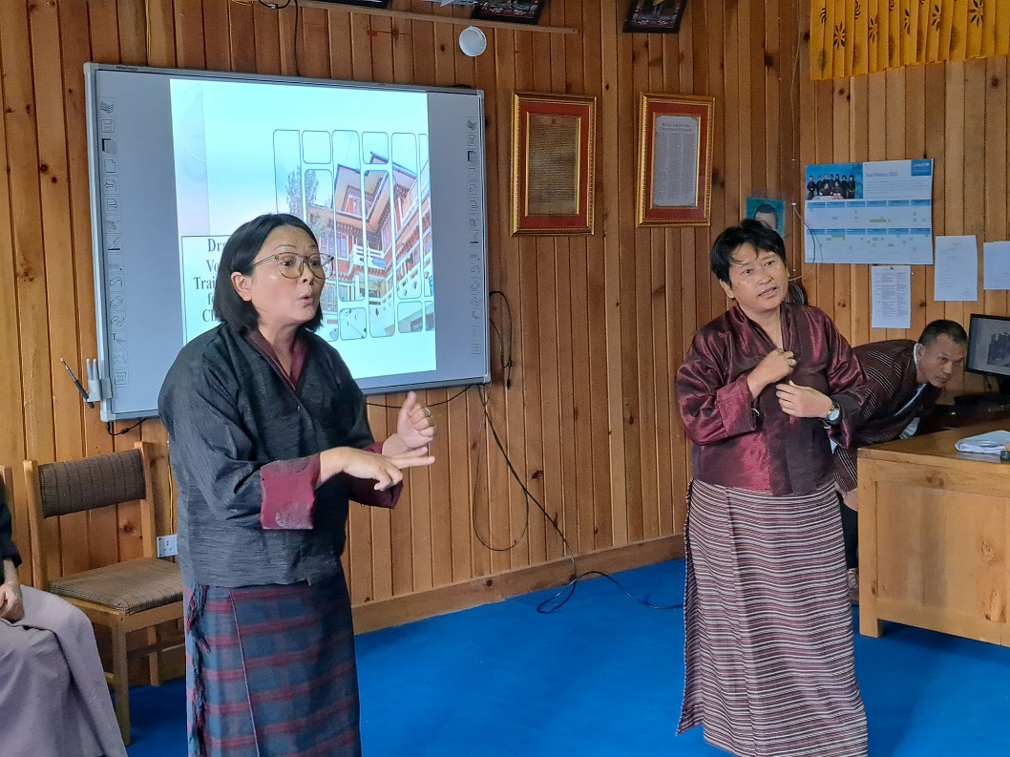

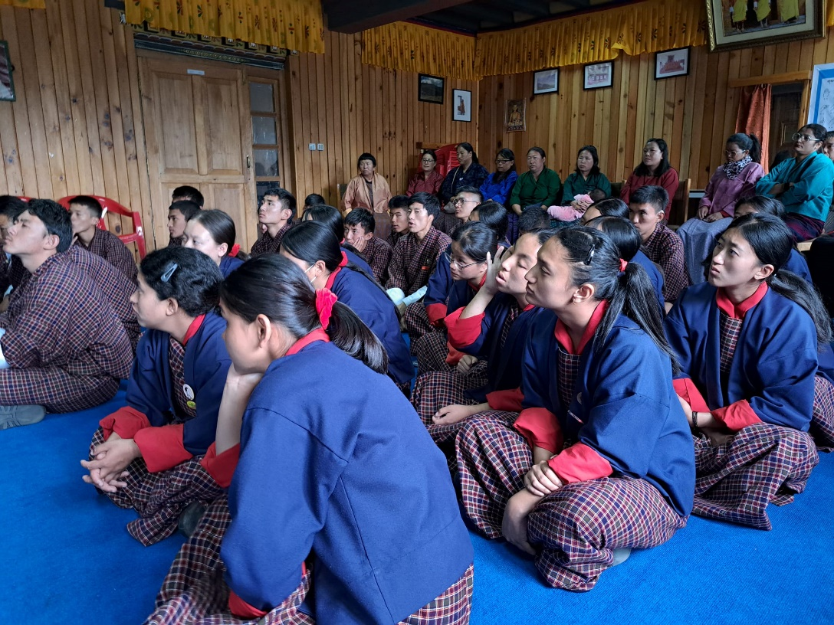

Civic Engagement Workshop for Persons with Disabilities

We're absolutely delighted to share the resounding success of our recent "Civic Engagement Workshop for People with Disabilities (PWDs)." In this all-encompassing program, we've provided dedicated advocates with a wealth of essential tools: empowering leadership skills, effective policy advocacy strategies, impactful communication techniques, voter education, and mobilization strategies. Our ultimate goal of the program was to empower our students to champion inclusivity and fortify the bonds of our community.
This incredible milestone was attainable due to the vital technical assistance from Helvetas Bhutan , the passionate engagement of the Election Commission of Bhutan, and funding support provided by the Canada Fund for Local Initiatives, we are collectively shaping a society that is not only more inclusive but also stronger.
Draktsho Vocational Training Centre conducted a voter education programme for persons with disabilities, last Friday. According to the ECB, they will work with civil society organization’s to facilitate and provide services to persons with disabilities. During the programme, the ECB talked about the five registered political parties, electoral laws, ethical use of social media, and refraining, resisting, and reporting corrupt practices.
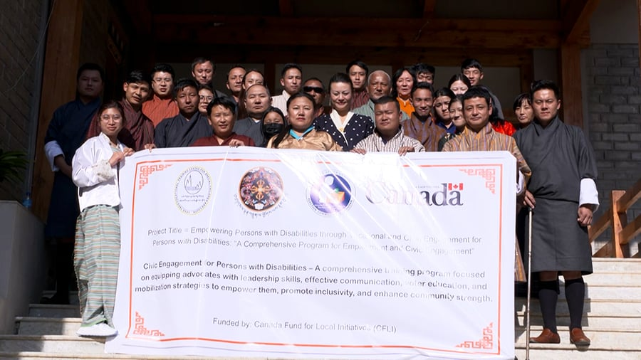
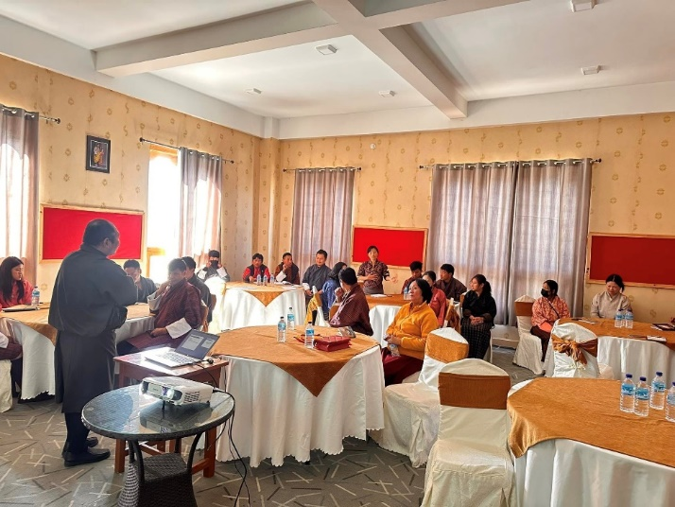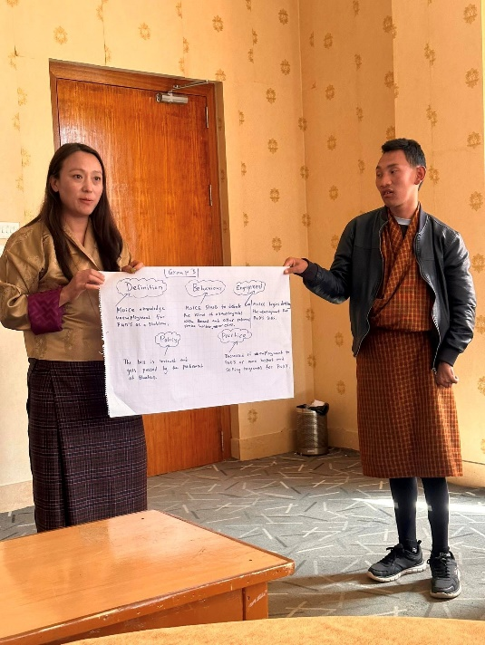
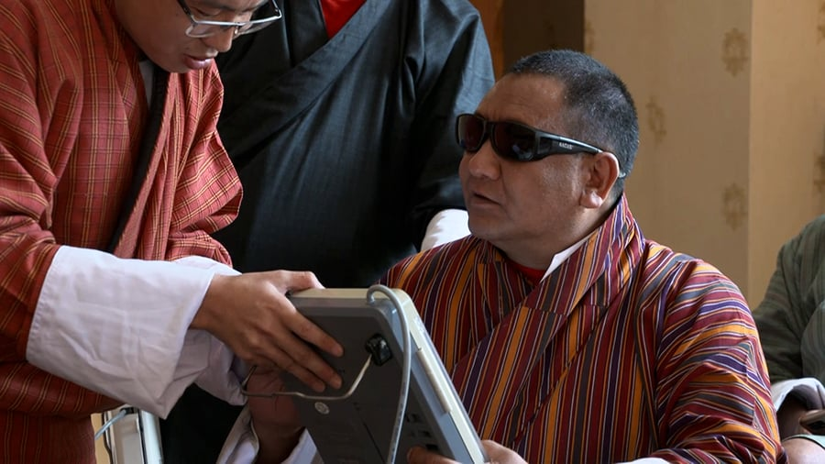

Exchange Program

4 students with deafness from Draktsho East Centre attended the exchange programme organized by Anam Prem Foundation in Gowahati, Assam from September 28th to October 2nd. The event provided a platform for persons with hearing impairments to exhibit their talent in singing, dancing, sketching, photography, news reporting, miming, etc. Nearly 25 states from various regions of India took part this year, including Draktsho East from Bhutan.
The event took place, coincident with the birth anniversary of Mahatma Gandhi. This exchange programme was possible with support from Opening Your Heart to Bhutan.

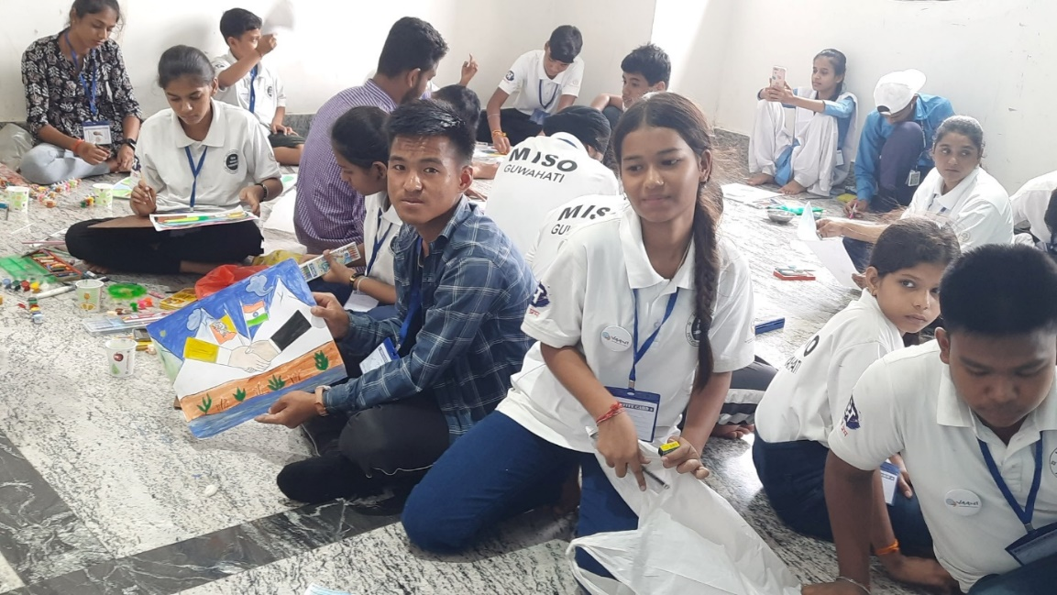

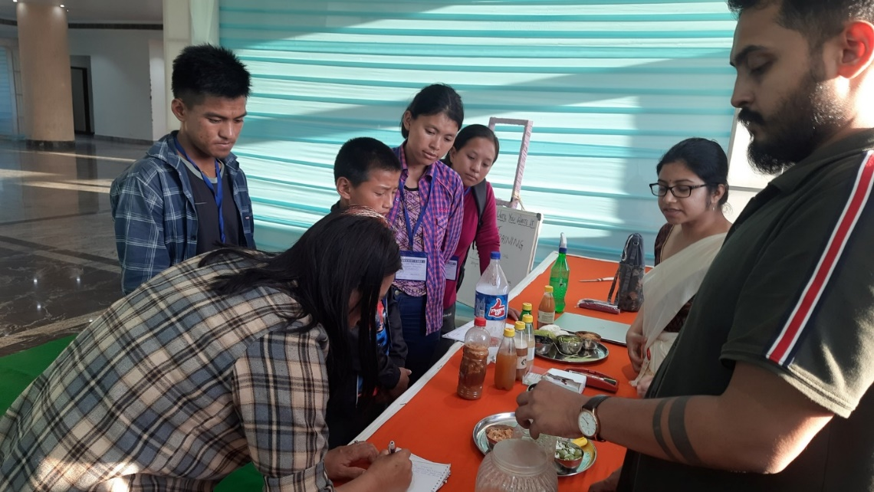

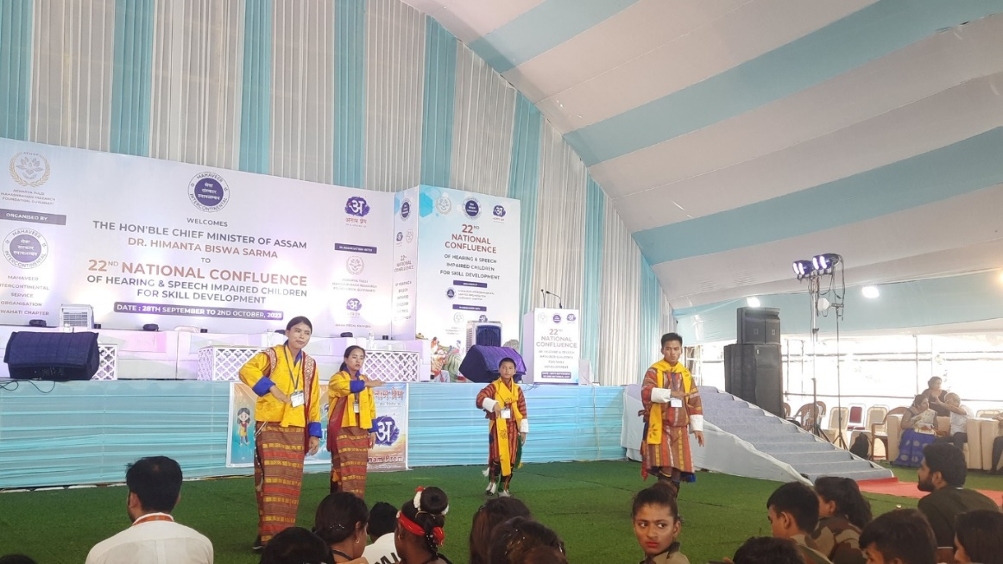

World Cerebral Palsy Day

The world cerebral palsy day is observed on 6th October every year and this year Draktsho observed this special day with the theme “together the stronger”. The celebration beganwith an awareness campaign at Kanglung Primary school and then continued the program at Draktsho East Centre with various cultural programs and also fun games.
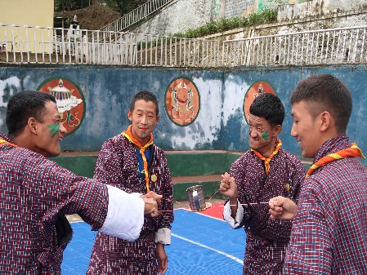
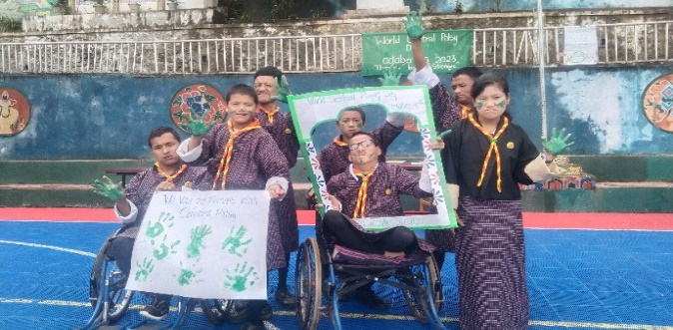

Global Hand Washing Day
Draktsho observes the Global Hand Washing Day on 15th October Annually. In 2023 we celebrated the day in collaboration with the group of students from Sherutbtse College at our Draktsho East Centre and since that day we have been observing this day annually. Though the main aim is remain clean and maintain proper health and hygiene, it is important to know the methods to do so. The students were taught how to wash their hands thoroughly and the benefits of washing hands.
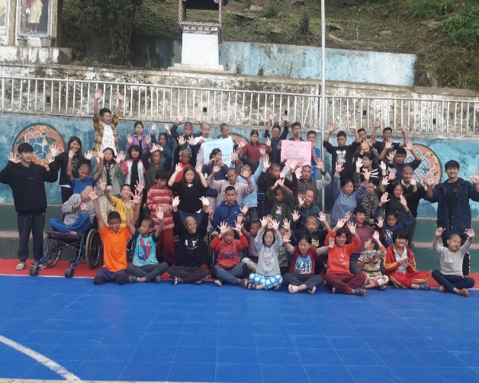

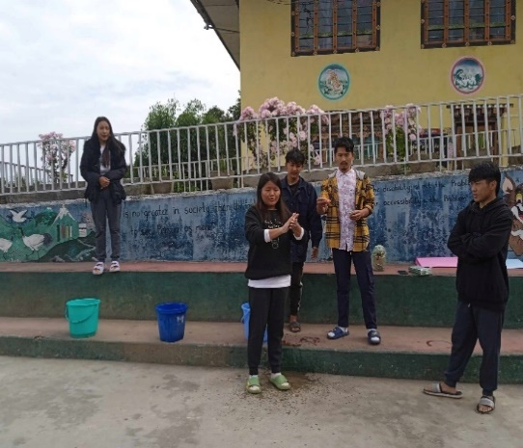

Awareness and Sensitizing Workshop

Draktsho organized a workshop on a knowledge sharing and best practices to sensitize the parliamentarians, private sectors and also government agencies of persons with disabilities in Bhutan on 11th October. The workshop also focused on the issues and challenges faced by persons with disabilities, caregivers and parents. The aim of the workshop was to create awareness on these challenges so that the policy makers and job providers will move towards creating a happier and inclusive society for this vulnerable group. The event was held at Hotle Zirikha, Thimphu and supported by Helvetas Bhutan Project Namdrel IDEA.

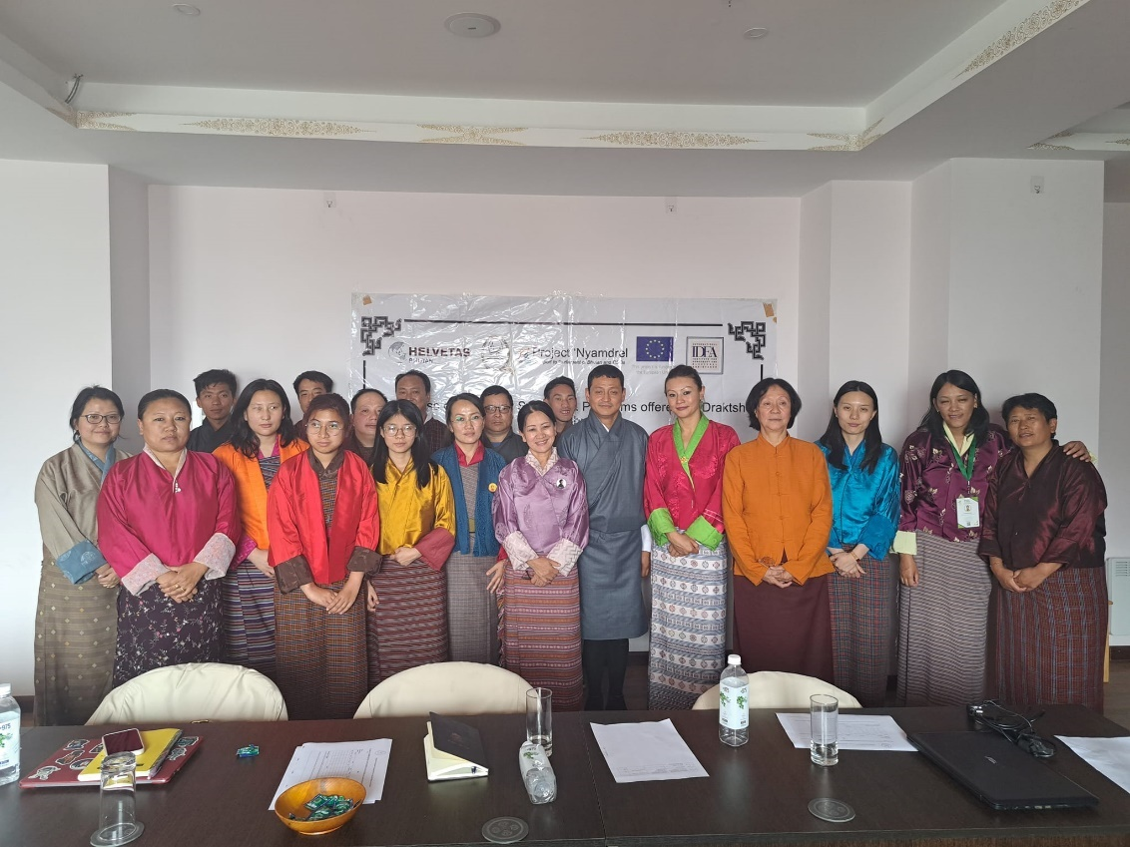
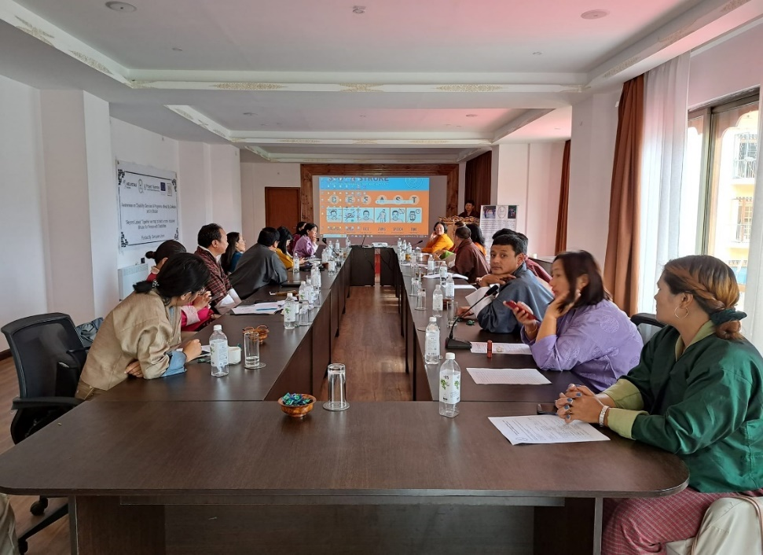

A Blessing
It was truly an honour and blessing to for Draktsho to have been selected as one the CSO’s to receive empowerment and also a donation from His Holiness Kathok Situ Rinpoche during Rinpoches birthday celebration at the Memorial Chorten. Draktsho was one of the 4 CSO’s that was fortunate to receive blessings from Rinpoche and was be able to witness Rinpoches birthday celebration.

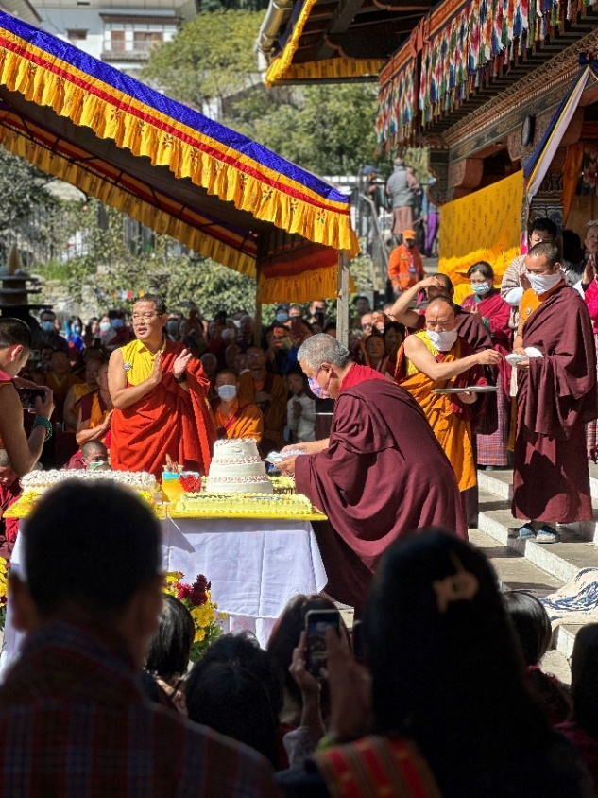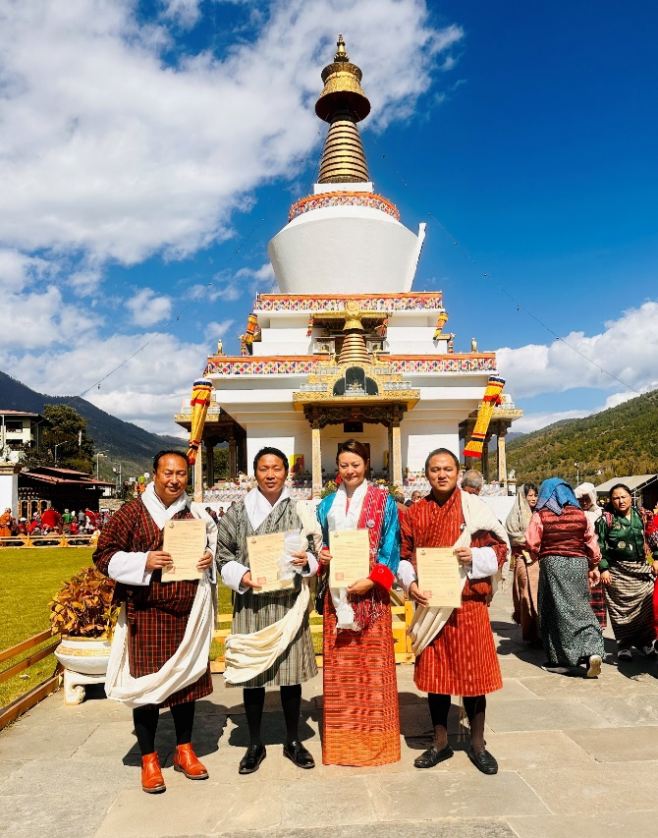

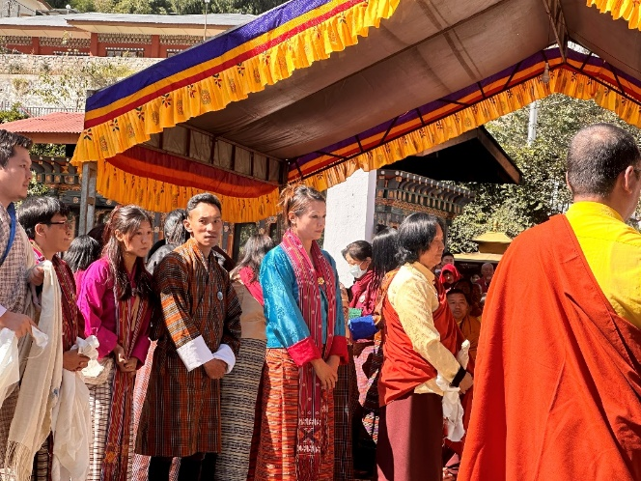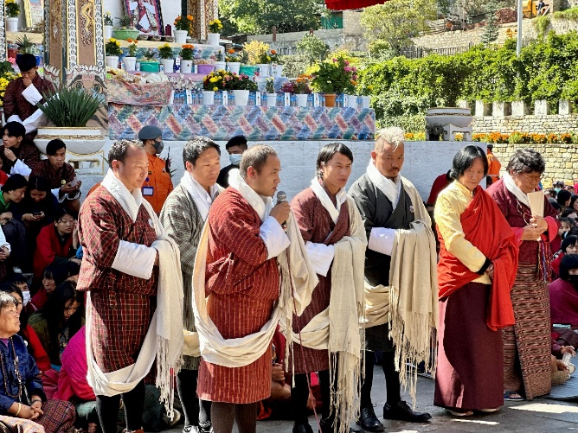

Dental Camp

On 3rd November a free Dental checkup camp was organized at Draktsho East Centre by Project DANTAK from Thimphu. All the students and also the staffs underwent this free dental health checkup camp.

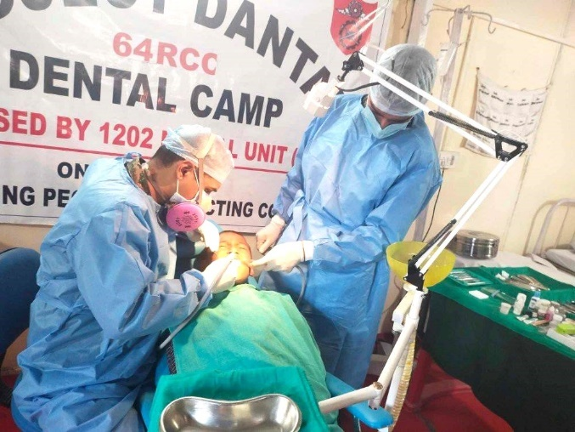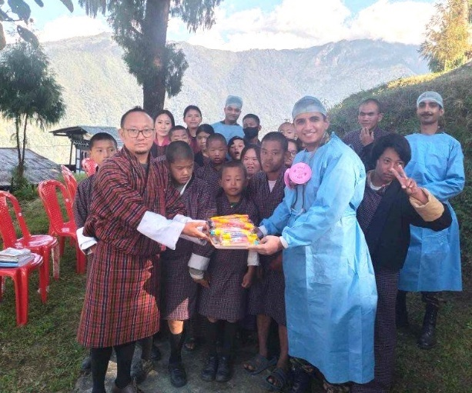

Medical Health Checkup Camp

On 20th November a team from DANTAK Thimphu lead by Lt.Col (Dr) Mohan Sharma conducted a free medical health checkup camp at Draktsho East Centre. Persons with disabilities face huge challenges in accessing the health facilities due to many factors that has cost implications and also the distance especially in the rural communities. It was really a noble initiative taken by DANTAK Thimphu to provide this free health checkup so that many underlying health issues could be diagnosed and cured with further referrals.
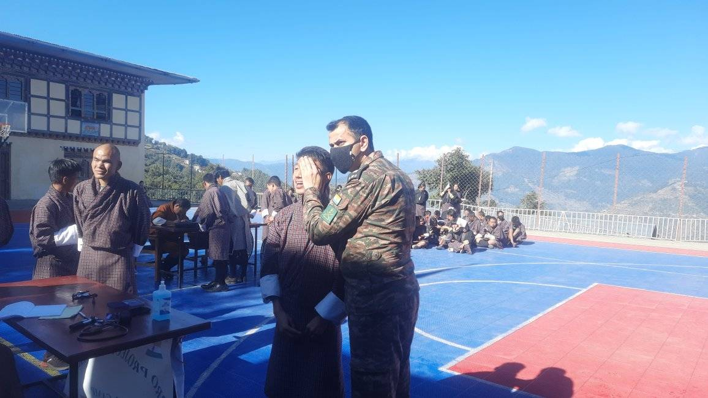

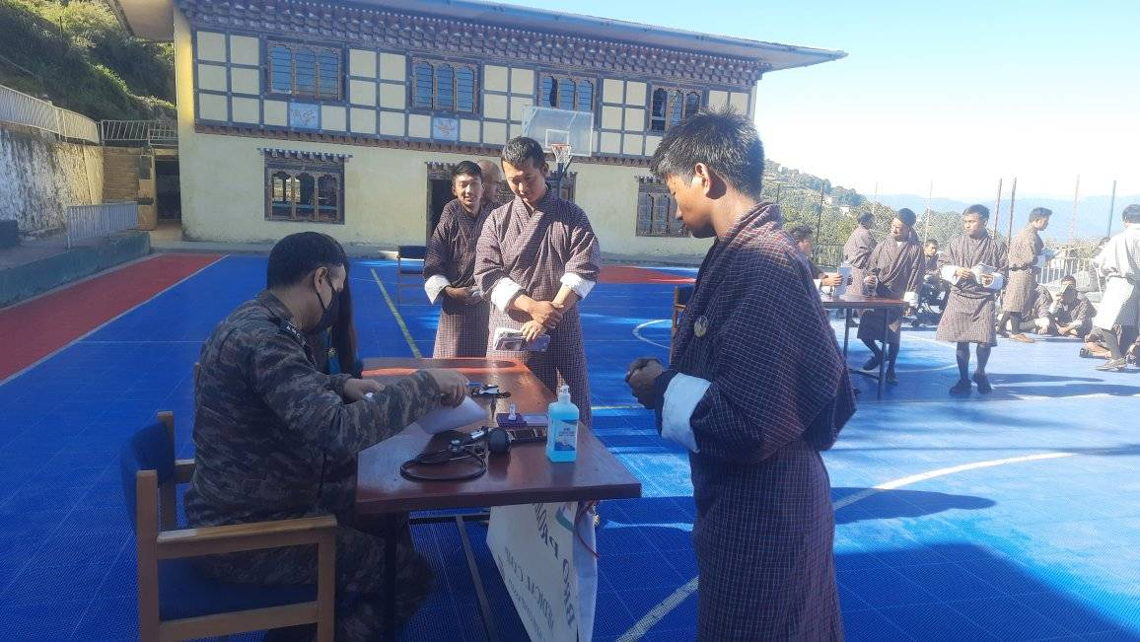

International Day of Persons with Disabilities

Draktsho Thimphu observed the International Day of Persons with Disabilities on 3rd December at the Bhutan Athletic Ground. Athletes and parents engaged themselves in sports and other fun games to celebrate joy, happiness and promote inclusion through the platform of sports. The event concluded with lunch and the event was support by the CRT Grant from Special Olympics International. Dasho Dil Maya Rai , a former Parliamentarian graced the occasion.
