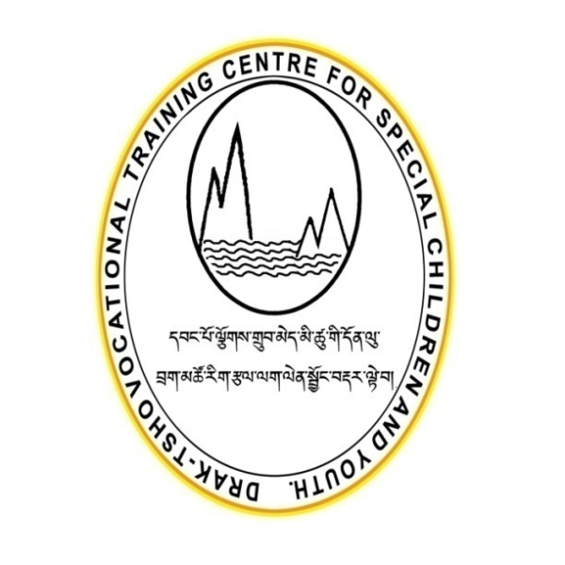

**DRAKTSHO VOCATIONAL TRAINING CENTRE FOR SPECIAL CHILDREN AND YOUTH**

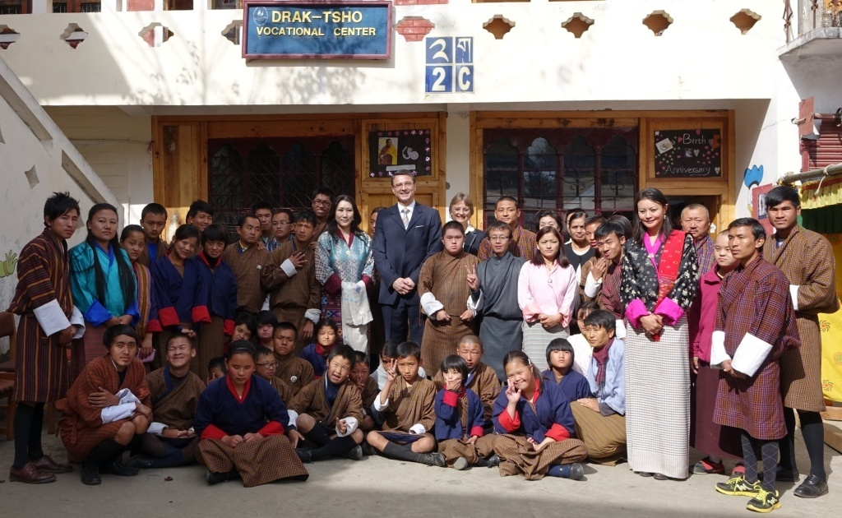

**Draktsho Annual Report 2016**

**Table of Contents**

1. **Foreword........................................................................................................... p. 3**
2. **Draktsho receives recognition from His Majesty the King........................... p. 4**
3. **World Down Syndrome Day........................................................................... p. 5**
4. **World Autism Day............................................................................................ p. 5**
5. **Draktsho Dharma Activity............................................................................... p.6-7**
6. **National Coaches Training Seminar............................................................... p.7-8**
7. **Disaster Management Training....................................................................... p. 8**
8. **Awareness and Fund Raising.......................................................................... p. 8-9**
9. **Inauguration Ceremony of Draktsho East Centre........................................ p. 9- 10**
10. **Foundation Day................................................................................................ p. 11**
11. **Celebration of International Day of Persons with Disabilities ................. p. 11-13**
12. **Programs and Activities................................................................................... p. 13-18**
13. **Success Stories ................................................................................................. p. 19**
14. **Challenges ..................................................................................................... p. 19**
15. **Our Pledged Donors ...................................................................................... p. 19-20**
16. **Partners ........................................................................................................... p. 20**
17. **Financial Report .............................................................................................. p. 21**
18. **Audit Report .................................................................................................... p. 22-23**

**Foreword**

The aim of vocational education is to provide age-appropriate training support to change the substantial limitations in present functioning by identifying suitable training for youth with various types of disabilities and providing intensive training for the highly capable youth and rehabilitation type of training for the moderate and severely handicapped youth so that they may receive reasonable remuneration and a promising better quality of life.

Our focus has been on providing vocational training to students with various types of disabilities; however, this is not an easy task as there is not enough money to provide a wide range of services. There are many children who need special equipments for training which are very expensive. We need to include more training for intellectually challenged youth which require adequate space, equipments and more staff. There are children who are unprotected and disowned by families; these children need protection, education, a safe and caring place to live. Draktsho has been picking up many such children who have undergone unimaginable traumas and disadvantages of life.

Life they say is a blessing but for some it seems so unfair and cruel. Whatever it maybe I feel it is every body’s responsibility to see that every child is protected, is receiving education, training and equal opportunities. Draktsho is trying very hard to reach our services to all those who need them. In doing so, we have few generous members contributing to fulfill our cause and goals.

Draktsho is extremely grateful to all our pledged donors, sponsors and partners for the great contribution. Your contribution has lifted much stress and helped us concentrate on the development of all our students. You all have selflessly committed to join us in making a better life for our children and youth.

Draktsho is so lucky to have you supporting us and being part of our family.

Good luck and thank you

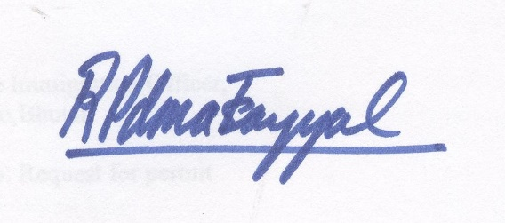

Rigzin Padma Tsogyal

Founder/Director

Draktsho

**Draktsho receives recognition from His Majesty the King**

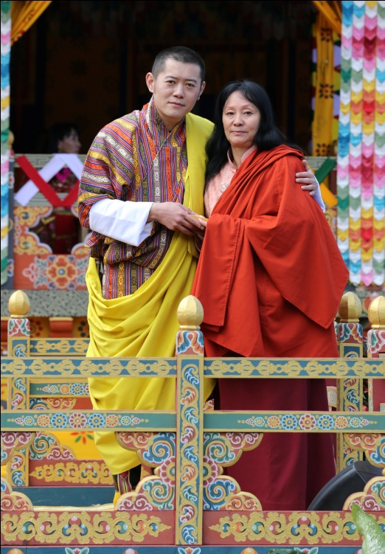 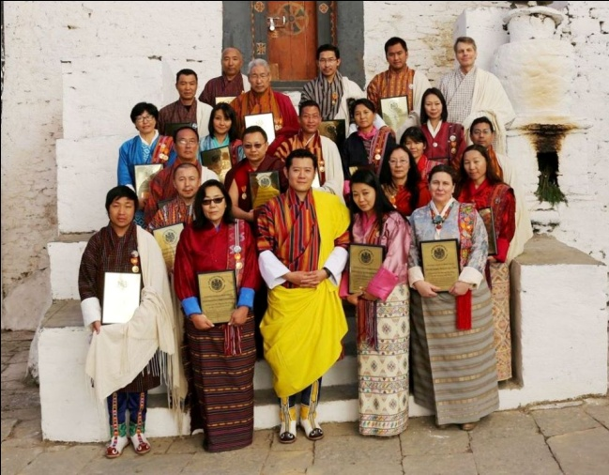

**His Majesty the King with 23 recipients from Civil Society Organization's**

Draktsho was awarded the National Order of Merit (Gold) by His Majesty the King of Bhutan on the 109th National Day on 17th December,2016 at Trongsa. The National Order of Merit award was granted for "volunteering time and effort towards promoting human values, our culture and tradition, and our national objectives; for working passionately and tirelessly for the benefit of others; for taking on the responsibility to provide support and assistance wherever the government is unable to reach, and for keeping alive the sacred values of compassion and empathy". His Majesty awarded the same to 23 other Civil Society Organizations in Bhutan for their contribution towards Gross National Happiness.

This is the 2nd award Draktsho received from His Majesty the King of Bhutan, the first medal, The National Order of Merit was granted to the Founder/Director, Rigzin Padma Tsogyal herself in recognition for her contributions in empowering children & youth with disabilities in Bhutan. Draktsho is blessed and humbly proud to be recognized by His Majesty the King of Bhutan for our humble service in enhancing the living standard of children, youth and people living with disabilities in Bhutan.

**World Down Syndrome Day**

Draktsho in collaboration with Bussi-En Social Welfare Organization and Ability Bhutan Society commemorated the World Down Syndrome Day on 21st march,2016. Students, parents, teachers and volunteers came together to raise awareness on Down Syndrome through cultural programs by the students and a interactive open discussion forum amongst parents. The program was held at the Children's park, Changlimithang.

**World Autism Day**

On 2nd April Draktsho joined by other organizations working in the field of disability worldwide to celebrate the World Autism Day. Teachers, parents, volunteers and students gathered at Draktsho Centre to celebrate this special occasion to demonstrate their skills, experience, joy and participate in sharing of gifts, personal skills with their friends and families. The program was organized in 2 locations, Draktsho Thimphu and Draktsho East Centre in Tashigang. In Tashigang parents, teachers, students and also the local head " gup" with other local leaders joined the awareness walk from Sherubtse College till Draktsho East Centre. The walk took almost 3 hours to complete. Apart from cultural programs and walk the students also took part in the art competition.

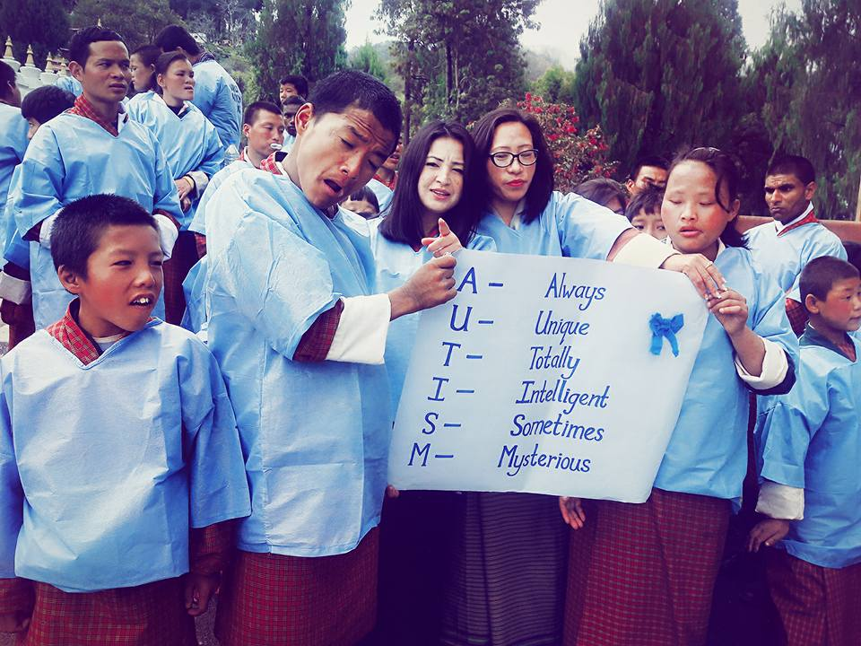 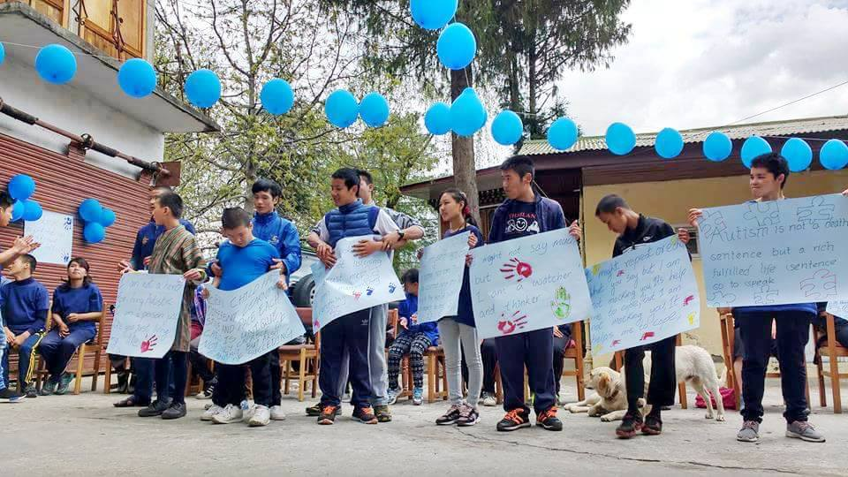

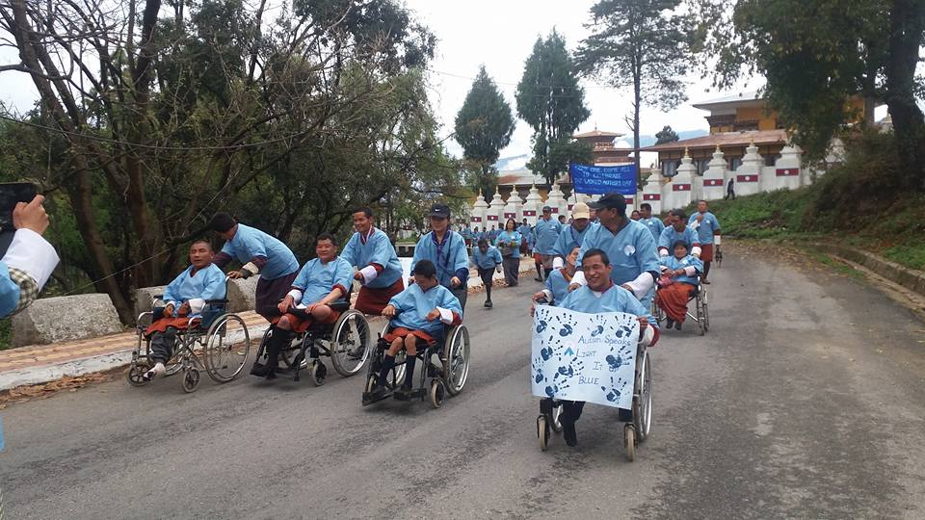

**Draktsho Dharma Activity**

On 6th May, for the first time the founder of Draktsho initiated a new activity known as " Draktsho Dharma Activity". This activity was initiated with the aim to feed dogs, fishes, insects and other hungry animals in Thimphu for the benefit for all sentient beings. Teachers, parents and students gathered at Draktsho with bread, flour, butter and other edible items for the program. Prayers were offered with butter lamps before the crowd dispersed in different directions to feed insects and animals. The founder said, this would continue to be our sacred annual activity and probably call 6th May “Draktsho Feeding Day.” She said that this kind of activities were practiced in olden days on auspicious days by villagers and it should not die with modernity.

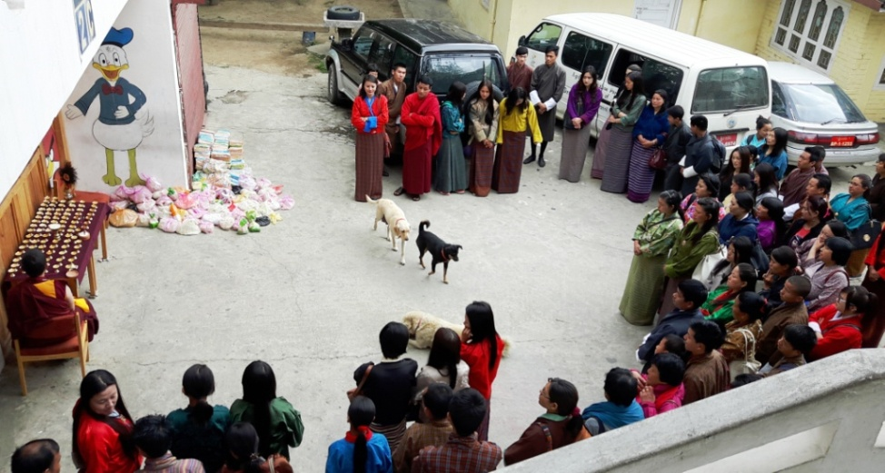

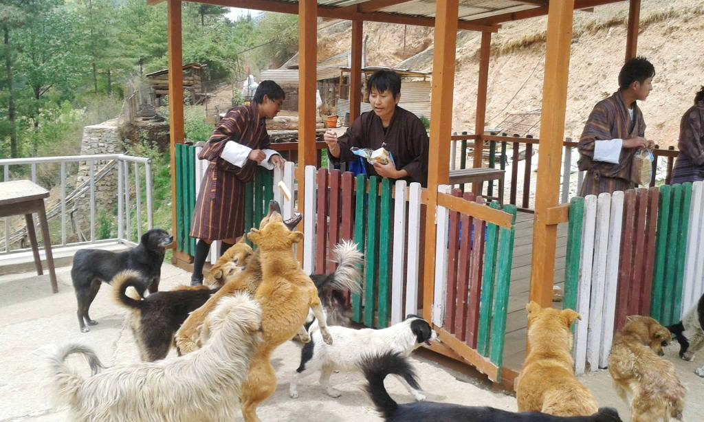

**National Coaches Training Seminar**

Draktsho in collaboration with Special Olympics Bhutan and Special Olympics Bharat organized the 1st National Coaches Training Seminar from 26th-28th May,2016. The aim of the training was to equip teachers/ instructors/coaches with basic technical skills on how to train children and youth with disabilities in sports activities. There were 35 participants from the government and non-governmental sectors who participated at the 3 days program. The participants underwent both Leadership and practical session that was led by professionals from Special Olympics Bharat.

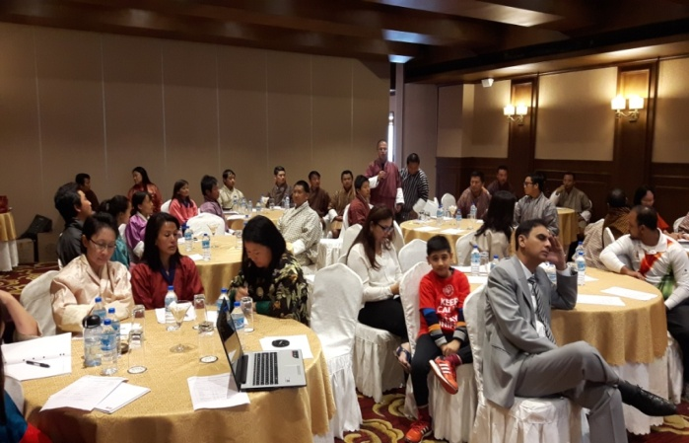

**Leadership workshop at Ariya Hotel**

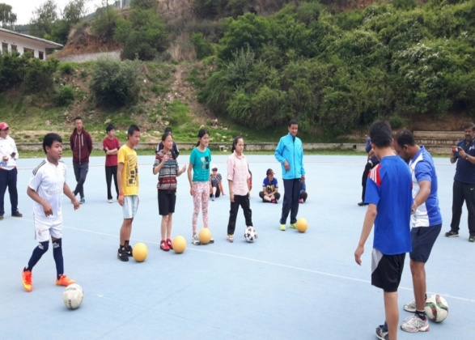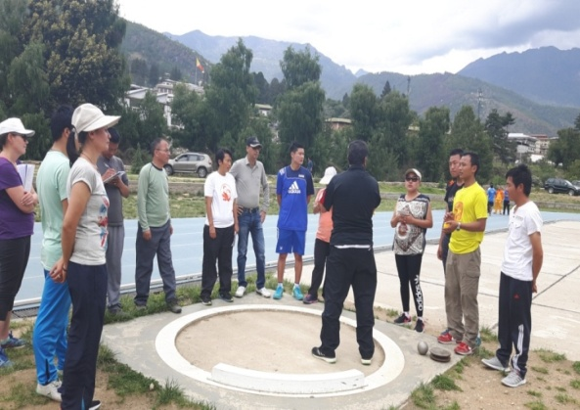

**Athletes and teachers undergoing training by SO Bharat Coaches**

**Disaster Management Training**

Disaster can happen anywhere to anyone so the need to be prepared to face any type of natural disaster is essential for all. Persons with disabilities are more vulnerable in such circumstances as most may not be able to cope up first with their disability and second lacks the sense to look help from able persons when such disaster occur. Bhutan due to its mountainous geographical terrains has high risks of experiencing earthquakes, flood, fire, windstorm and also landslides.

Senior students of Draktsho and the teachers underwent a 4 days training course on "Disaster Management" that was lead the Department of Disaster Management under Ministry of Education from 26th-29th July. The training focused on equipping the participants with knowledge about how to take precautions and avoid injuries/save a life during occurrence of various natural disasters. The training covered topics on earthquake, fire, flood and also First Aid. The participants underwent both theory and practical sessions. The project activity was funded by UNICEF Bhutan.

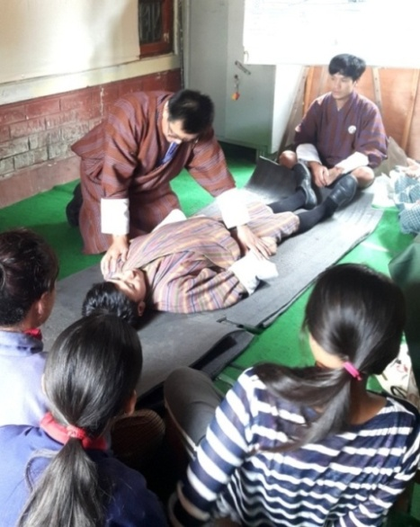 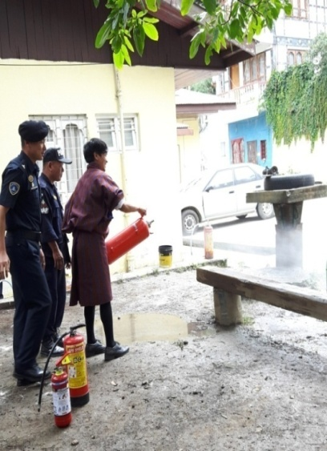 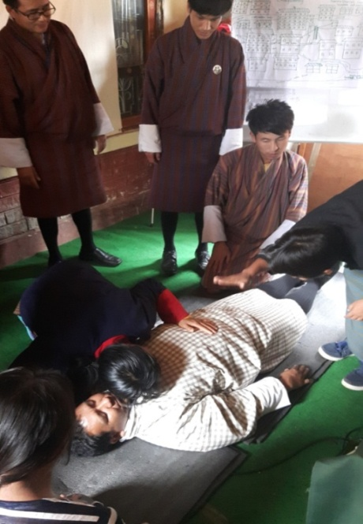

**Fund Raising and Awareness**

In 2016 Draktsho organized its fund raising and awareness program in a unique way, "108 Circumabulation of the Buddha Statue" at Kuenselphodrang (Buddha Point). The fund raising and awareness program is one of Draktsho's annual event where students usually showcase their talents through various cultural and extracurricular activities. Unlike other past events the turnout of participants was almost 1000 people who gathered to make "kora" of the Buddha Statue. The auspicious event concluded with students performing cultural programs and awarding prizes to the lucky draw winners.

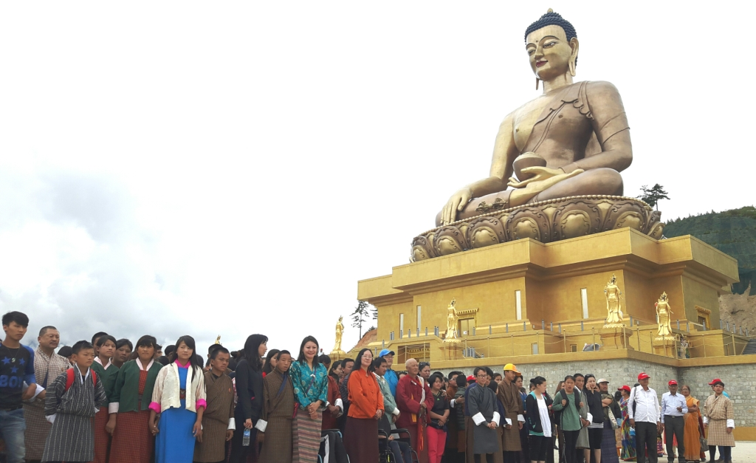

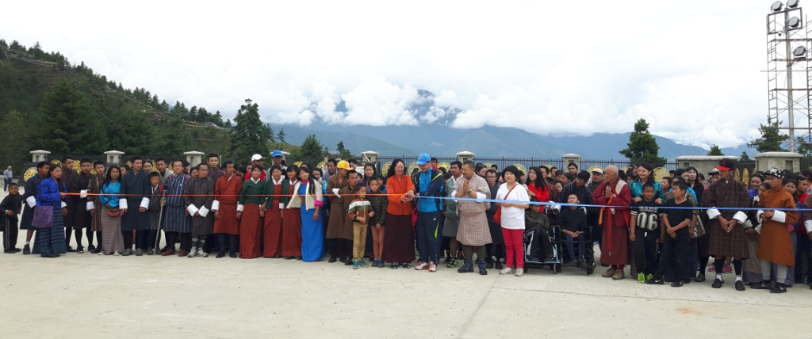

**Opening by the JICA Chief Representative Mr.Koji Yamada & founder Rigzin Padma Tsogyal**

**Inauguration Ceremony of Draktsho East Centre**

In 2010 Draktsho successfully established its first branch in Rongthung, Tashigang providing free educational and vocational training services including boarding facilities to 70 students. The centre was named “Draktsho East Centre" and it was located in a rented building.

Building infrastructure was one of Draktsho's long term goals and this came true when the Embassy of Japan in Delhi supported in building Draktsho East Centre in Kanglung in 2015. The Embassy provided financial support to establish a Academic Block and a Boys Hostel which was completed in 2016. On behalf of the Embassy of Japan Mr.Yasujiro Miyake, Councelor of Embassy of Japan in India and Dasho Dzongda of Tashigang inaugurated the opening of Draktsho East Centre on 3rd September,2016. Students, parents, teachers and the local leaders attended the inaugural ceremony. We aim to provide our services to 200 students by end of 2017.

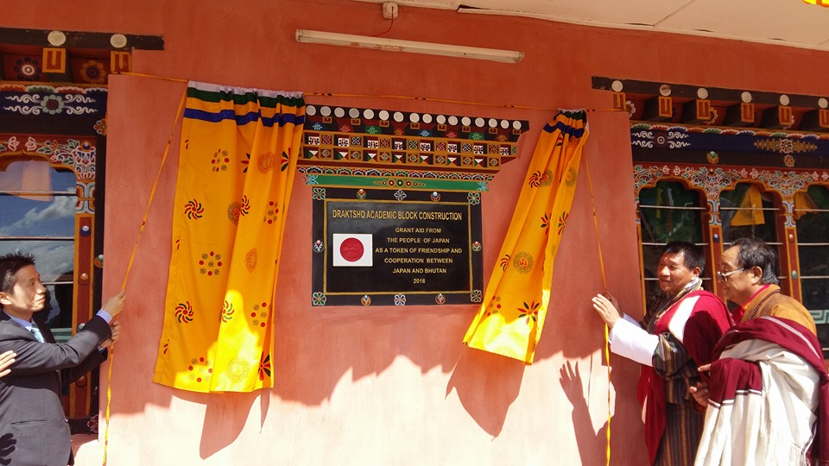

**Mr.Yasujiro Mayake and Dasho Dzongda of Tashigang**

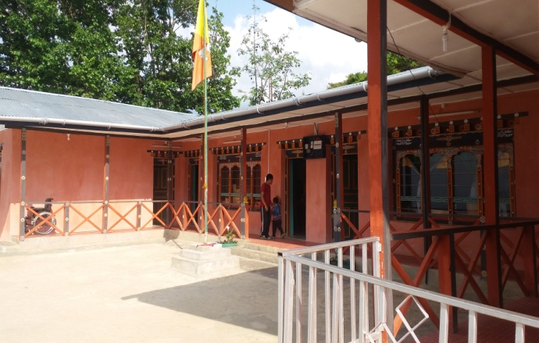

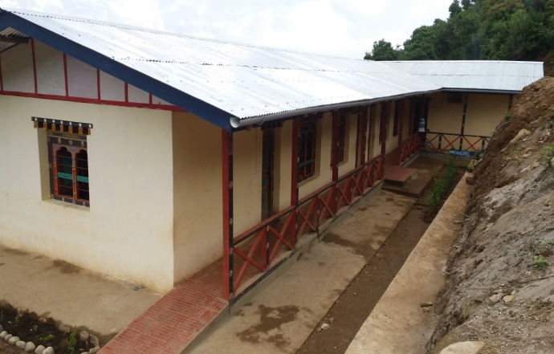

**Foundation Day**

Draktsho marked its 16th years of establishment on 2nd October 2016. Draktsho family consisting of the teachers, parents, students, volunteers and relatives celebrated the day feasting at Namseling area.

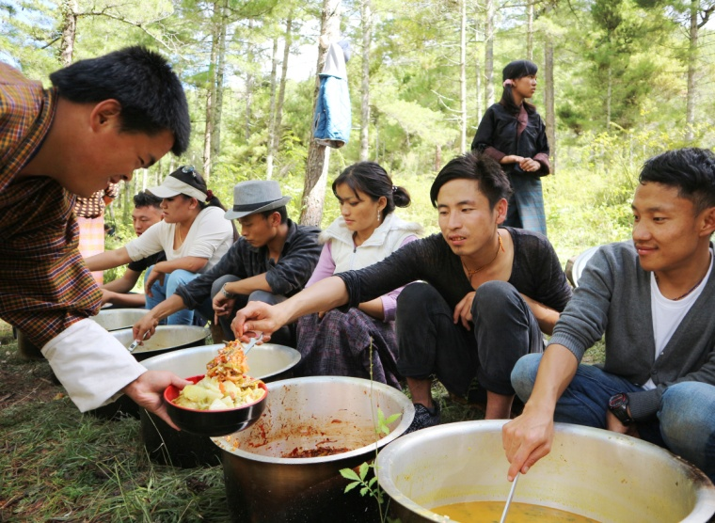 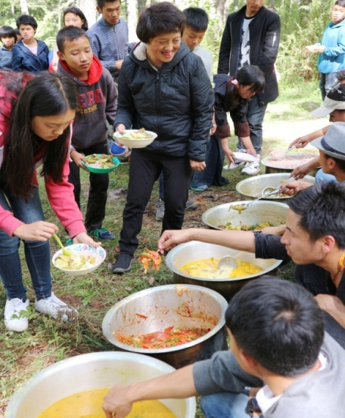

**Celebration of International Day of Persons with Disabilities**

3rd December is observed as the International Day of Persons with Disabilities globally and Draktsho celebrates the day involving students with disabilities from other institutes and Sen Schools. 3rd December is observed as one of Draktsho's most celebrated day as the event raises awareness on the capabilities of the children and youth with various types of disabilities through the medium of sports moving towards inclusion. Every year we have sponsors for this event; this year the event was conducted at Thimphu Athletic ground with sponsorship from the Royal Monetary Authority.

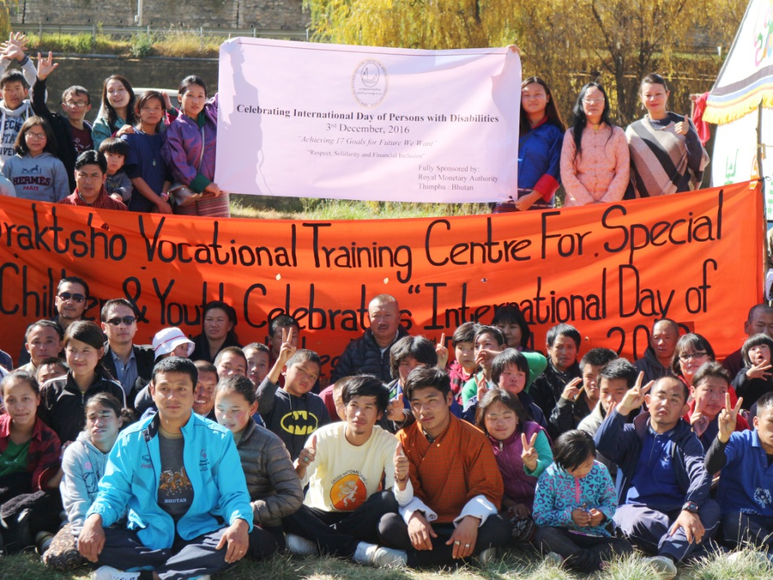

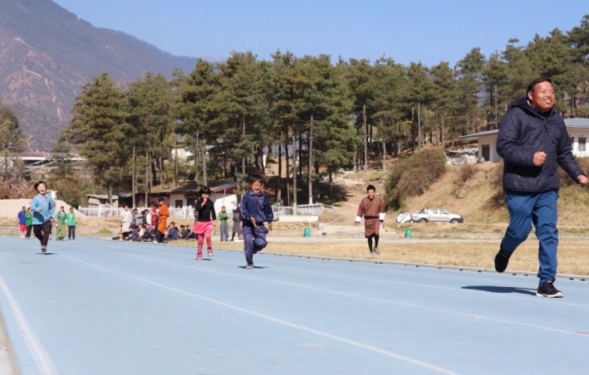

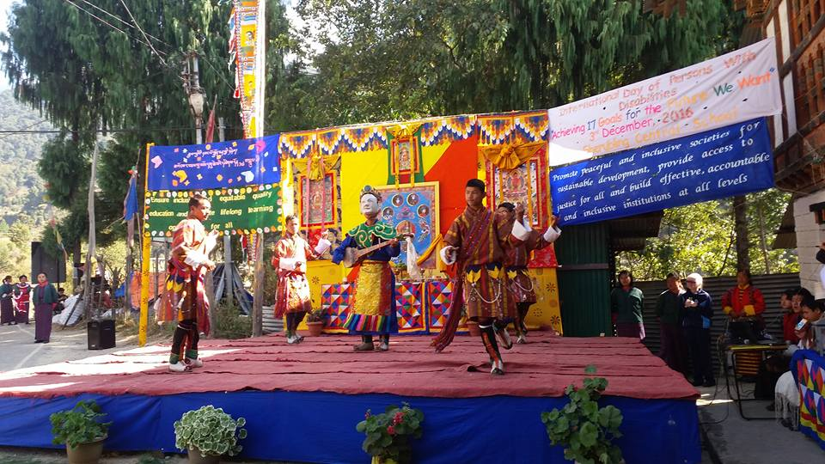

The Students of Draktsho East Centre in collaboration with Khaling Central School performed various cultural items like traditional dances, theatre acts and singing in Khaling town on 3rd December.

**Programs and Activities**

**Vocational and Co-curricular programs:**

The Vocational training and other co-curricular activities given below are some of the training programs offered at the centre. The vocational training is traditional based and it suits the capacities of the students. New skills depending on the requirement of the students would be introduced in the future.

**Main Vocational Courses offered:**

1. Tailoring

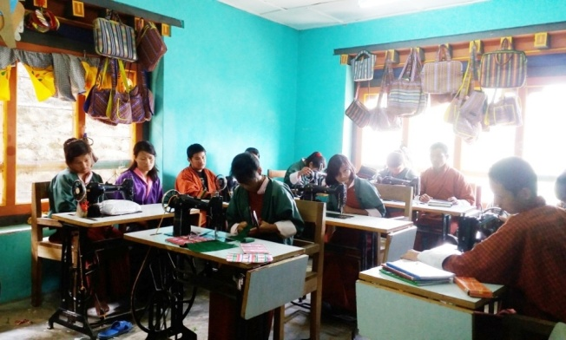 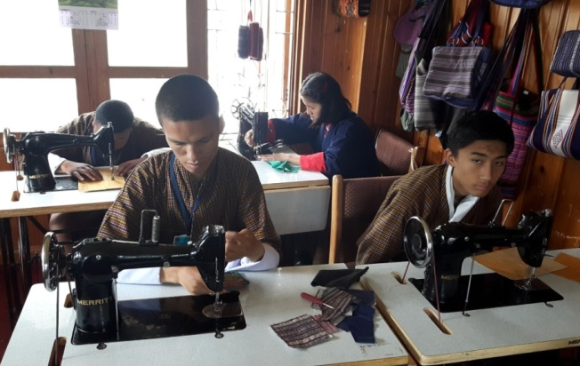

Tailoring course takes 2 to 4 years to graduate; an intellectually challenged may take more years.

1. Traditional art and painting

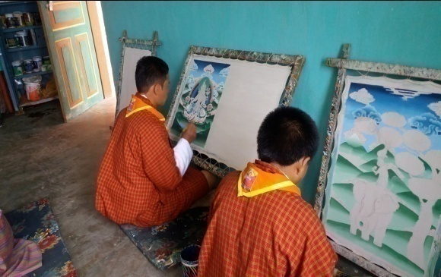 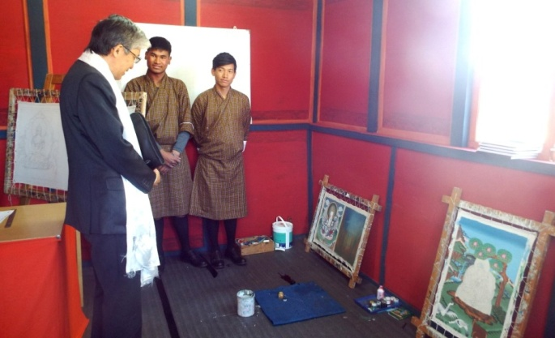

Art and painting takes 5 to 7 years to complete the course, however, it is flexible to allow the students learn at ease.

1. Embroidery

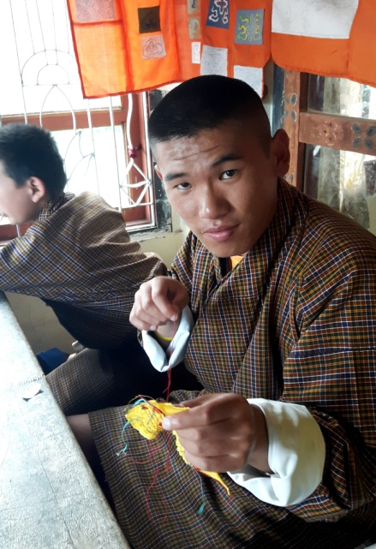 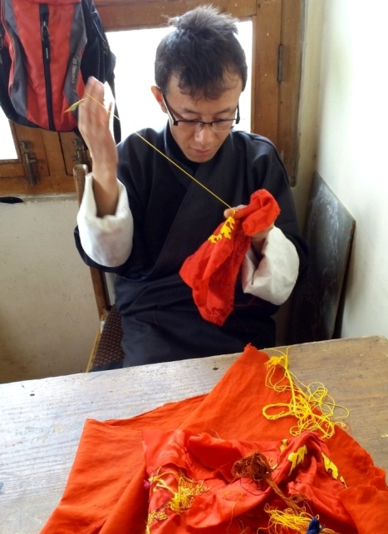

Embroidery is a high-level training, it needs good hand eye coordination and good concentration. Most of the students in this class are with hearing and speaking impairment, there are few students with mild intellectual challenges. The course takes 5 to 7 years to graduate.

1. **Weaving**

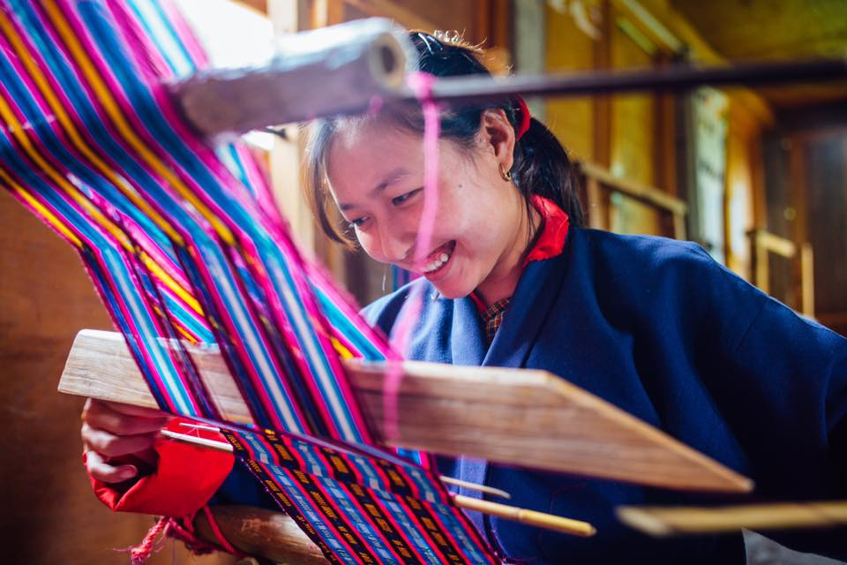 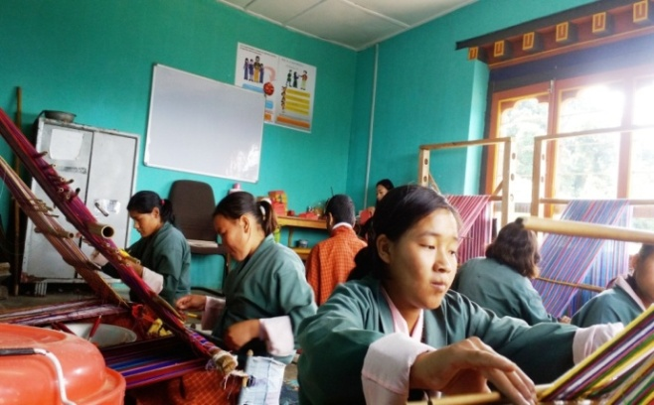

Weaving is an interesting skill development course. There are all types of youth learning weaving as it has several areas of practice. Though it is more suitable for women, men also enjoy weaving. The course takes 3 to 7 years, depending on the level of intelligence and hand coordination skills.

1. **Basket weaving(cane and plastic)**

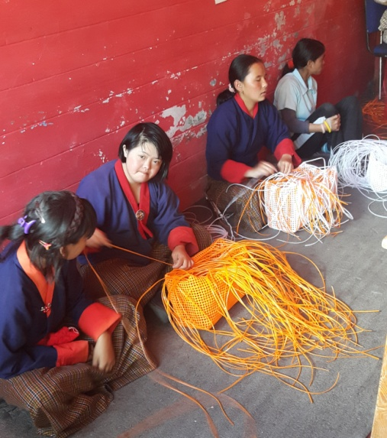

Basket weaving is pre-vocational program for Draktsho. Most of the intellectual students are placed here to determine their motor skills before transferring them to higher level training. Basket weaving develops hand eye coordination, able to sit for a long time in their seats, it also helps control behaviour problem and learn discipline.

1. **Souvenir carpentry (wood carving)**

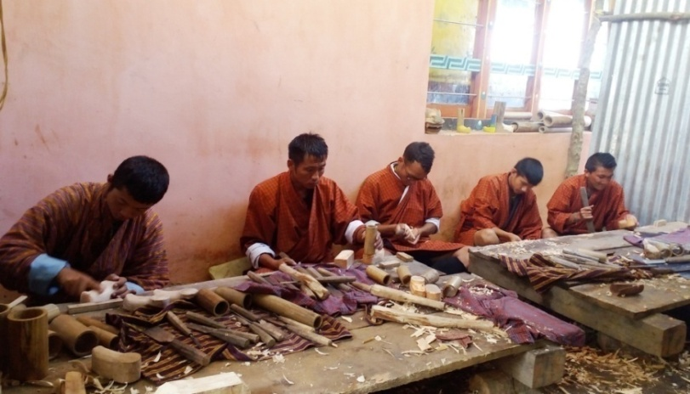

Wood carving requires good hand eye coordination, besides learning carving and designing, we make small wooden souvenirs. The period of training is 5-7 years.

1. **Souvenir making (cards, bookmarks and doll making**)

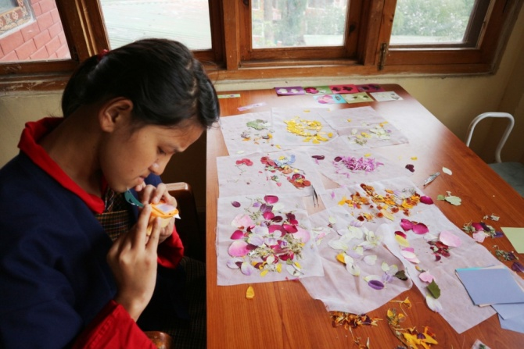 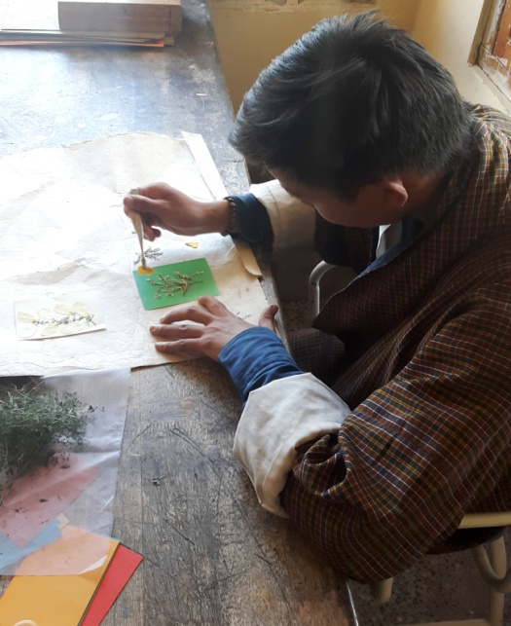

Book marks, Cards, Paper bags and boxes, small dolls are made by youth with mild cerebral pulsy students. The training in this area determines the creativity of a student as they design the cards and book marks. It takes 1 to 3 years of training.

1. **T-Shirt and Mug Printing**

The printing training need youth with high level intelligence. We have very few students in this class.

1. **Envelope Making**

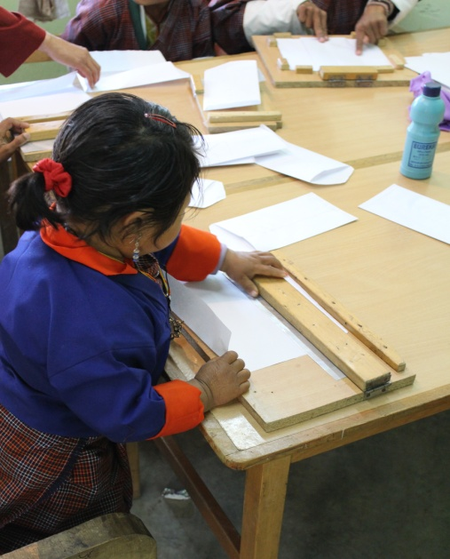 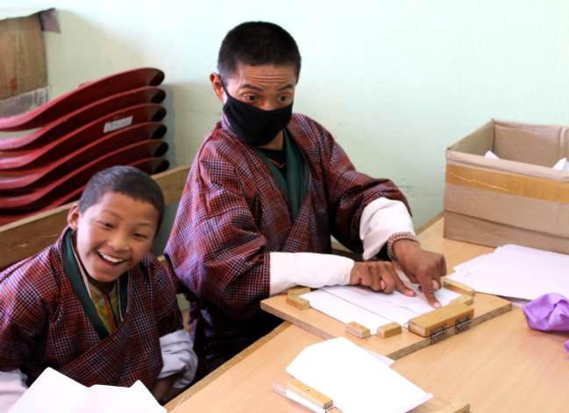

Envelopes are made by youth with moderate IQ level students and physically challenged students. It takes a group of students to complete an envelope as they lack fine motor skills.

1. **Pottery**

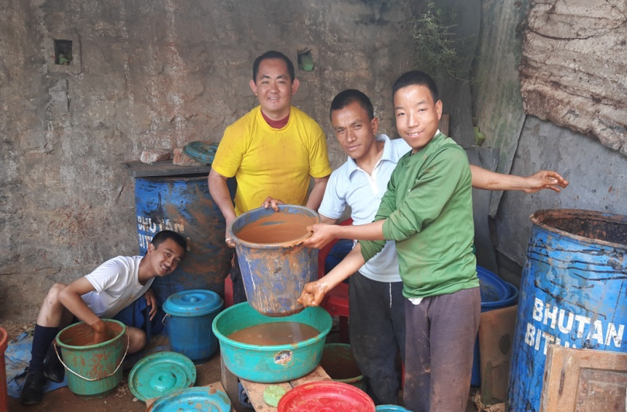 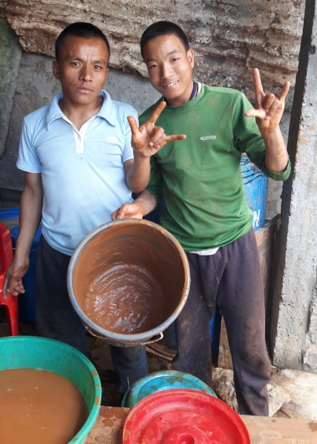

Pottery is a new skill initiated to train severely challenged students. The outcome of this training is yet to determine.

**Life skills offered:**

1. Personal management skills
2. Sign language (communication skills)
3. Social Behaviour, domestic behaviour
4. Work related or Functional Academic
5. Safety skills
6. Occupational skill

**Co-curricular Activities:**

1. **Social skills**: dancing, singing, acting and cultural disciplinary programs are taught to the students to built their communication and socialization skills. These activities not only boost's their self esteem but also make them happy and feel inclusive.
2. **Physical fitness programs**: Draktsho is often used as the base for promoting sports for athletes with disabilities as Draktsho has maximum number of children and youth with various types of disabilities. Draktsho organizes a sports competition annually nationwide to promote the Special Olympics movement giving all special athletes a platform to showcase their abilities. This activity not only keeps one fit but brings together everyone experiencing joy, happiness, contentment and victory through inclusion.

The Special Olympics Bhutan which was founded in 2010 by people from different walks of life also operates under the umbrella of Draktsho.

In 2011, 4 athletes (2 boys and 2 girls) participated at the Special Olympics held in Athens, Greece where they participated in track and field events. The athletes won gold in the mixed relay race for the first time. Again in 2015 4 athletes with intellectual disabilities participated at the Special Olympics held in Los Angeles, California. The team brought home 6 medals (3 gold's,2 bronzes and 1 silver) in individual events. They created history in Bhutan by winning that many medals at an Olympic level. They broke barriers proving many wrong and becoming the pride of the nation.

1. Apart from the vocational training, educational and life skill program, the students are also given opportunities to development individually through counseling, personal coaching and guidance.

Following one of its long-term goals Draktsho has successfully established its first branch in Rongthong (now shifted to the new premises at Sheningkhar) Tashigang with support from the Finish government. The centre is known as Draktsho East Centre and unlike the centre based in Thimphu it provides boarding facilities to 120 students. The students at Draktsho Thimphu are day scholars and at present there are 200 students (127 boys and 73 girls) in total.

**Success Stories**

1. The construction of three one storied buildings (Academic block, boys’ hostel and girls’ hostel) at Kanglung,Tashigang was supported by the Embassy of Japan, Embassy of Federal Republic of Germany in Delhi and Opening and Your Heart to Bhutan.

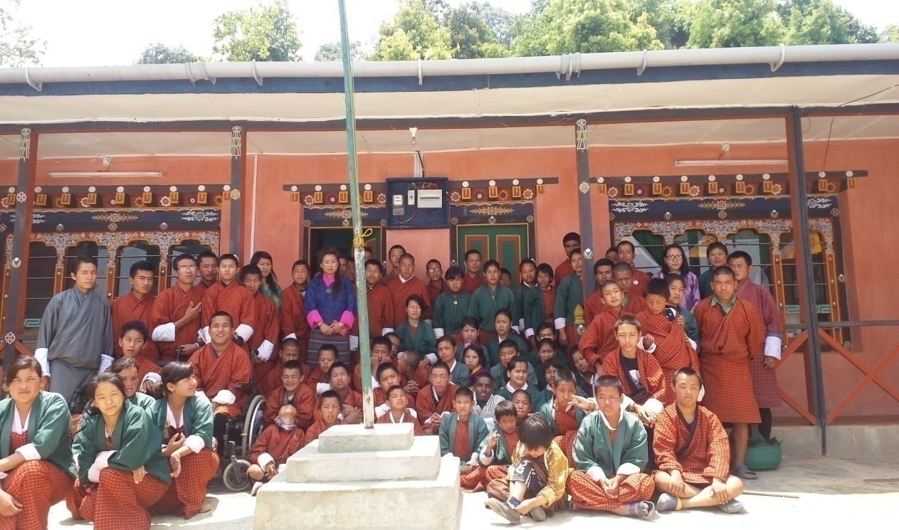

1. 12 students graduated this year; they are all employed at the Production Unit of Draktsho. The Ministry of Labour and Human Resources is providing Apprentice Training Program (ATP) support to 12 graduates of Draktsho.

**Challenges**

Overhead and maintenance cost has always been the biggest challenge for Draktsho. Lack of infrastructure is another major problem.

**Our Pledged Donors**

In order to reinforce the financial constraint of Draktsho, the following organizations and individuals pledged to support the organization by being "pledged Donors" (In country donors) for Draktsho in 2015. Their contribution and concern to support Draktsho has strengthened its ongoing activities and secured its existence to continue its work well into the future to benefit the children and youth with disabilities in Bhutan.

|  |  |  |  |
| --- | --- | --- | --- |
| **Sl** | **Name** | **Organization** | **Contribution** |
| 1 | Ashi Sonam Choden Dorji | White Tara Tours | Nu.100,000 |
| 2 | Dasho Ugen Tshechup and Aum Dechen Jamyang | Singye Group of Companies | Nu.300,000 |
| 3 | Ashi Bidha |  | Nu.50,000 |
| 4 | Dasho Sonam Tobgay Dorji and Aum Tashi Pem Jamyang |  | Nu.60,000 |
| 5 | Aum Sangay Zam | Proprietor, Rinchen High School | Nu.60,000 |
| 6 | Aum Sonam Choden and Mr.Ugyen Wangchuk | Proprietor, Hotel Jumolhari | Nu.40,000 |
| 7 | Mr. & Mrs. B B Gurung | Proprietor, 8 Eleven, Thimphu | Nu.5000 |
| 9 | Mrs. Kaoru Aoki | Zhidhey Bhutan Tours and Trek | Nu.30,000 |

**Partners**

|  |  |  |  |
| --- | --- | --- | --- |
| Sn. | N ame | Contribution | Comments |
| 1 | UNICEF | * Capacity Building -Teacher/staff trainings * Supply of training materials / equipments, * Curriculum development |  |
| 2 | Save the Children | * Supply of training materials and equipments |  |
| 3 | Opening Your Heart to Bhutan | Construction of girls’ hostel, supplying mattresses, blankets and bed sheets for Draktsho East |  |
| 4 | Dr. S. Rolf | $ 1200 annually | Sponsorship for 2 students |

**Financial Report**

**Audit Report 2016**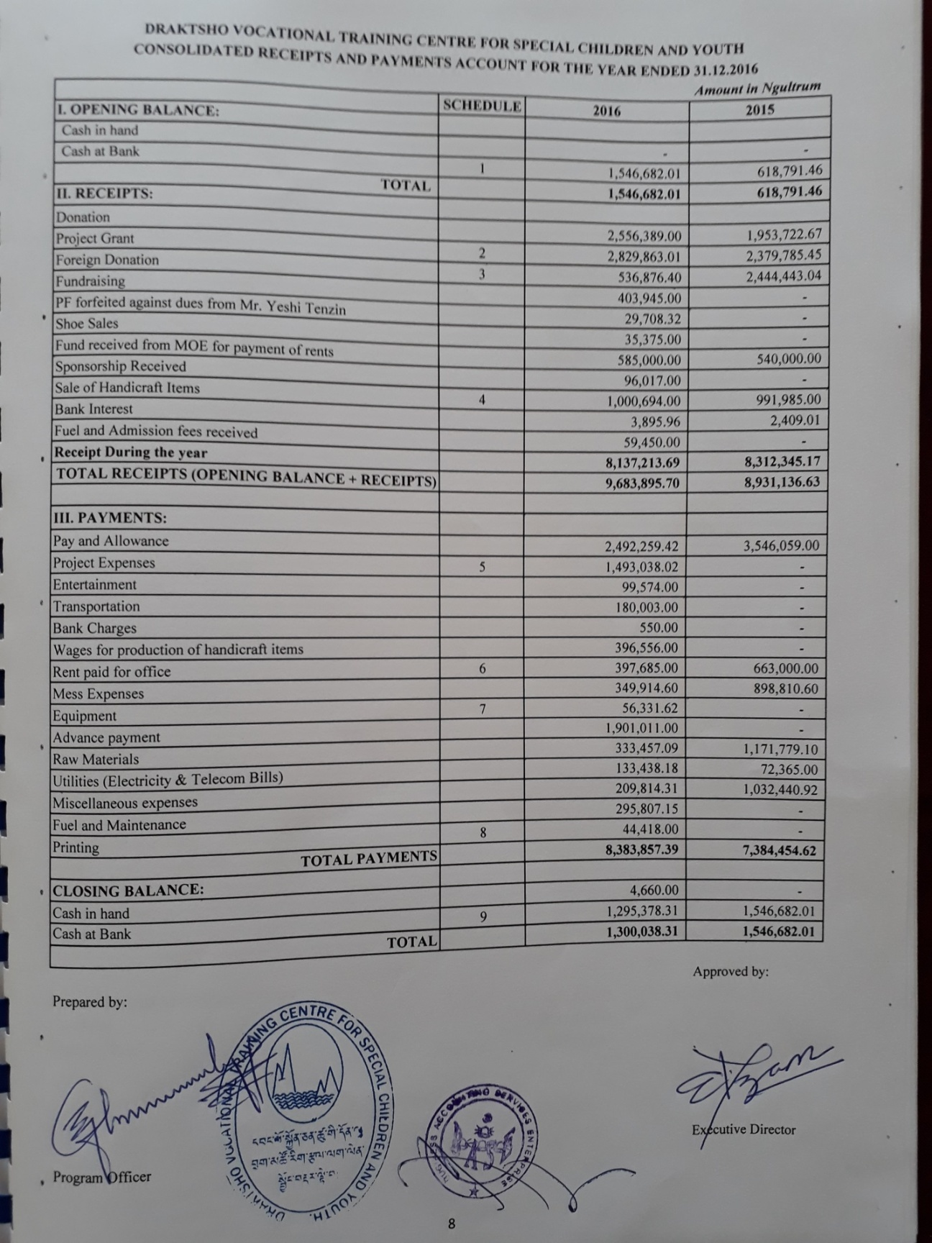

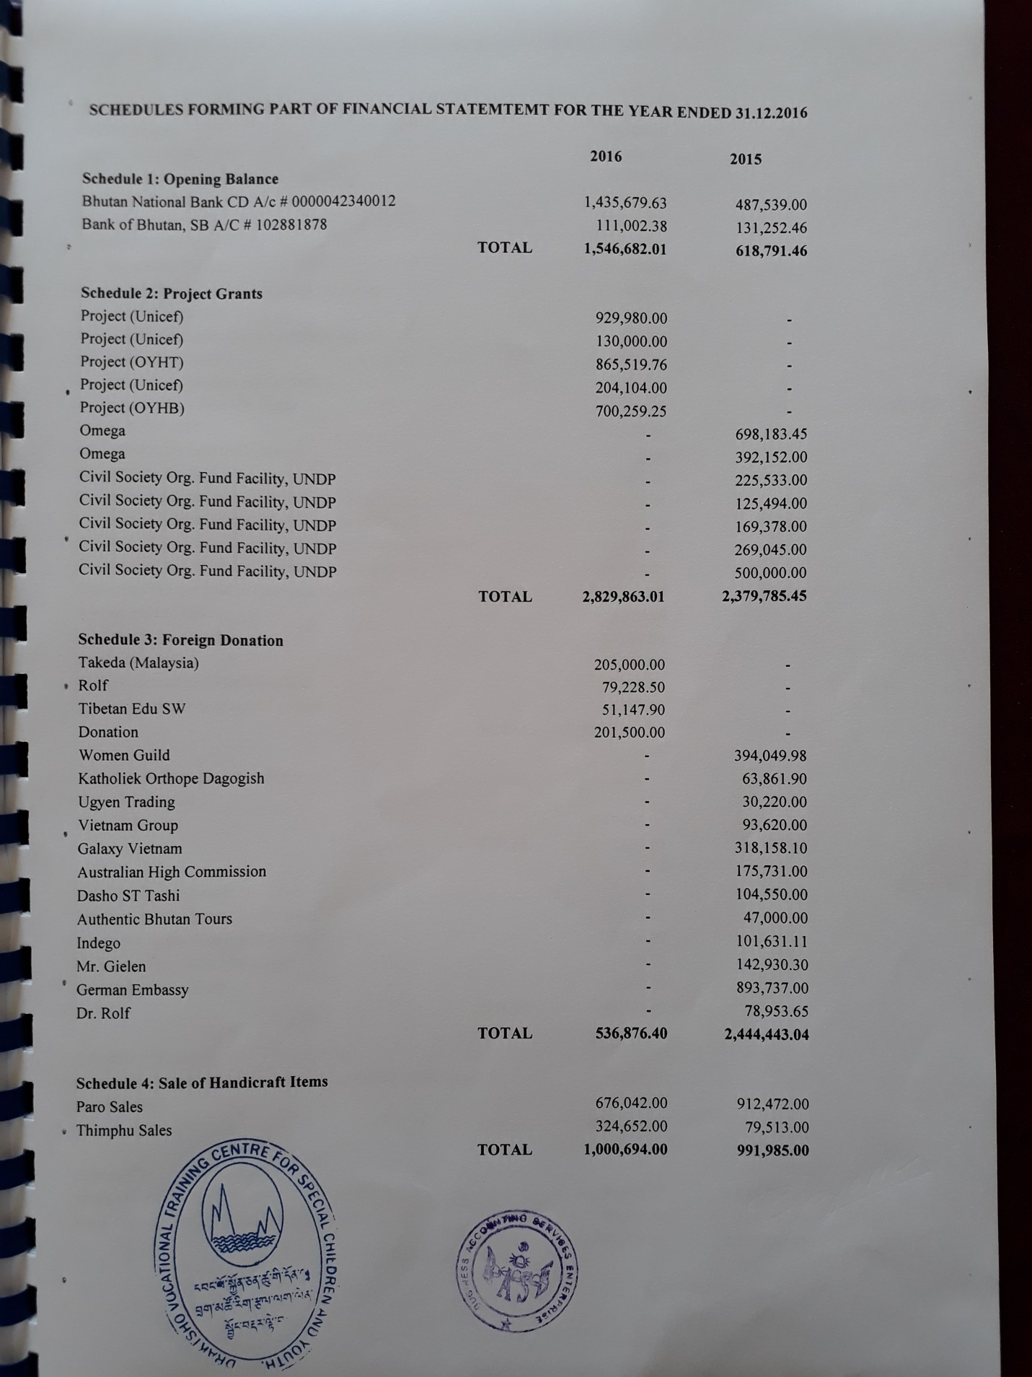

Thank You, Tashi Delek

Deki Zam

Exe. Director

Draktsho

Email. [dekzang@hotmail.com](mailto:dekzang@hotmail.com)

Mb: 77273144