|  |
| --- |
| C:\Users\user\Desktop\Draktsho logo.jpg |
| Draktsho Vocational Training Centre for Special Children and Youth |
| **Annual Report 2021** |
|  |

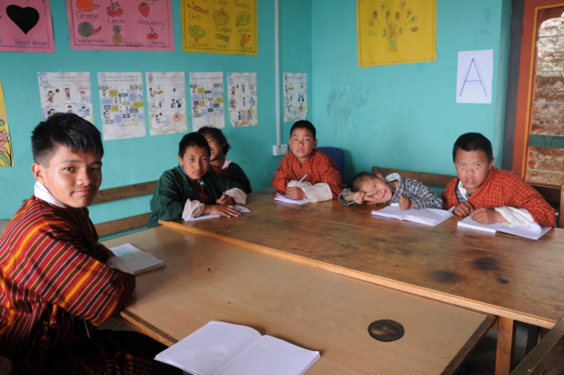

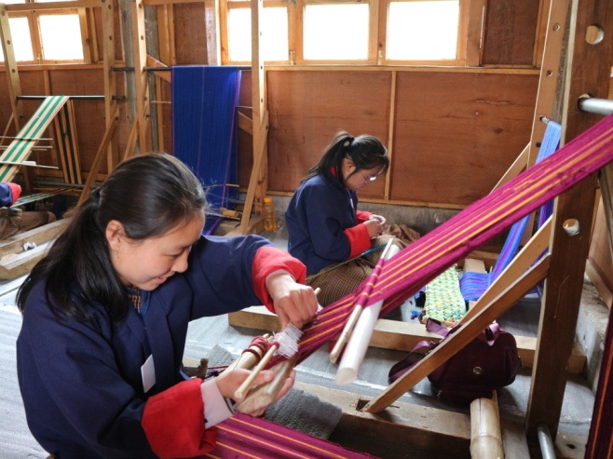 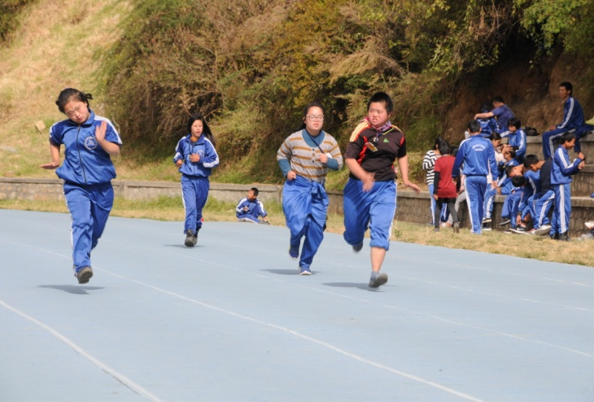

Table of Contents

**Foreword** 3

Activities for the Year: 4

World Down Syndrome Day: 21st March 4

Autism Awareness Day 5

Critical Skills Training for Persons with Disabilities: 27th May 7

Draktsho Ex-students Visit: 7th June 9

Dental Health Care: 10

Eco-Van Donation 11

International Day of Persons with Disabilities 12

# 

# **Foreword**

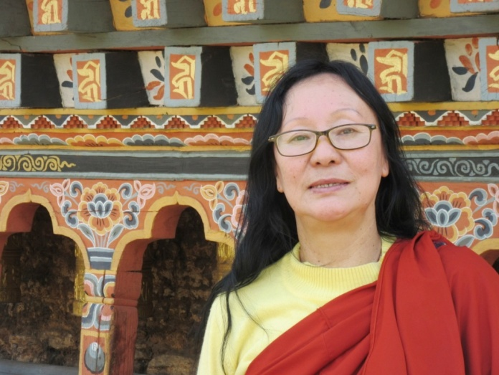

Draktsho is a pioneer in the country in the field of disability, we strongly feel responsible to tend to the need of people living with disabilities specially the children and youth who need to be guided and provided with educational, vocational and life skill training. Draktsho feels responsible to remove barriers they might face other-wise relating to accessing educational and vocational training services.

Providing services to the persons with disabilities involves huge financial resources and Draktsho has been continuously striving towards achieving financial self-reliance to support the children and youth with disabilities across the country. In order to achieve this goal, Draktsho has been trying to incorporate activities like farming and handicraft production etc. over the last few years; we are continuously researching for areas to sustain our activities.

The COVID-19 pandemic in 2020 has resulted in collapse of many businesses and institutions. Draktsho relies heavily on foreign visitors and donors to finance its activities. With the ban on travel in and out of country, one of Draktsho’s main sources of income has been completely undermined. However, with the protection and support from our guardian His Majesty the King, our people have been saved. I cannot find enough words to express our gratitude to our King for his concern and continuous work to save his people and country from the Pandemic. We the people of Bhutan are blessed to have a Noble King like Jigme Khesar Namgyel Wangchuck.

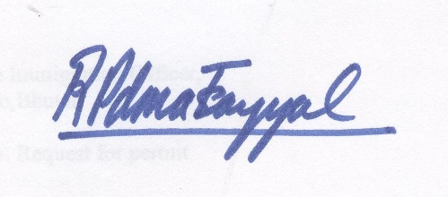

Rigzin Padma Tsogyal

Founder & Director

Draktsho

# Activities for the Year:

## World Down Syndrome Day: 21st March

In December 2011, the General Assembly declared 21 March as World Down Syndrome Day ([A/RES/66/149](http://undocs.org/A/RES/66/149)). The General Assembly decided, with effect from 2012, to observe World Down Syndrome Day on 21 March each year. Every year Draktsho also joins the world in celebrating this special day to advocate the rights, inclusion and wellbeing of people with Down Syndrome.

Teachers, students, parents and volunteers of Draktsho East Centre gathered at the center and had a wonderful day spreading love through singing, dancing and feasting. Such events not only help promote awareness on Down Syndrome but also creates opportunities for people from all walks to life together to share love, kindness and happiness.

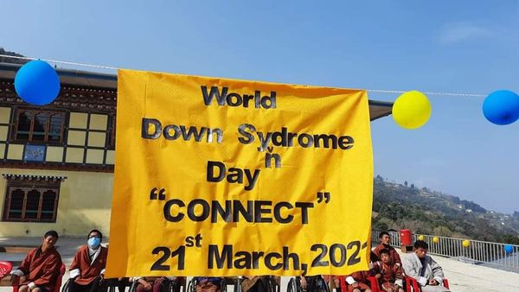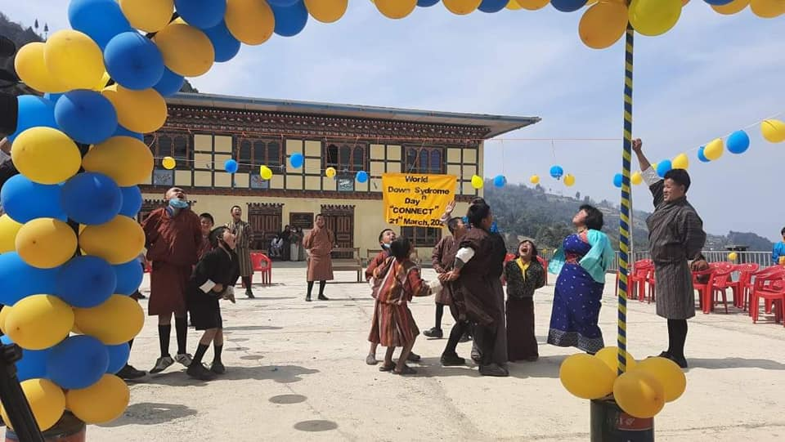

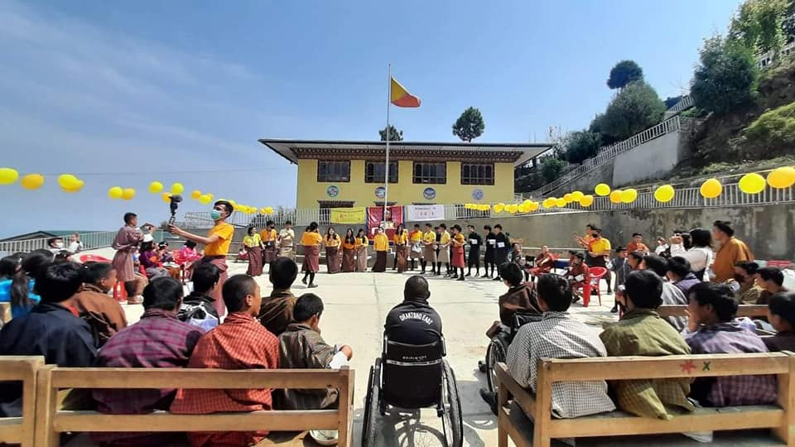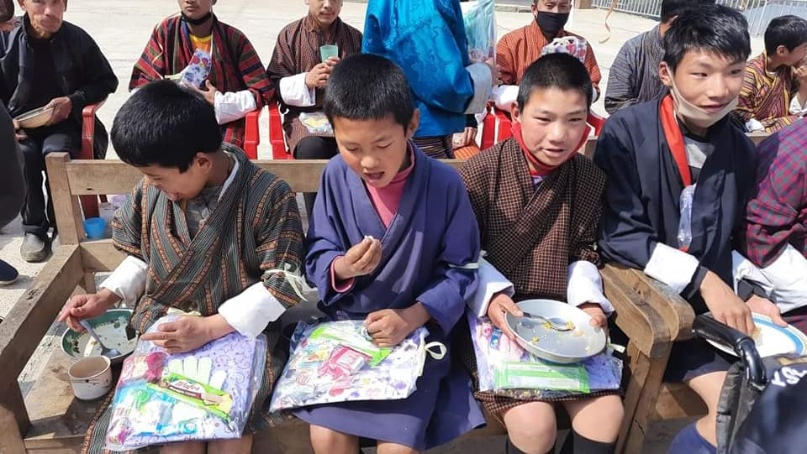

## 

## Autism Awareness Day

Draktsho also joined the world in celebrating the World Autism Awareness Day on 2nd April.

5 Civil Society Organizations working in the area of disability in Bhutan joined hands together to celebrate this special day. Ability Bhutan Society, Disabled People's Organization, PhenSem Parents Supporting Group, Bhutan Stroke Foundation and Draktsho created awareness about Autism and spread love by "*Lighting Up Blue* " the Memorial Chorten. This joint collaboration of Lighting Up Blue the memorial Chorten was joined by persons with disabilities, parents, caregivers and people from different walks of life.

On the other end in Tashigang, Draktsho East the day was commemorated by offering butter lamps and Zhabten to His Majesty the Fifth King of Bhutan. This was followed by students and teachers engaging in varieties of fun games like badminton, marble, caramboard, table tennis, fish out bottles, etc. The lovely day concluded with lunch.

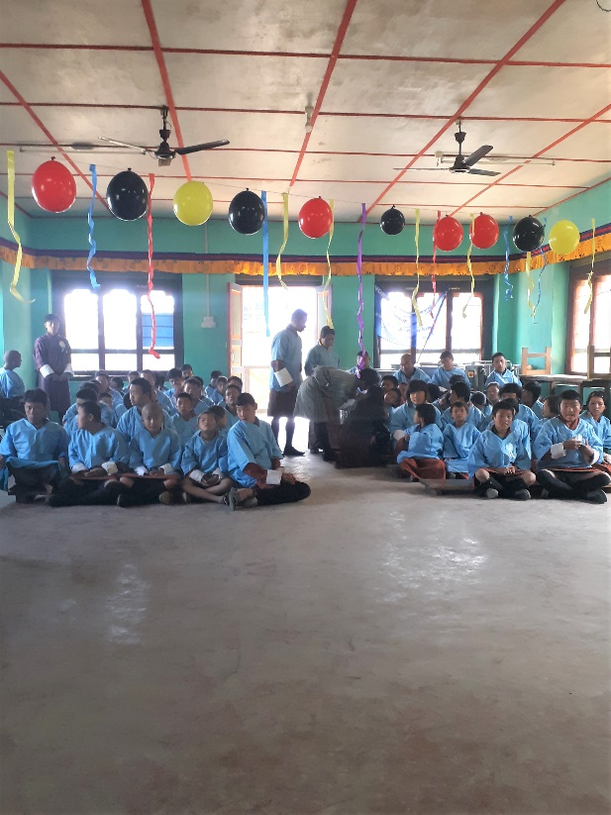 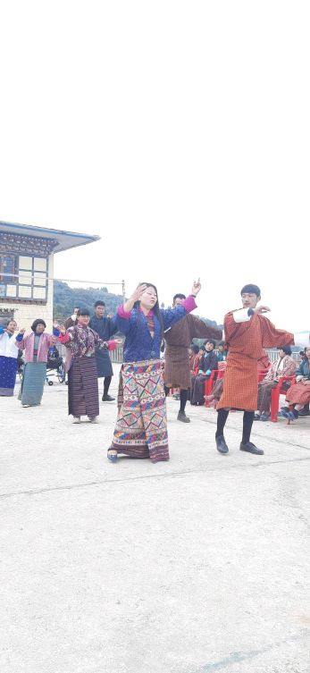



## 

## Critical Skills Training for Persons with Disabilities: 27th May

In collaboration with [Ministry of Labour and Human Resources, Royal Government of Bhutan](https://www.facebook.com/molhrbt?__cft__%5b0%5d=AZWSBPAoSf3eDnyADktJH6vZ8QsvsbO-DBGAtL_XHF-icFmRZ2lh3Xt1eEacyfpMBTRst2V64spngRVbo1HACI-Oysm2rl0ldOifzlktGxGFZShn_pnjC9AEnS2fSzAzARUEtS9Bd7kqSfyEh78ajUc0fU-c4I1Z53eUOxpW84v7blNLu1qku3qVWFz3vpYygfQxBHoUxbaL7wiirvo6Yg_x&__tn__=-%5dK-y-R) and other organizations for persons with disabilities like, [Ability Bhutan Society](https://www.facebook.com/absbhutan/?__cft__%5b0%5d=AZWSBPAoSf3eDnyADktJH6vZ8QsvsbO-DBGAtL_XHF-icFmRZ2lh3Xt1eEacyfpMBTRst2V64spngRVbo1HACI-Oysm2rl0ldOifzlktGxGFZShn_pnjC9AEnS2fSzAzARUEtS9Bd7kqSfyEh78ajUc0fU-c4I1Z53eUOxpW84v7blNLu1qku3qVWFz3vpYygfQxBHoUxbaL7wiirvo6Yg_x&__tn__=kK-y-R), [Bhutan Stroke Foundation](https://www.facebook.com/Bhutan-Stroke-Foundation-107162531113357/?__cft__%5b0%5d=AZWSBPAoSf3eDnyADktJH6vZ8QsvsbO-DBGAtL_XHF-icFmRZ2lh3Xt1eEacyfpMBTRst2V64spngRVbo1HACI-Oysm2rl0ldOifzlktGxGFZShn_pnjC9AEnS2fSzAzARUEtS9Bd7kqSfyEh78ajUc0fU-c4I1Z53eUOxpW84v7blNLu1qku3qVWFz3vpYygfQxBHoUxbaL7wiirvo6Yg_x&__tn__=kK-y-R), [Draktsho Vocational Training Centre for Special Children & Youth](https://www.facebook.com/draktsho/?__cft__%5b0%5d=AZWSBPAoSf3eDnyADktJH6vZ8QsvsbO-DBGAtL_XHF-icFmRZ2lh3Xt1eEacyfpMBTRst2V64spngRVbo1HACI-Oysm2rl0ldOifzlktGxGFZShn_pnjC9AEnS2fSzAzARUEtS9Bd7kqSfyEh78ajUc0fU-c4I1Z53eUOxpW84v7blNLu1qku3qVWFz3vpYygfQxBHoUxbaL7wiirvo6Yg_x&__tn__=kK-y-R) and [Phensem Parents Support Group, Bhutan](https://www.facebook.com/Phensem-Parents-Support-Group-Bhutan-2057096871259652/?__cft__%5b0%5d=AZWSBPAoSf3eDnyADktJH6vZ8QsvsbO-DBGAtL_XHF-icFmRZ2lh3Xt1eEacyfpMBTRst2V64spngRVbo1HACI-Oysm2rl0ldOifzlktGxGFZShn_pnjC9AEnS2fSzAzARUEtS9Bd7kqSfyEh78ajUc0fU-c4I1Z53eUOxpW84v7blNLu1qku3qVWFz3vpYygfQxBHoUxbaL7wiirvo6Yg_x&__tn__=kK-y-R) and has successfully commenced five month training courses to 45 trainees with disabilities in bakery, massage and tailoring at NLD Training Institute, NIWI and Lekdrup Skills Development Institute respectively.

This training was funded by Asian development Bank through the MoLHR with the aim to provide equal training opportunities with equal access to persons with disabilities so that PWDs can also find meaningful job opportunities in their life and live independently.

8 students and 1 teacher from Draktsho was also a part of this critical skills training.

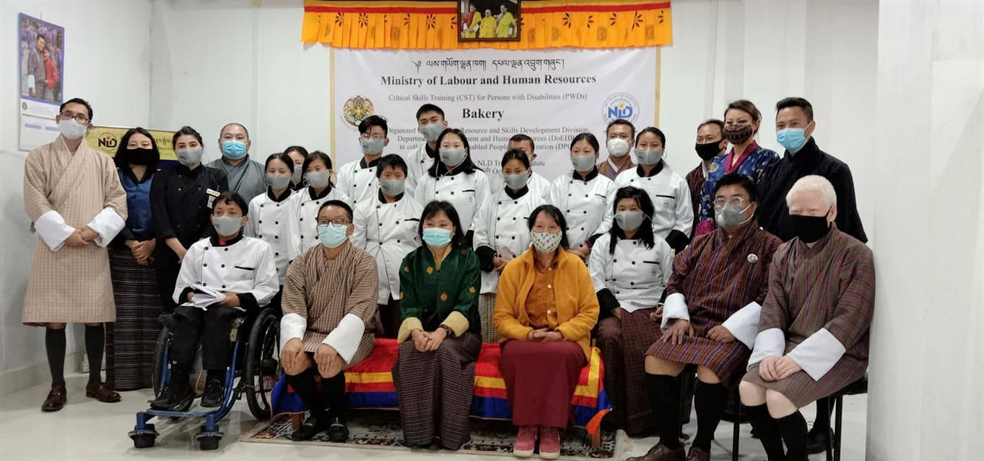

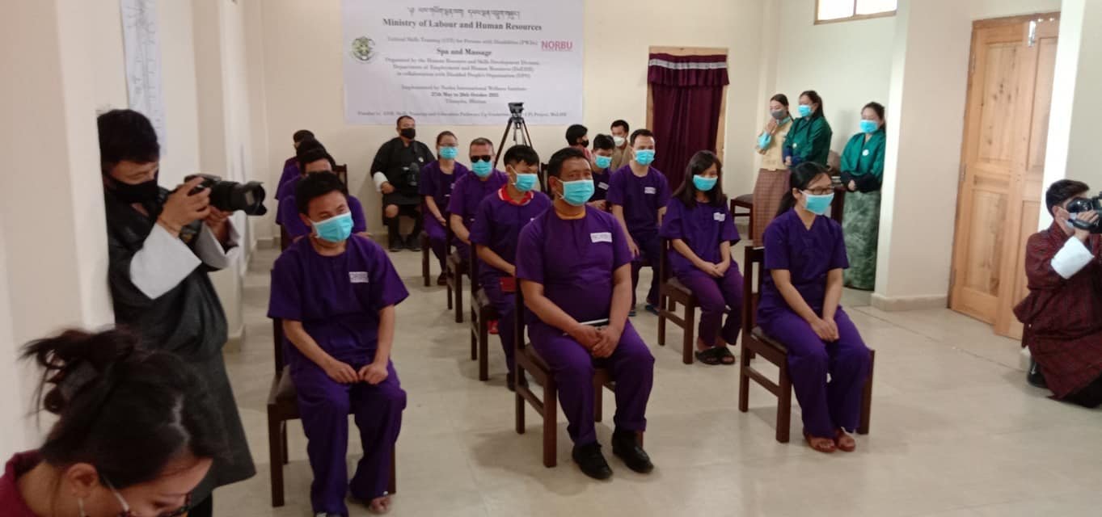

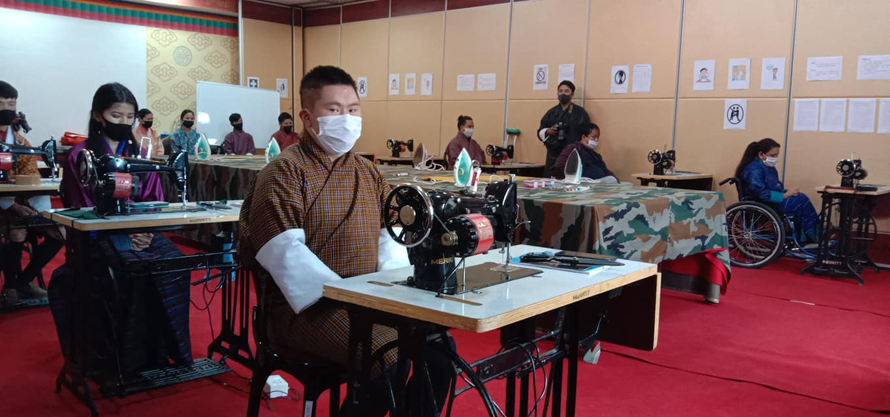

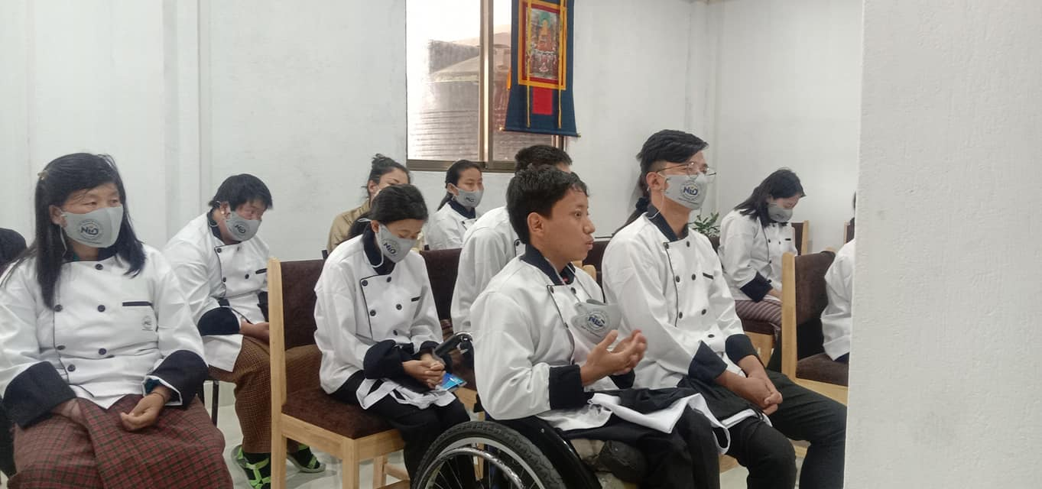

## Draktsho Ex-students Visit: 7th June

It was a wonderful day when 16 graduates of Draktsho paid a surprise visit to meet their teachers and other students. All these 16 students are gainfully employed, in fact few of them successfully managed to start their business such as bakeries. So thoughtful of these students to come with refreshments and a cake to show their gratitude.

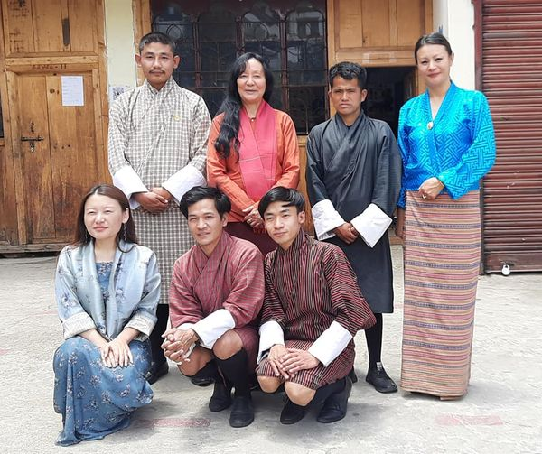 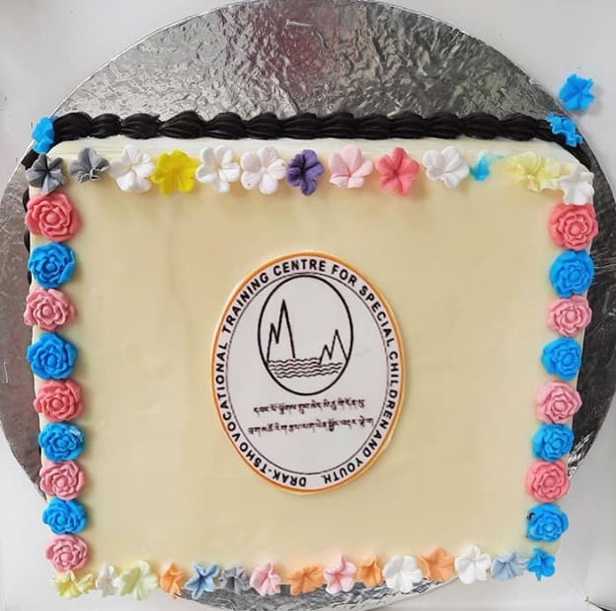

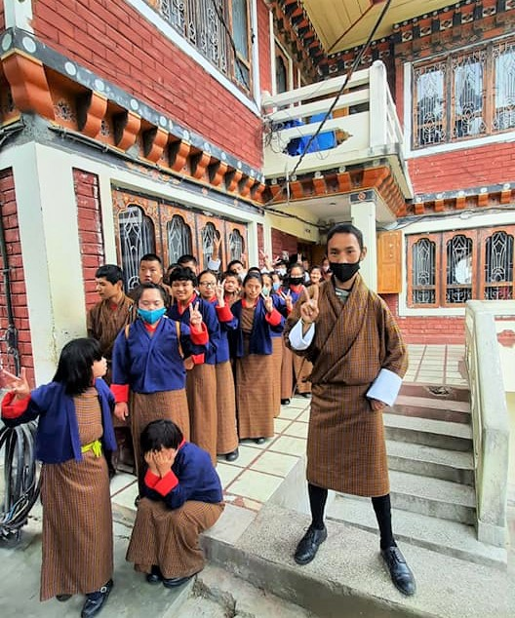 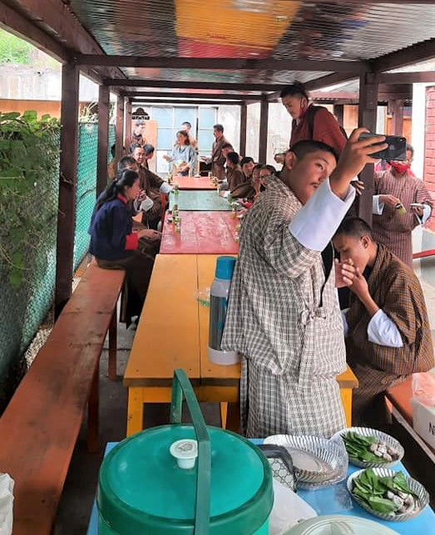

## Dental Health Care:

Students of Draktsho, their families/caregivers, staffs and volunteers received a free Dental Care checkup and treatment organized by medical team from Project DANTAK. The team was led by Dr. Sunali Joshi Kayshap who has conducted many similar campaigns for those who are not able to have access to Dental medical health facilities. Dr. Sunali and her team conducted a thorough check up starting from cleaning, filling, extraction and also referrals for those who require further treatment. This is the first Dental Campaign that was organized at Draktsho Thimphu and we remain grateful to Project DANTAK, Dr. Sunali and her team for taking time out to organize this event. This event is dedicated to Their Majesties 10th Royal Wedding Anniversary.

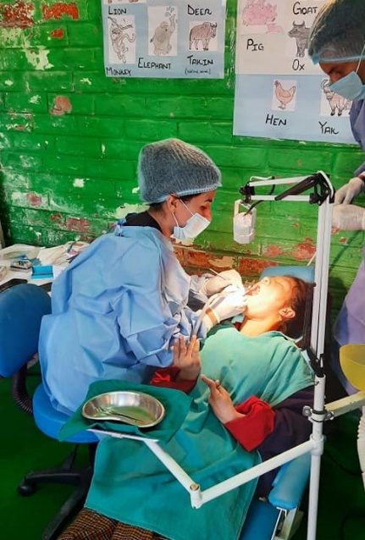 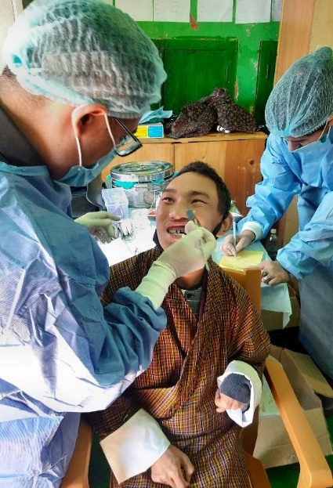 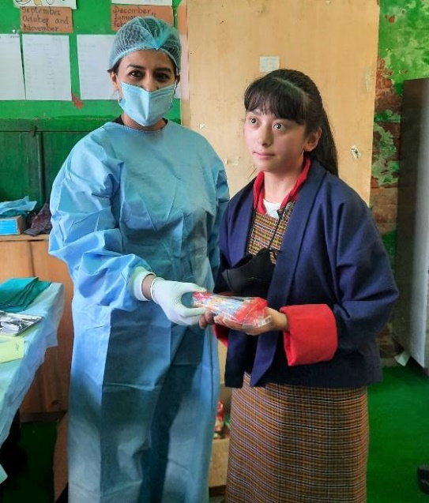

## Eco-Van Donation

The President of Draktsho Board of Director’s, Father Kinley Tshering donated a 7-seater Eco-Van to Draktsho strengthening the capacity of the organization.

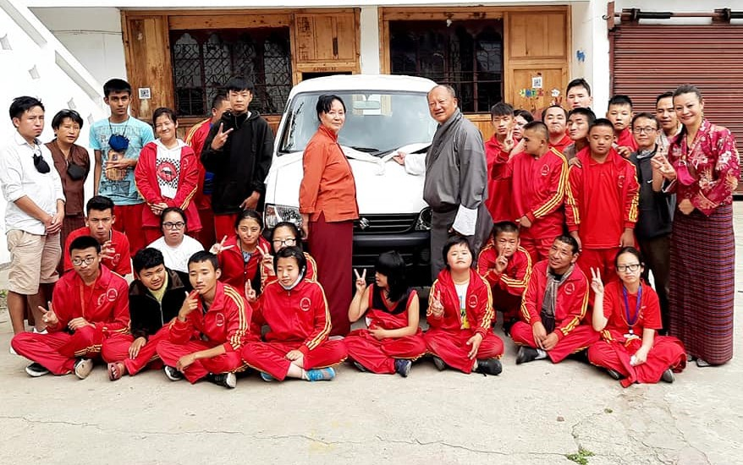

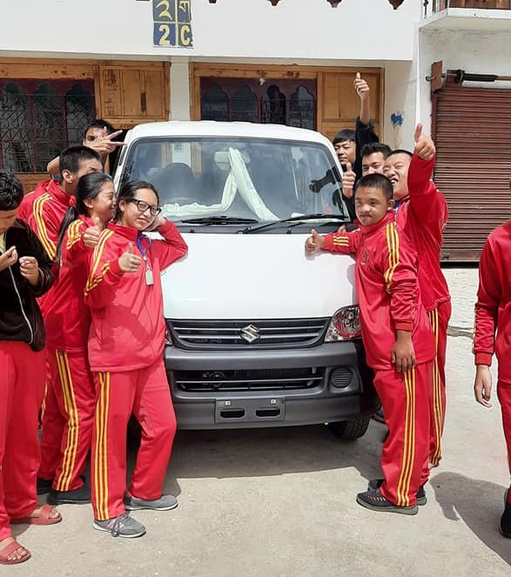

## International Day of Persons with Disabilities

Draktsho celebrated the International Day of Persons with Disabilities at the Athletic Ground today where Athletes, teachers and parents participated in track and field events. This special occasion was graced by the President of Draktsho's Board of Directors Father Kinley Tshering. The Athletes were from Changangkha Middle Secondary School and Draktsho. The event is sponsored by Christmas Record Grant, Special Olympics International.

