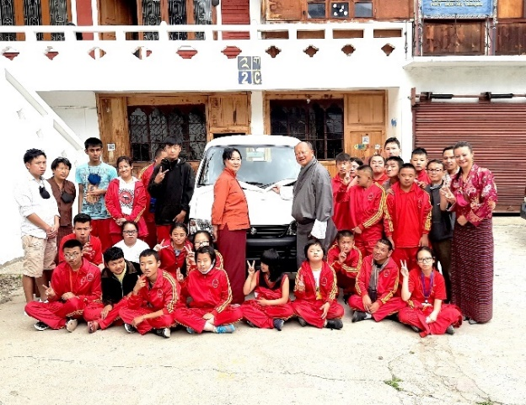

**Draktsho Annual Report 2024**

**Table of Contents**

**Introduction** 3

**Programs in 2024: Empowering Through Inclusion, Skills, and Advocacy** 3

**1. Vocational Skills Development and Entrepreneurship** 3

**Cooking Class – Draktsho Thimphu** 3

**Entrepreneurship and Financial Literacy Workshop – Draktsho East** 4

**2. ICT and Digital Inclusion** 4

**ICT lab Launch– Draktsho Thimphu and Draktsho Thimphu** 4

**3. Awareness and Advocacy Programs** 5

**World Down Syndrome Day** 5

**Autism Awareness Day** 5

**Cerebral Palsy Day, Deaf Culture & IDPD** 6

**Legal Awareness & Disability Rights** 7

**4. Inclusive Education and Capacity Building** 7

**Capacity Building for Private Schools and ECCDs** 7

**Disaster Preparedness and Safety Training – Draktsho East** 8

**5. Inclusive Sports and Community Integration** 8

**Foundation Day and Sports Day – Draktsho East** 8

**Annual Sports Day and IDPD Celebration – Thimphu** 9

**6. Partnerships and Support Initiatives** 9

**Donation of a New Bus – Thimphu** 9

**Accessible Infrastructure – Draktsho East** 10

**MoU with Druk Ride** 10

**7. Student Engagement and Social Development** 10

**Volunteer Programs and Visits** 10

**Life Skills Events** 10

# 

# **Introduction**

The year 2024 has been an inspiring journey of growth, resilience, and advocacy for the Draktsho Vocational Training Centre for Special Children and Youth. Both our Thimphu and East centres undertook numerous transformative programs and initiatives to empower children and youth with disabilities. These activities, rooted in the principles of inclusivity, skill development, and community engagement, have not only benefited our students but also raised awareness, fostered collaboration, and influenced national discourse on disability inclusion.

# **Programs in 2024: Empowering Through Inclusion, Skills, and Advocacy**

Draktsho’s programs in 2024 were built around four strategic pillars: **Vocational Skill Development**, **Inclusive Education and Advocacy**, **Digital Empowerment**, and **Community Engagement**. These programs aimed to create a more inclusive society by providing students with practical skills, emotional support, and a sense of belonging, while also sensitizing the broader community.

# **1. Vocational Skills Development and Entrepreneurship**

## **Cooking Class – Draktsho Thimphu**

Initiated on March 13, 2024, this program provides students with hands-on cooking experience to build essential life and vocational skills. More than just learning recipes, the program helps instill values of teamwork, hygiene, responsibility, and entrepreneurship. The students prepare dishes like *Puri and Aludam*, which are then sold to staff and visitors. This small business component allows students to learn basic costing and profit calculation, simulating a real-world sales experience. Held every two months, the program provides continuous engagement and joy to participants while building capacity for independent living.

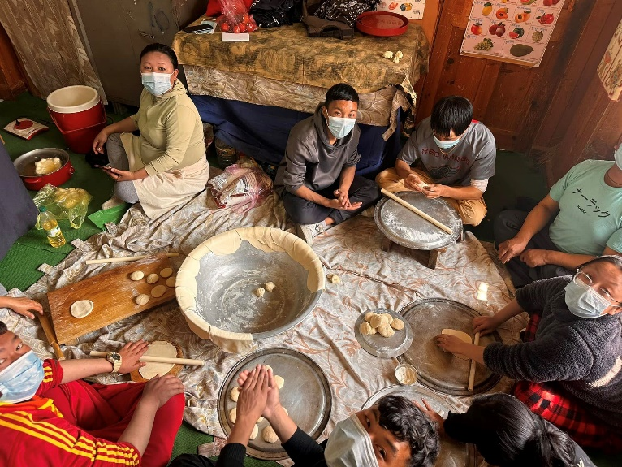

## **Entrepreneurship and Financial Literacy Workshop – Draktsho East**

This two-phase program, organized by Innovate Bhutan and funded by UNICEF, trained youth with disabilities in digital marketing, budgeting, and business planning. Through interactive sessions and peer collaboration, participants developed confidence and competence in presenting business ideas. The highlight was a final pitching event where students proposed real micro-businesses and received seed funding for implementation. This program is a significant step toward self-employment and financial independence.

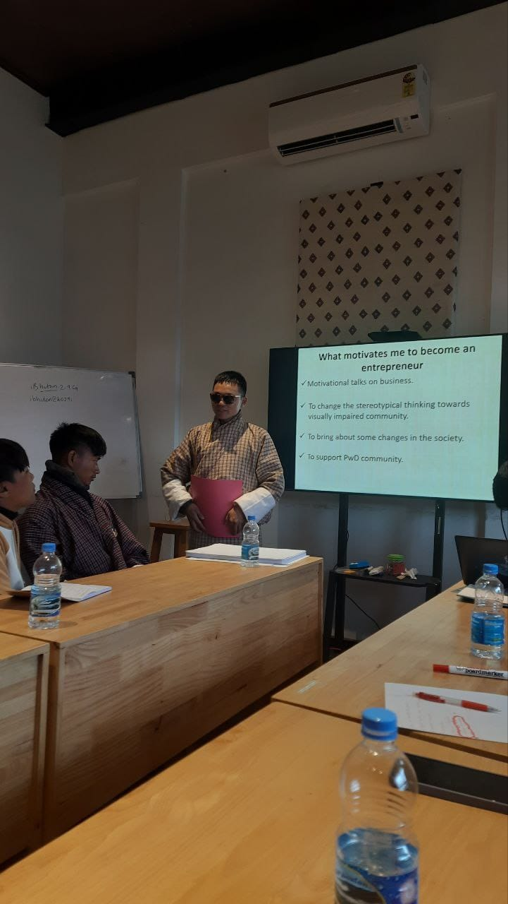

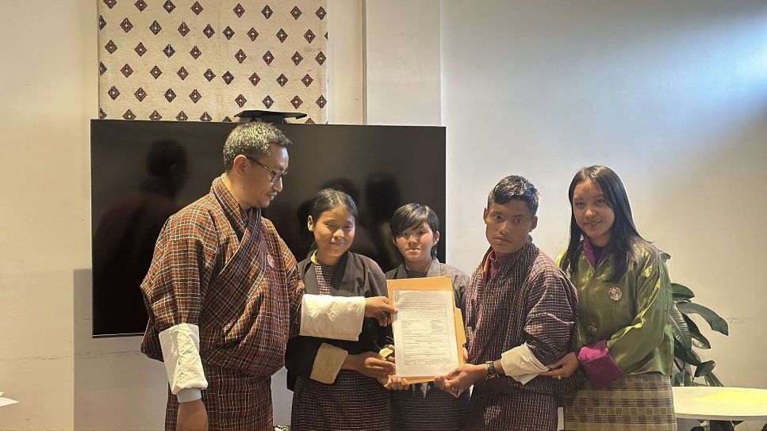

# **2. ICT and Digital Inclusion**

## **ICT lab Launch– Draktsho Thimphu and Draktsho Thimphu**

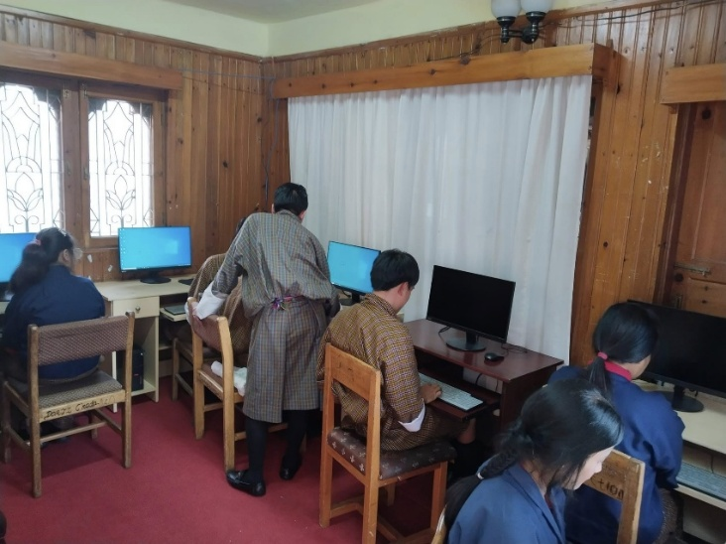Recognizing the importance of bridging the digital divide for persons with disabilities, Draktsho launched a dedicated ICT Unit. The program empowers students to be technologically literate and better prepared for the modern workplace. Importantly, this training is offered in a supportive environment using adaptive methods, enabling all learners to participate meaningful. The Draktsho East lab is especially important for youth from rural backgrounds who otherwise lack exposure to digital tools. It is helping them build skills that increase their employability and self-esteem.

# **3. Awareness and Advocacy Programs**

## **World Down Syndrome Day**

Held on March 21st, this celebration emphasized awareness and acceptance of individuals with Down syndrome. At Draktsho Thimphu, students, teachers, and volunteers celebrated at the Takin Zoo, wearing colourful outfits and face paints to symbolize the beauty of diversity. Draktsho East partnered with Rongthung Primary School to conduct educational sessions and interactive games 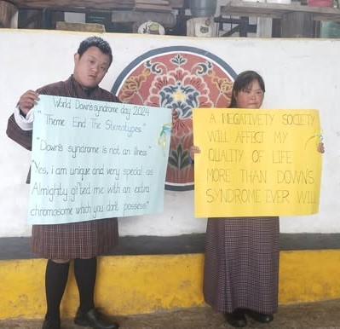with students and teachers, promoting empathy and dismantling harmful stereotypes.

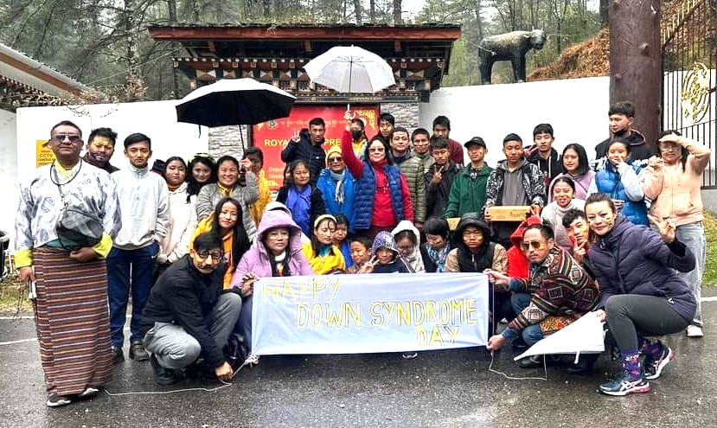

## **Autism Awareness Day**

Observed on April 2nd, the day was marked by inclusive celebrations in both centres. In Thimphu, a gathering at the centre fostered solidarity and shared joy among staff and students. A community-level event at Kaja Throm brought together five civil society organizations for an evening of cultural performances, songs, and cake-cutting. Draktsho East collaborated with Sherubtse College to spread awareness among youth and future leaders.

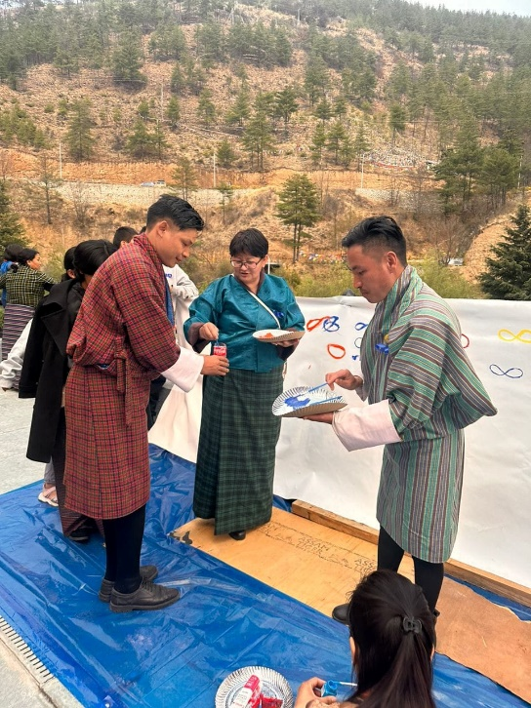

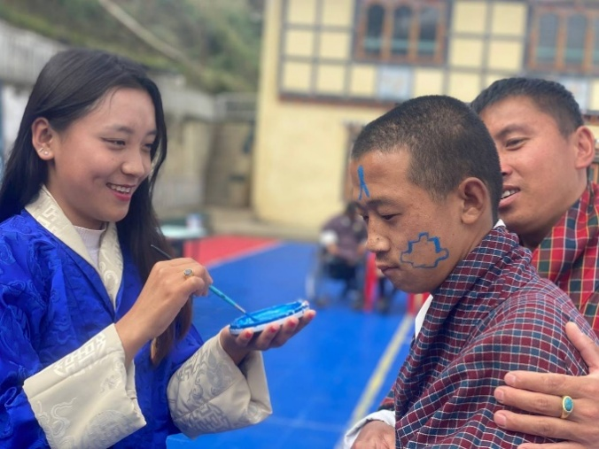

## **Cerebral Palsy Day, Deaf Culture & IDPD**

These events offered platforms for both awareness and celebration. Draktsho East organized cultural performances, panel discussions, and peer engagement programs. Programs on Deaf culture educated participants on inclusive communication practices such as sign language, and sensitization programs for local government authorities focused on accessibility in public services and governance.

## **Legal Awareness & Disability Rights**

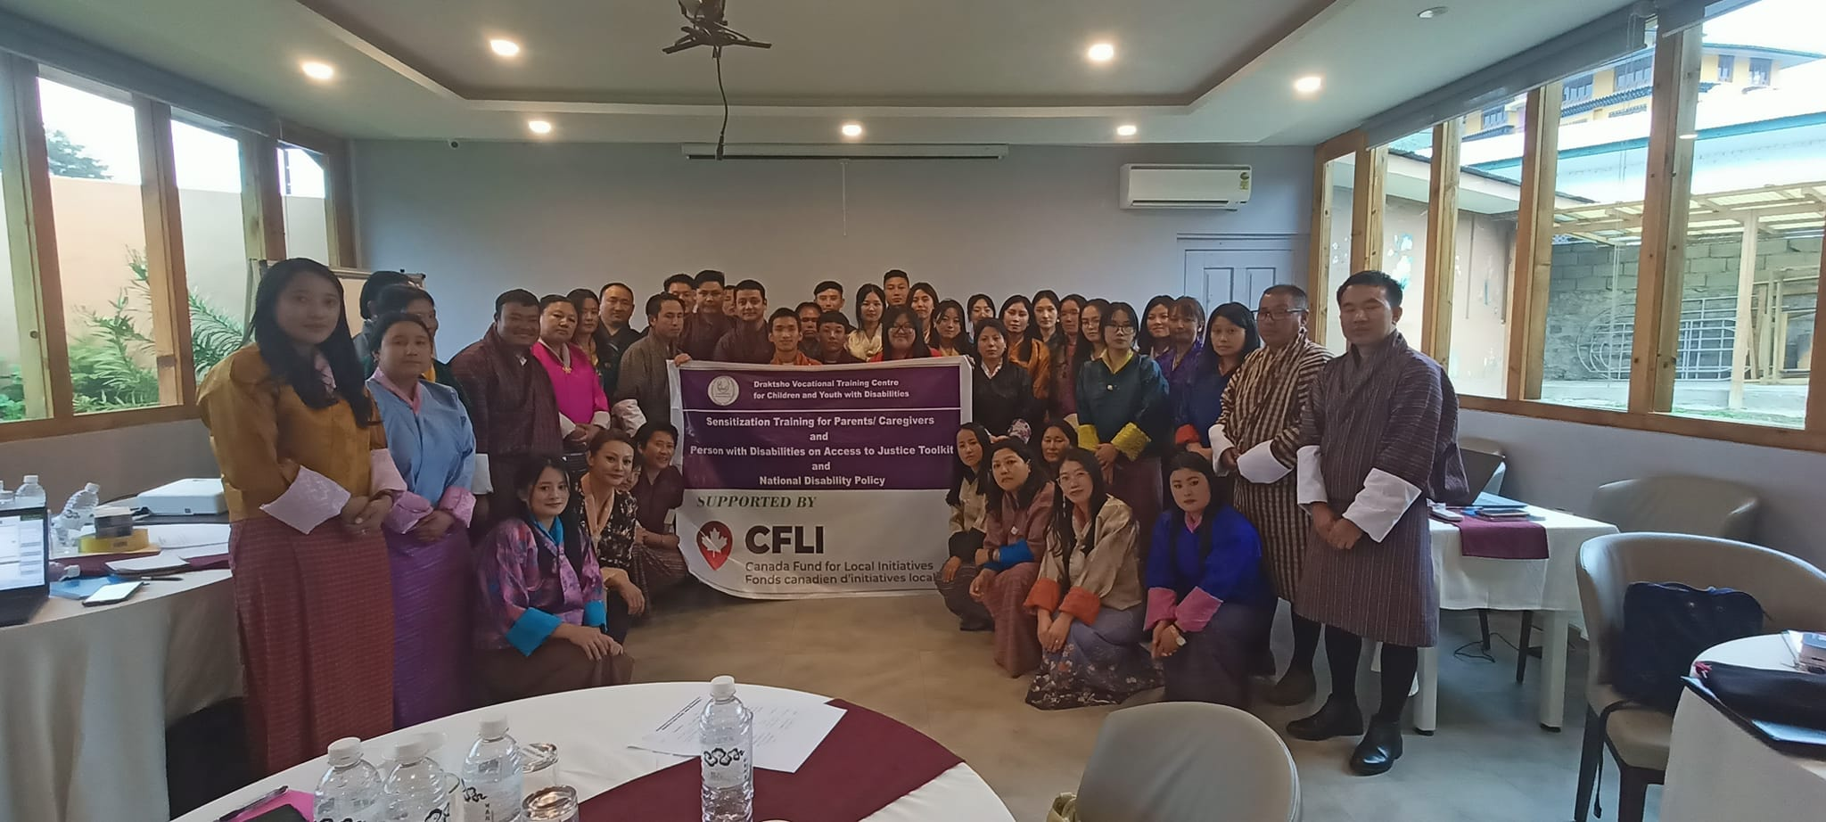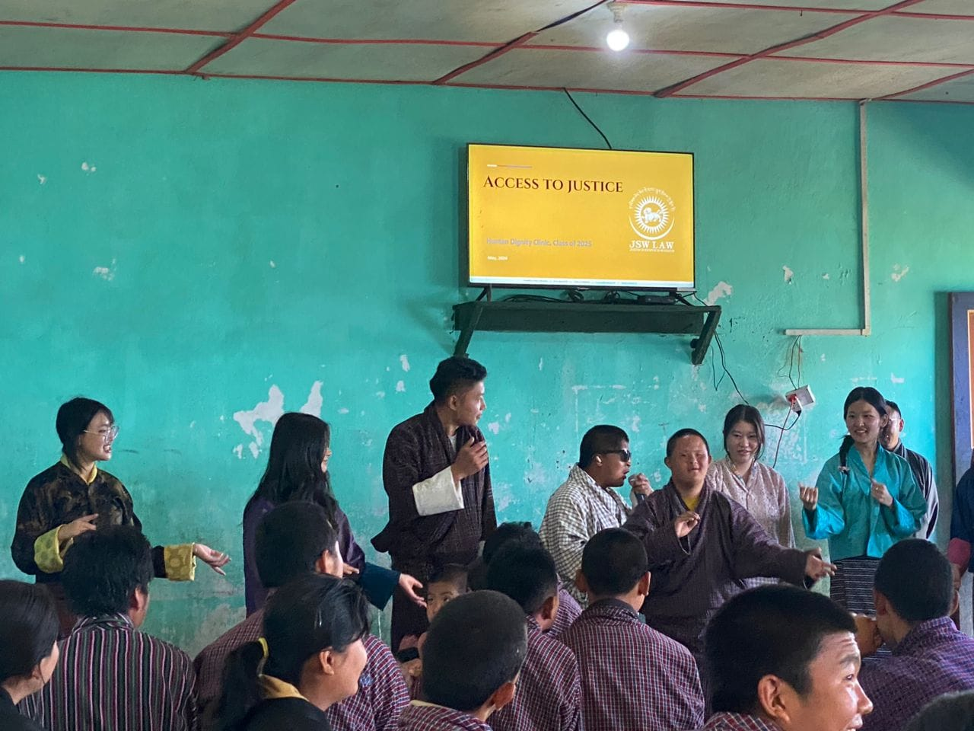Draktsho partnered with Jigme Singye Wangchuck School of Law and UNDP to conduct a legal literacy program tailored to persons with disabilities. The sessions introduced the "Access to Justice Toolkit" and focused on issues like legal identity, guardianship rights, and grievance mechanisms. These were followed by a two-day sensitization program (July 4–5) supported by the Canada Fund for Local Initiatives, which also focused on Bhutan’s National Disability Policy at Paro for Parents and Caregivers of the children with disability. These programs have equipped students and caregivers with knowledge and confidence to advocate for their rights.

# **4. Inclusive Education and Capacity Building**

## **Capacity Building for Private Schools and ECCDs**

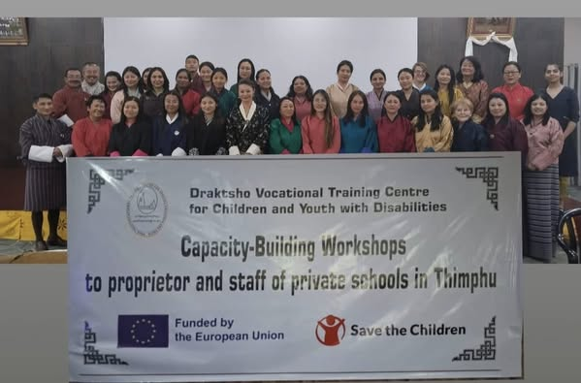In collaboration with Save the Children, Draktsho conducted a workshop aimed at enhancing the ability of early childhood and school-level educators to support children with disabilities. Facilitators from Drugyel Primary School, Ability Bhutan Society, and Phensem Parents Support Group shared practical strategies for inclusive classroom management and adaptive learning. The workshop helped bridge gaps between special education institutions and mainstream schools, fostering a more unified and inclusive education system.

## **Disaster Preparedness and Safety Training – Draktsho East**

A full-fledged mock drill, supervised by the Disaster Management Coordinator, trained staff and students in evacuation procedures, first aid, and disaster roles. Students participated actively in simulations of earthquake scenarios, while staff were divided into specialized teams for search and rescue, medical response, and logistics. This initiative promotes resilience and ensures safety in emergency situations.

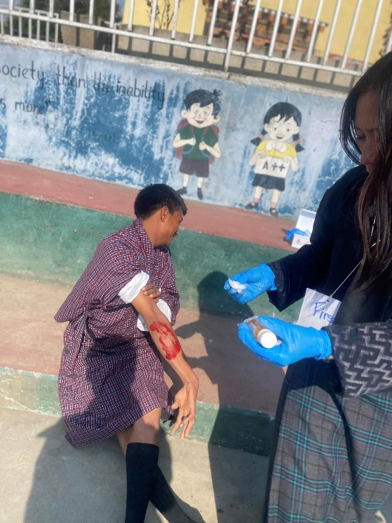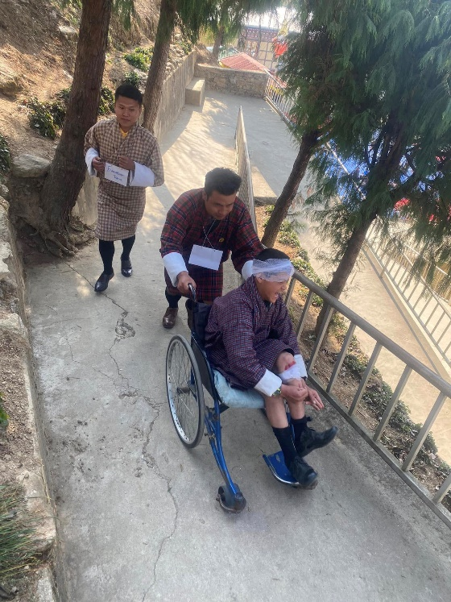

# **5. Inclusive Sports and Community Integration**

## **Foundation Day and Sports Day – Draktsho East**

Celebrated on April 10th, this event marked both the foundation anniversary of Draktsho East and its commitment to physical health and inclusion. Activities were carefully adapted for diverse needs—archery for wheelchair users, water-carrying races for students with cerebral palsy, and long jumps and shot puts for others. These events promote teamwork, motor skills, and a spirit of healthy competition, regardless of ability.

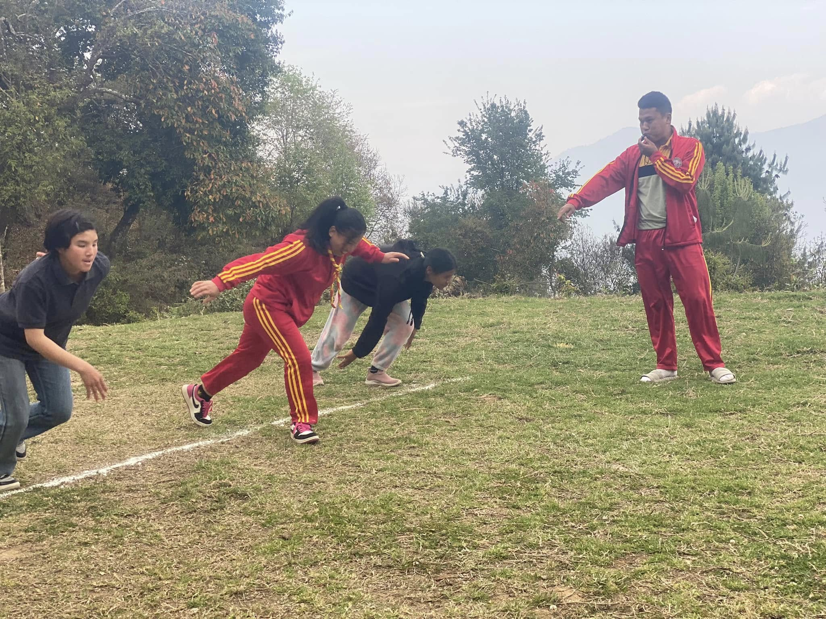

## **Annual Sports Day and IDPD Celebration – Thimphu**

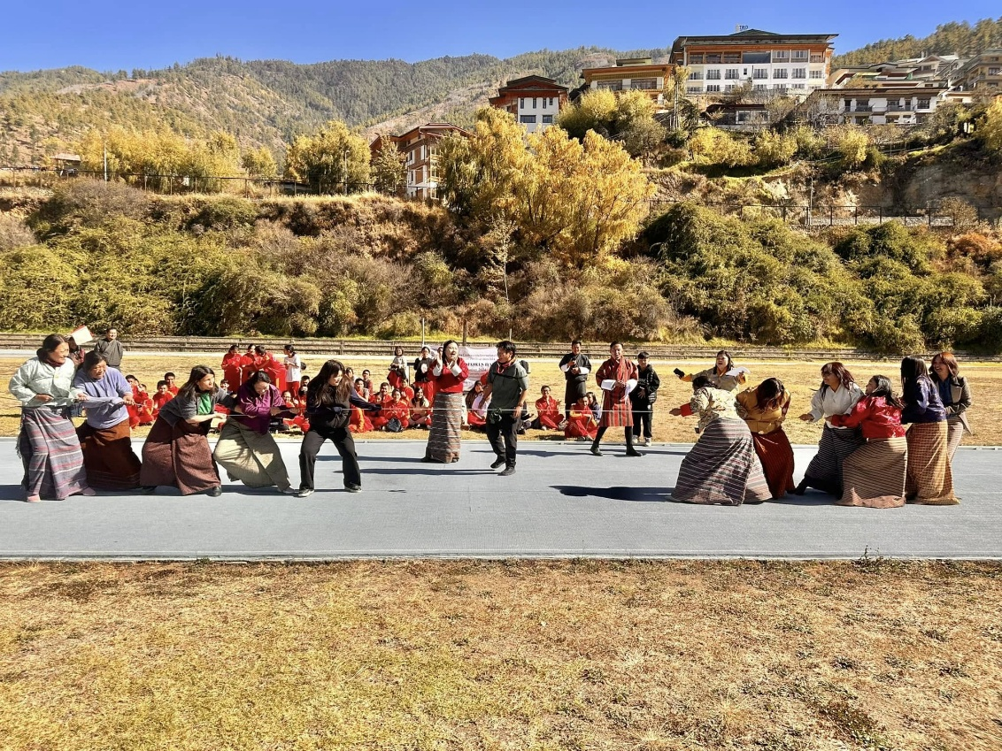On December 3rd, Draktsho Thimphu observed International Day of Persons with Disabilities (IDPD) alongside its Annual Sports Day in partnership with Special Olympics Bhutan. The day featured track and field events and interactive fun games. The presence of parents, volunteers, and Ms. Norbu Dema from Bhutan Foundation made the event more meaningful, reinforcing community support and pride in the abilities of students.

# **6. Partnerships and Support Initiatives**

## **Donation of a New Bus – Thimphu**

“Opening Your Heart to Bhutan” donated a new school bus, significantly improving transportation access for students with mobility challenges. The bus ensures regular attendance, safety, and ease of commute for students from remote parts of Thimphu.

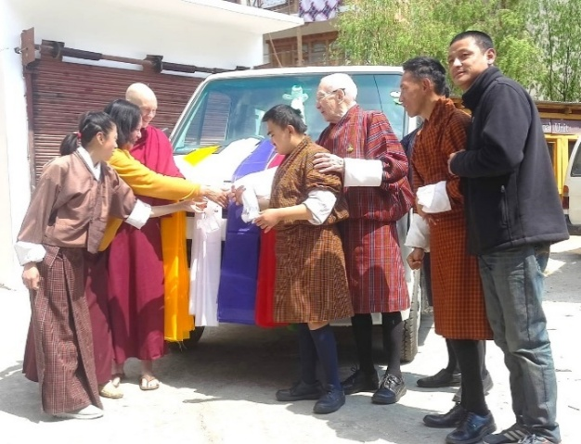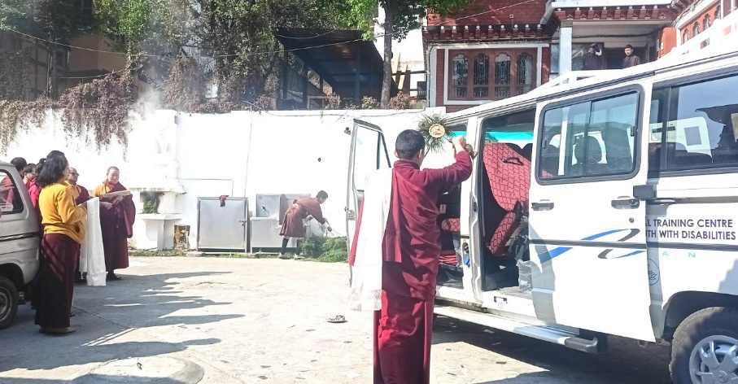

## **Accessible Infrastructure – Draktsho East**

The same partner funded construction of accessible toilets and improved walkways. These upgrades have had a profound impact on the dignity and independence of students with physical disabilities.

## **MoU with Druk Ride**

Through the MoU, Druk Ride committed to supporting fundraising and collaborative awareness activities for disability inclusion. The partnership opens avenues for broader community involvement and resource mobilization.

# **7. Student Engagement and Social Development**

## **Volunteer Programs and Visits**

Draktsho East hosted the GNH Club from Sherubtse College and received a visit from Trashigang Dzongda. Such engagements strengthen community ties and expose students to external support and inspiration.

## **Life Skills Events**

Cooking competitions, World Peace Day celebrations, and school picnics allowed students to enjoy leisure and develop practical life skills. These social activities are essential for emotional well-being and social integration.

The year 2024 was a year of progress, resilience, and transformation for Draktsho. Through diverse and impactful programs, we deepened our commitment to empowering children and youth with disabilities by equipping them with life skills, vocational training, digital competencies, and legal knowledge. Each initiative, whether it was a cooking class, a legal awareness program, or an inclusive sports day, reflected our unwavering belief in the potential and dignity of every individual, regardless of ability.

With strong partnerships, dedicated staff, and the continued support of national and international collaborators, we created more inclusive spaces, built critical infrastructure, and fostered awareness in communities across Bhutan. These efforts not only enriched the lives of our students but also contributed meaningfully to the national agenda of inclusion and equity.

As we look ahead, Draktsho remains committed to strengthening its programs, expanding outreach, and advocating for the rights of persons with disabilities. Together with our partners, families, and the broader community, we will continue to break barriers, promote acceptance, and create a society where every individual is given the opportunity to thrive.